**Unit 7: Atomic Theory**

Unit 7C: Photoelectron Spectroscopy (PES)

### Knowledge/Understanding:

* Photoelectric effect
* How photoelectron spectroscopy works

### Skills:

* Determining electron configuration from photoelectron spectra

**Notes:**

**The Nature of Light**

All light (_________________________________________________) is electromagnetic radiation. These _______________ of energy consist of two perpendicular fields: an ________________ field wave and a ____________________ field wave.

### http://secure.lcogt.net/files/styles/fourcol-image/public/spacebook/Electromagnetic%20waves_0.png?itok=FJgH1k1_

### These electromagnetic waves collectively make up the ______________________________________.

**Light Wave Properties**

Each electromagnetic wave has a unique set of ____________________, __________________, and ________________ values that describe it.

*Wavelength*:



*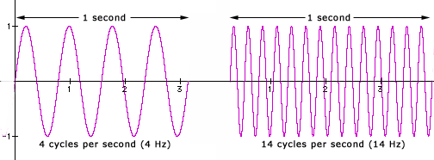Frequency:*

*Speed of light:*

**Speed of Light Equation**

Wavelength and frequency are _____________________ related in proportion to the speed of light as described by the equation:

*Note: make sure your units match! Units for c are _______, so wavelength must be in ______________ before using the equation.

**Energy of a Photon Equation**

The energy of a light wave is directly proportional to its __________________ and therefore indirectly related to its __________________ per the equations below:

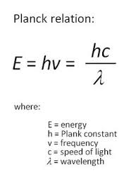

Planck’s Constant (h) = 6.63x10-34 Js

The ability to quantify the energy of a light wave based upon its wavelength was used as evidence to support the presence of ______________ energy levels via _________________ spectra.

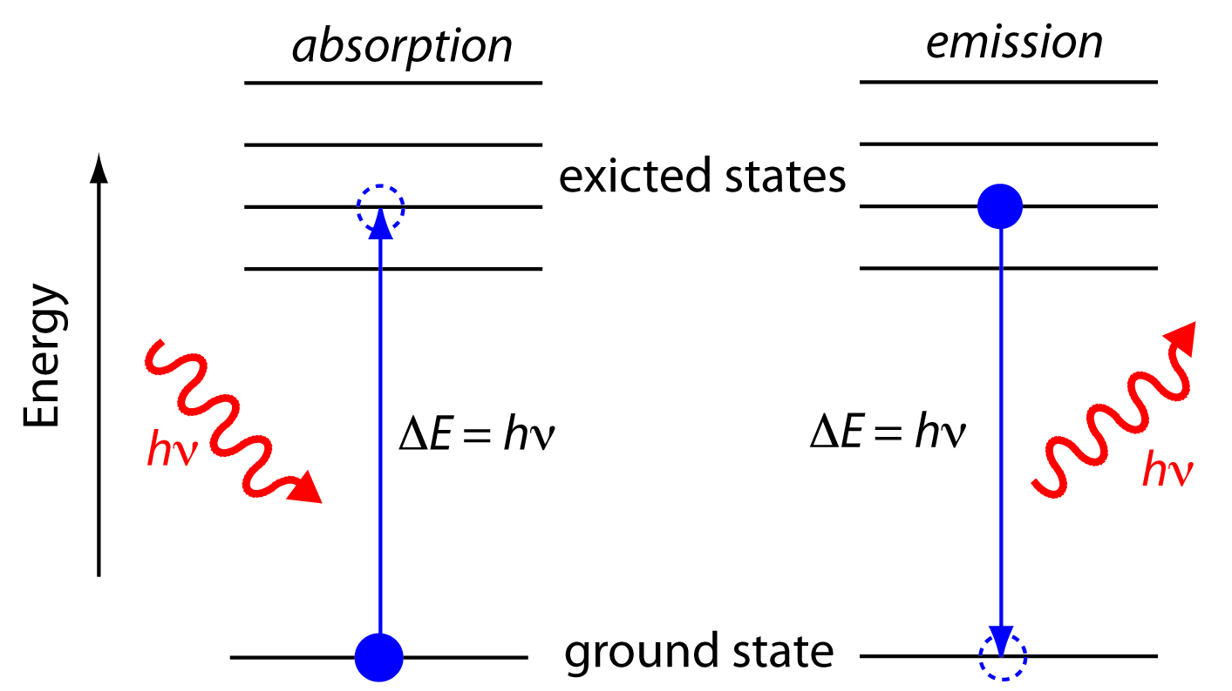

3s

3s

Same _______________

Emitted/Absorbed

=

Same _______________

Required to Move

Between Energy Levels

1s

1s

**Duality of Light**

Light energy exhibits evidence of behaving both as a ___________ and as a __________________. This duality is typically shown with the following experiments.

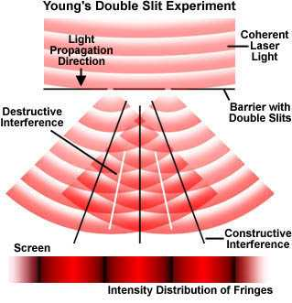**Light as a wave**

Dual Slit Clip: <https://www.youtube.com/watch?v=Iuv6hY6zsd0>

## Light as a particle

Most commonly observed phenomena with light can be explained by waves.

|  |  |  |
| --- | --- | --- |
| Phenomenon | Can be explained in terms of waves. | Can be explained in terms of particles. |
| [Reflection](http://hyperphysics.phy-astr.gsu.edu/hbase/phyopt/reflectcon.html#c1) | http://hyperphysics.phy-astr.gsu.edu/hbase/imgmod2/wavp.gif | http://hyperphysics.phy-astr.gsu.edu/hbase/imgmod2/parp.gif |
| [Refraction](http://hyperphysics.phy-astr.gsu.edu/hbase/geoopt/refr.html#c1) | http://hyperphysics.phy-astr.gsu.edu/hbase/imgmod2/wavp.gif | http://hyperphysics.phy-astr.gsu.edu/hbase/imgmod2/parp.gif |
| [Interference](http://hyperphysics.phy-astr.gsu.edu/hbase/phyopt/interfcon.html#c1) | http://hyperphysics.phy-astr.gsu.edu/hbase/imgmod2/wavp.gif | http://hyperphysics.phy-astr.gsu.edu/hbase/imgmod2/parn.gif |
| [Diffraction](http://hyperphysics.phy-astr.gsu.edu/hbase/phyopt/diffracon.html#c1) | http://hyperphysics.phy-astr.gsu.edu/hbase/imgmod2/wavp.gif | http://hyperphysics.phy-astr.gsu.edu/hbase/imgmod2/parn.gif |
| [Polarization](http://hyperphysics.phy-astr.gsu.edu/hbase/phyopt/polarcon.html#c1) | http://hyperphysics.phy-astr.gsu.edu/hbase/imgmod2/wavp.gif | http://hyperphysics.phy-astr.gsu.edu/hbase/imgmod2/parn.gif |
| [Photoelectric effect](http://hyperphysics.phy-astr.gsu.edu/hbase/mod1.html#c2) | http://hyperphysics.phy-astr.gsu.edu/hbase/imgmod2/wavn.gif | http://hyperphysics.phy-astr.gsu.edu/hbase/imgmod2/parp.gif |

But the ______________________________ suggested a particle nature for light.

photoelectric effect:

When visible or ultraviolet light is shone on a substance, the energy from the photons of light ___________________ electrons in the substance. If the energy exceeds the ____________________________ of an atom in the substance, the electron is _________________.

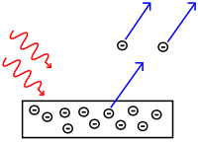

The emitted electrons are called __________________________.

The effect is produced strongly by ____________________ light and more weakly by lower _______________________. Light whose frequency was lower than a certain critical value did not _____________ any electrons at all. This dependence on frequency didn't make any sense in terms of the classical wave theory of light.

If light is only behaving as a wave, it would consist of _______________ and ____________________ fields. The stronger the fields, i.e., the greater the wave's ___________________, the greater the forces that would be exerted on electrons that found themselves bathed in the light. Therefore, it should have been amplitude (__________________) that was relevant, not frequency.

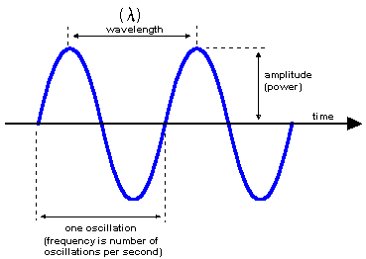

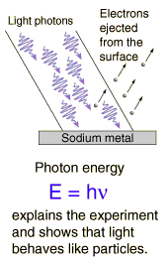However, the only effect amplitude (brightness) had on electron emission was the _________________ of electrons emitted. It had no effect on their _______________________ (speed they are eject with)!

This provides evidence that light was behaving as “_________________” of energy. The more we increase the intensity, the more packets of energy we are sending at the metal to come into contact with the ___________.

Photoelectric Effect Simulation:

http://phet.colorado.edu/en/simulation/photoelectric

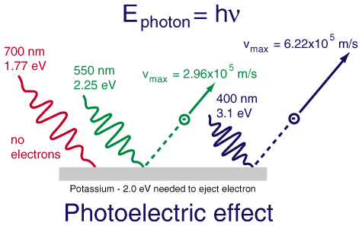The dependence on ___________________ not only proves that the wave model of light needs modifying, but with the proper interpretation it allows us to determine how much energy is in one _____________, and it also leads to a connection between the wave and particle models that we need in order to reconcile them.

## 1 eV = 1.602x10-19 J

A low-frequency red or infrared photon has less energy than the ___________________________ of the electron to its nucleus (EB), so a beam of them will not __________ any electrons.

A high-frequency blue or violet photon, on the other hand, packs enough of a punch to allow an electron to get out of the metal electrode. At frequencies ______________ than the minimum, the photoelectric current continues to increase with the frequency of the light as electrons are ejected with more and more kinetic energy (________________).

## Photoelectron Spectroscopy

photoelectron spectroscopy or photoemission spectroscopy (PES):

The term “photoelectron spectroscopy” is generally used for the technique when applied to ___________, and “photoemission spectroscopy” is generally used for electrons emitted from ___________ surfaces.

In photoelectron (or photoemission) spectroscopy, a substance is bombarded with _____________, which have a given amount of _____________ based on their frequency:

By measuring the ________________________ of the emitted electron, *Ek*, and predetermining the “______________________”, *Wo*, of the substance (the amount of additional energy it takes to move the delocalized electron to the _______________ of the material—zero for gases, but nonzero for solids), we can calculate the _______________________, *EB*, of the electron from Einstein’s equation for the photoelectric effect:

The photons used for photoelectron spectroscopy range from ultraviolet light to X-rays.

Ultraviolet photoelectron spectroscopy (UPS) and extreme ultraviolet photoelectron spectroscopy (EUPS) are used to study ________________ electrons and the electrons that participate in chemical bonding. X-ray photoelectron spectroscopy (XPS) is most often used to study ___________ electrons, particularly in solids.

## Interpreting Photoelectron Spectra

The XPS spectrum for gold looks like the following:

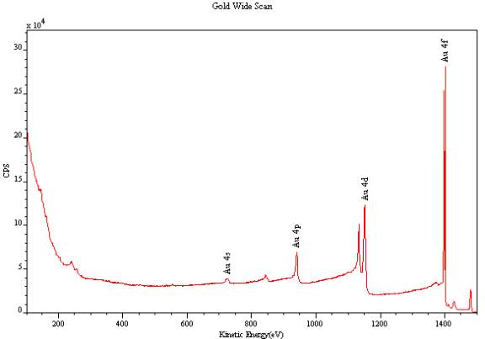

Notice that the peaks for 4s, 4p, 4d, and 4f are different _____________. The height of the peak is proportional to the _______________ of electrons in a given sublevel.

Analysis of UV photoelectron spectra for a single element with a relatively low atomic number is straightforward. For example, the following is an idealized plot of the photoelectron spectrum for lithium:

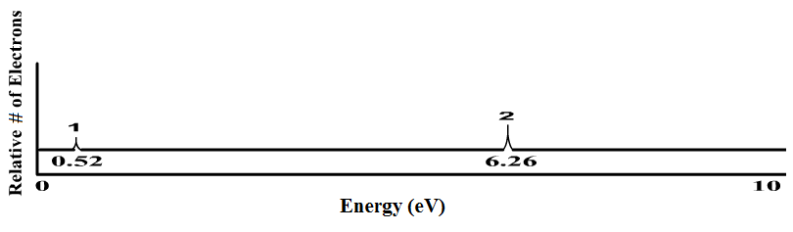

1s

2s

The *x*-axis has units of ______________________ of the electron, usually electron-volts (____). Recall that electrons in higher sublevels have ________ binding energy, which makes them easier to remove. This means the peak at the left corresponds with the easiest-to-remove electrons (for lithium, this is the ____ electron). The peak at the right corresponds with the electrons that are _____________ to remove (for lithium, these are the two ____ electrons).

The *y*-axis indicates the _____________ of photons emitted with that energy. This means the height of each peak is proportional to the ____________________________ in the corresponding sub-level. Notice that the peak at 6.26 eV (the 1s electrons) is twice as high as the peak at 0.52 eV (the 2s electron). This means there are twice as many electrons in the 1s sublevel as in the 2s sublevel. The only element that matches this spectrum is lithium (_____________).

### Sample Problem:

Q: Identify the element represented by the following photoelectron spectrum:

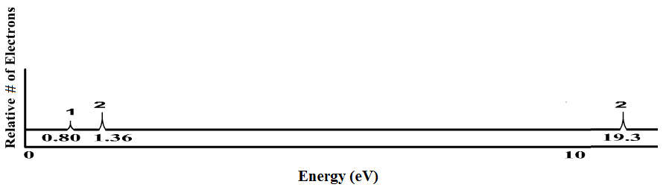

A:

**Duality of Electrons**

It wasn’t long after the duality of light was discovered that similar behavior was theorized and supported for electrons.

### The ________________ behavior of electrons was well accepted and supported by multiple experiments, including the ____________________.

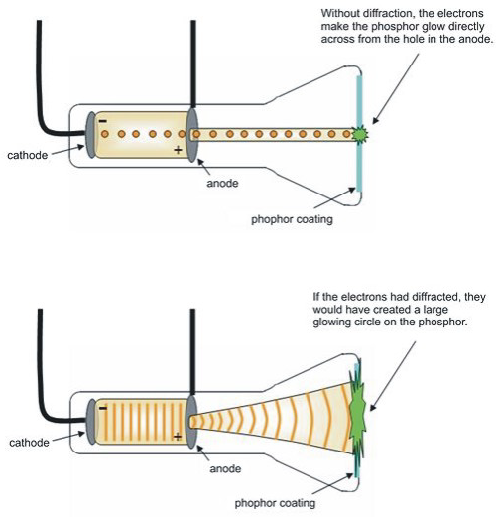

### Additionally, the ability to ________________ the cathode beam with a given electrostatic charge allowed for a specific _______________________ ratio to be determined. Evidence for mass characteristics supports particulate behavior.

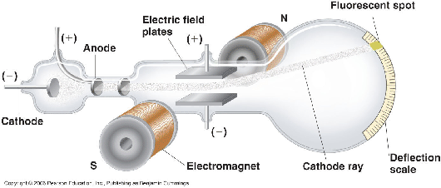

### Young's duel slit experiment with electrons

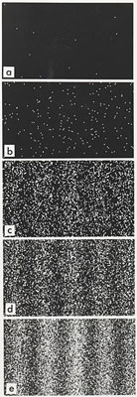A group from the lab of Akira Tonomura performed an analogous experiment with electrons: [Young's experiment, one electron at a time](http://www.tiptop.iop.org/full/pwa-pdf/16/5/phwv16i5a24.pdf), from which we take the following images.

|  |
| --- |
|  |
| Successively longer integration times as electron arrivals (white dots) are recorded. |

The ____________________________________ pattern mirrors the results of light ______________ from the duel-split experiment.

Evidence for electron wave behavior provides further support for the ________________________________________ and the application of ___________________________ equation to predict electron positioning in _________________, since it assumes wave behavior.

