Unit 6/7 Review Packet
Electron Configuration, Quantum Mechanical Model, Periodic Trends
- Explain how the Quantum Mechanical Model utilizes the theories proposed by Rutherford and Bohr.

- How is Schrödinger’s equation used to express electron behavior? What is the disadvantage to specifying the location of an electron? (Hint: Uncertainty)

- An apple appears red to the eye, if a median wavelength for red light is about 655nm, what energy of photon is being absorbed by the photoreceptors in your retina?

- Which neutral element is represented by the following electron configuration?
- 1s²2s²2p⁶3s²3p⁶4s²3d⁹
- Write out the proper configuration for part a, explaining the reasoning behind any changes you made.

- Follow the AUFBAU Principle, Hund’s Rule, and the Pauli Exclusion Principle to complete the following orbital electron configurations. Make sure your diagram reflects the most stable configuration.

- Cadmium ²⁺ b. Germanium¹⁻
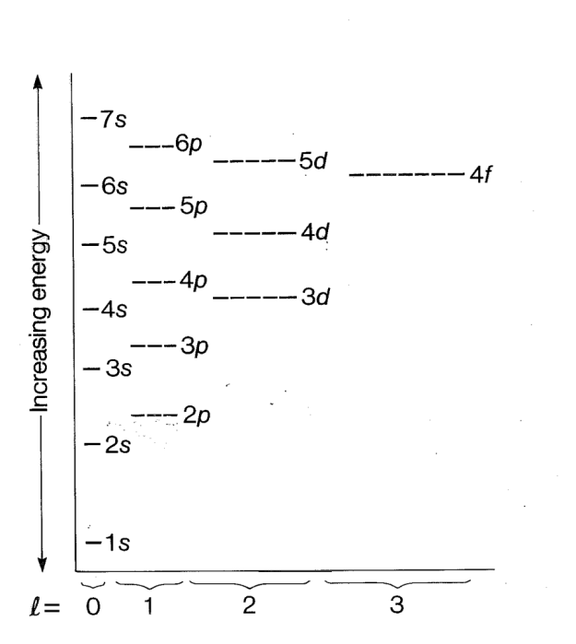

- How many orbitals are full in 5b?

- For 5b: Identify the four quantum numbers for the 2nd electron in the 3rd orbital of 3d and explain the significance of each.

- For the electron diagram in 5a:
- Circle the {n = 2, l = 1, m_{l} = -1, m_{s} = 1/2} electron
- Put a box around the {n = 3, l = 2, m_{l} = 1, m_{s} = -1/2} electron
- What allows electrons to pair-up in orbitals despite having repulsive electrostatic charges? Explain.

- Which of the following are isoelectric with krypton?

Se³⁻ Zr⁴⁺ Cd⁷⁺ Sr²⁺ Br²⁻

- A sample of silver is exposed to electromagnetic energy with a frequency of 9.97x10¹⁴ s⁻¹ a. How much energy (in eV) are the electrons of the silver atoms being exposed to?

- If the binding energy for a silver 5s electron is 0.23eV, describe what you would see if the silver sample was being analyzed via photoelectron spectroscopy. The work function for silver is 4.26 eV.

- What would be the minimum wavelength (nm) required to emit a 5s electron?

- If a 5s electron emitted from a sample of silver was found to have a KE = 3.77x10⁻¹⁸J, what wavelength (nm) of electromagnetic energy was the sample likely hit with?

- How would the KE of a 5s and a 3p electron (E_{B}=58.3eV) compare if both were emitted from when exposed to x-rays with a frequency of 1.69x10¹⁶ s⁻¹?

- Label the peaks and identify the element given the following photoelectron spectroscopy data.
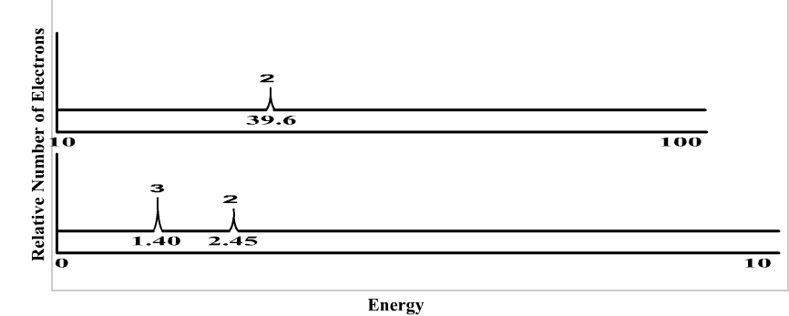

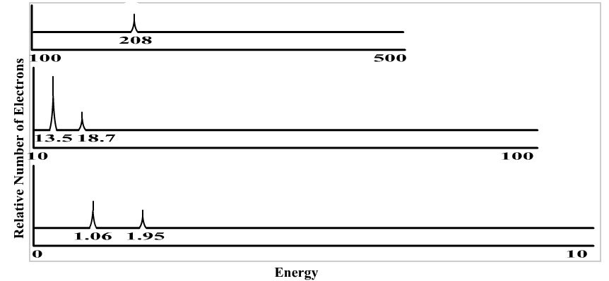
b.

- Referencing the photoelectron spec data in problem 12b, answer the following:
- Describe what would happen to the data if a -3 ion of the same element was analyzed.

- Describe how the spec data for the element silicon would compare to 12b.

- If the light source used for the analysis of 12b could now create a maximum wavelength of 62 nm. (Work function of 12b is 1.2eV).

- Describe the two atomic characteristics that influence radius and explain their effect using Coulomb’s Law.

- Explain why the trends for ionization energy and electronegativity are related to radius.

- Explain how Coulomb’s Law provides information on the 1st ionization energy for an atom.

- Explain why 2nd ionization energy is always larger than 1st ionization energy. Reference radius and Coulomb’s Law.

- Which trend is a good predictor of metal reactivity? Explain your reasoning.

- Which trend is a good predictor of non-metal reactivity? Explain your reasoning.

- Predict the products of the following reactions. If a reaction would not occur, write “No Rxn”.

- KCl (aq) + Li (s)

- Rb (s) + Na₂SO₄ (aq)

- Br₂ (l) + MgF₂ (aq)

21) If the first ionization energy for calcium is 1200 kJ/mol, predict the relative energies associated with the following.
a. Ca 2nd ionization energy
b. Ca 3rd ionization energy
c. K 1st ionization energy
d. Se 1st ionization energy

