Unit 4 Name ____________________
Types of Reactions & Date ____________ Block ____
Solution Stoichiometry

Unit 4A – Types of Reactions

Knowledge/Understanding Goals:
- Know the 5/6 types of inorganic reactions that will be on the AP exam.

Skills:
- Be able to identify what type of reaction will occur between reactants.
- Predict the products of a reaction.
- Apply stoichiometry to predict amounts of reagents needed and products formed.

Notes:

There are 5/6 inorganic reactions that you will need to be able to identify and predict the products for:
- Decomposition
- Synthesis
- Single Displacement
- Double Displacement
  - Solution Chemistry:
- Combustion

Synthesis
In a synthesis reaction, _______________ reactants combine to form ____________________ product molecules.

Ex: 4Al(s) + 3O₂(g) 2Al₂O₃(s)

General Types of Synthesis Reactions
- _________ combines with a _______________ to form a ________
2Na(s) + Cl₂(g)

- Soluble ______________ combine with water to form _______ (metallic _________)
Na₂O (s) + H₂O(l)

- ______________________ and water form ________.
CO₂(g) + H₂O(l)

- Carbonic acids are typically more straight forward

P₄O₁₀ (s) + H₂O(l)

- Phosphate, sulfate, and nitrates are a bit more tricky since you must track your ________________________.
  - Oxidation State: the “_________” an atom takes on in a ______________ compound. Electrons are still being __________ (covalent bonds), so oxidation states are formed/balanced rather than ionic charges.
    - Listed first/middle = _____________ (lower electronegativity)
    - Listed last = ________________ (higher electronegativity)

- Note that the non-metal (P) retains its oxidation state of ____. That is why we formed phosphoric acid (H₃PO₄) rather than phosphorus acid (H₃PO₃)

H: 3(+1) =
P: 1(___) =
O: 3(-2) =

P: 4(+5) =
O: 10(-2) =

H₃PO₃
P₄O₁₀
H: 3(+1) =
P: 1(___) =
O: 4(-2) =

H₃PO₄
- Metallic Oxides and Non-metallic Oxides form _________
CaO (s) + SO₃(g)
Non-metallic Oxide
Metallic Oxide

- Boron compounds combine with an electron pair ____________ (lewis acid/base)
BI₃(s) + NH₃(g)

Lewis Dot Structure:

- Common Sense Synthesis (really only one option)
H₂(g) + Cl₂(g)
E
2H₂(g) + O₂(g)

Decomposition
In a decomposition reaction, a reactant molecule is _________________ into multiple products.

Ex. 2H₂O₂ (aq) 2H₂0 (l) + O₂ (g)

General Types of Decomposition Reactions
- ____________________ of Ionic Binary Compounds (________)
  - Ionic salts can be forced to separate into their metal and non-metal ________________ states in the presence of ______________ energy.
E
2NaCl (s)
***Notice this is NOT the _____________________ of a salt that we see with __________________, as dissolving of an ionic compound is not a reaction!***
NaCl (aq)

- Decomposition of Oxyacids, Metallic Carbonates, and Metallic Chlorates
  - _____________ decompose into ______ and a _____________________.
H₂SO₄(aq)
Oxyacid

  - Metallic Carbonates decompose into _____________ and carbon dioxide.
CaCO₃ (aq)
Metallic Carbonate

    - Typically self-balancing
    - Very common on old AP tests

  - Metallic Chlorates decompose into __________________ and ________.
2KClO₃(aq)
Metallic Chlorate

    - Typically require balancing
    - Very common on old AP tests

Specific Types of Decomposition Reactions
- Ammonium carbonate decomposes into ____________________________________
(NH₄)₂CO₃ (aq)

- Ammonium hydroxide decomposes into _____________________________
NH₄OH (aq)

***Note that whenever ammonium is present on the reactant side, there is a good chance ammonia is a product, unless you are working with a single/double displacement reaction***

- Hydrogen peroxide decomposes into ____________________________
2H₂O₂ (aq)

***Note, oxygen and hydrogen are NOT the products***

- Water decomposes into __________________________
E
2H₂O(l)

Single Displacement Reactions
In a single displacement (SD) reaction, a reactant in its elemental state replaces an ion in an ionic compound, forcing the ion to take on its elemental form.

Ex: CuSO₄(aq) + 2Li(s) Cu(s) + Li₂SO₄(aq)

General Types of SD Reactions
- More reactive _______ replaces a less reactive _________ in a compound.
Zn(s) + Ni(NO₃)₂ (aq)
- Typically performed by placing a piece of metal in an ______________ ionic solution.
- Metal in the elemental form (neutral) must be more _______________ than the metal in the ionic form (+ charge) to replace it.
  - Which is the preferred state to be in, neutral or ion?

- More reactive ____________ replaces a less reactive ____________ in a compound.
F₂(g) + 2NaCl (aq)
- Typically involves the displacement of _____________ in solution.
- Non-metal in the elemental form (neutral) must be more _____________ than the non-metal in the ionic form (- charge) to replace it.

***Note: You are NOT expected to memorize the reactivity series to predict whether an SD reaction will occur or not. Information will be provided to you in the question if necessary***
- Special case of Hydrogen
  - Hydrogen can act as a metal or a non-metal due to its 1 valence electron in the first energy level.

      - Hydrogen acting as a metal.
_______________ metals can replace hydrogen in cold water.
2Na(s) + 2H₂O(l)

__________________________ metals can replace hydrogen in steam.
2Fe(s) + 2H₂O(g)

Some metals cannot replace hydrogen in water, but can in _________.
Zn(s) + 2HCl(aq)

      - Hydrogen acting as a non-metal.
Hydrogen is less reactive than the halides and will be readily _____________.
2NH₃(aq) + 3I₂(s)

Double Displacement Reactions
In a double displacement (DD) reaction, two ionic compounds exchange partners.

Ex: Mg(NO₃)₂(aq) + 2NaOH(aq) Mg(OH)₂(s) + 2NaNO₃(aq)

General Types of DD Reactions
- _____________________ (Metathesis) reactions: Two soluble ionic, salt solutions combine to produce a ____________________
2NaI(aq) + Pb(NO₃)₂(aq)

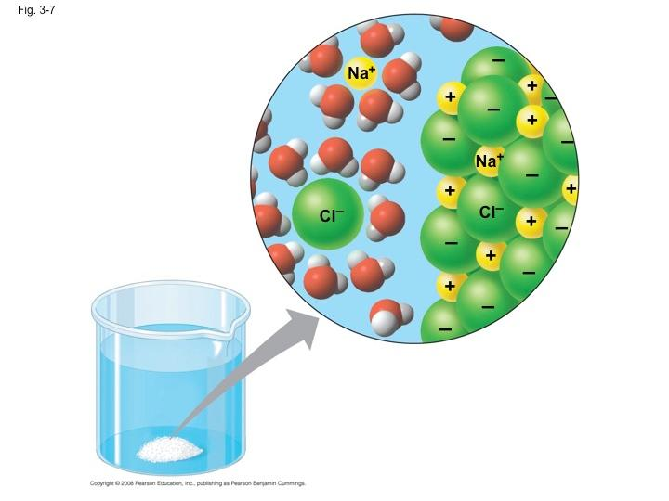
Solubility/Dissolving
In order for a compound to dissolve in water, the combined attraction between each _____ and the several __________ molecules surrounding it must be _____________ than the attraction between the _____. The stronger total attraction wins, which means the NaCl to the right dissociates and the ions dissolve in water.

dissolve: when a _____________ distributes itself throughout a _______________. A solute dissolves if the attraction between the solvent and the solute molecules or ions is stronger than the attraction of the solvent molecules for each other and also stronger than the attraction of the solute molecules or ions for each other.
dissociate: when an ________ compound splits into cations (positive ions) and anions (negative ions). (start and end with _______)
ionize: when a _____________compound forms ions in a solution. (only end with ____)
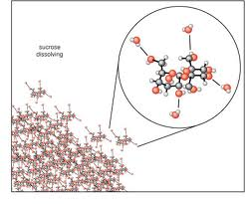
- Note that dissolution (dissolving), dissociating, and ionizing are different processes.
Ex: Glucose (a covalent molecule) ______________ in water, even though it does not form ions.

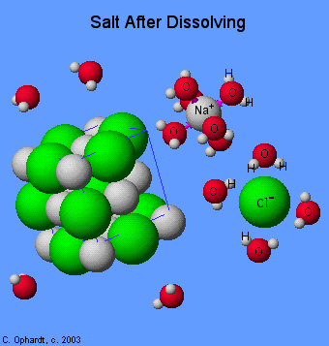
- Sodium chloride ____________ in water into Na⁺ and Cl⁻
ions, but it does not ionize because it is already made of
ions.

- HCl ____________ in water because the covalent H−Cl bond breaks
and the electrons divide unevenly forming H⁺ and Cl⁻ ions.
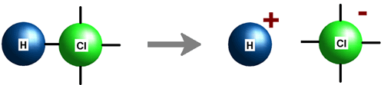

electrolyte:
strong electrolyte:
For example: NaCl (aq) → Na⁺ (aq) + Cl⁻ (aq)
HCl (aq) → H⁺ (aq) + Cl⁻ (aq)

weak electrolyte:
For example: HC₂H₃O₂ (aq) H⁺ (aq) + C₂H₃O₂⁻ (aq)
On the other hand, a precipitate (insoluble compound) forms when the attraction between ions is too strong for the water molecule attraction to overcome. So as soon as these ions come into contact with one another in solution, they combine and cannot be dissolved by the water.
The metathesis reaction between sodium carbonate (Na₂CO₃) and calcium chloride (CaCl₂) forms a precipitate:
Na₂CO₃ (aq) + CaCl₂ (aq) → NaCl (aq) + CaCO₃ (ppt) (1)

Once the calcium carbonate is formed, it doesn’t ________________. I.e., reaction (1) happens, but the reverse reaction (2), doesn’t:

CaCO₃ (s) + NaCl (aq) → CaCl₂ (aq) + Na₂CO₃ (aq) (2)

You should be able to predict the solubility (whether it will dissolve or not) of most products to see if a precipitate will form.
  - Soluble
    - All group 1 metals and NH₄⁺ are soluble***
    - All nitrates, chlorates, and acetates are soluble***
    - All halides (not F⁻) are soluble unless paired with Pb, Ag, or Hg
    - All sulfates are soluble except when paired with heavy group 2 metals, Pb, Ag, Hg

  - Insoluble
- All carbonates, phosphates, sulfites, and sulfides are insoluble, unless paired with rule 1 cations
- All chromates are insoluble, except when paired with Ca, Sr, and rule 1 cations
- All hydroxides are insoluble, except when paired with Ca, Sr, and rule 1 cations.

Practice: Write out the complete balanced equation for the following reactions, including phases.
      - Na₂CO₃( ) + Zn(NO₃)₂( )

      - AgC₂H₃O₂( ) + NaCl( )

      - KOH( ) + Fe(ClO₃)₂( )

- For precipitate reactions, _____________________ are often written out to isolate the species that are directly involved in a double displacement reaction.

Full Ionic Equations: Includes everything from the chemical equation, but anything soluble (aq) is shown dissociated into its ________. Solids, liquids, gases are all left __________________ as they are not dissolved by the solute (water). All molar ratios must remain intact through the use of _______________________!

Write the full ionic equation for practice problem #1.

Net Ionic Equations: Includes only the species directly involved in the ______________, if there is one. In other words, it includes only the parts of the full ionic equation that _____________ from the reactant side to the product side. (Go from being a soluble ion to an insoluble precipitate)
Any ions that do not change during the reaction are called ______________________ and are left out of the net ionic equation.

Write the net ionic equation for practice problem #1.

The net ionic equation shows that a reaction did occur in problem #1, as a _______ product was formed; the ZnCO₃ precipitate.
Write out the full and net ionic equations for practice problem #2.

If every species in your full ionic equation is aqueous, you will have no unchanged species in the equation and therefore no __________________________________. What does this mean? Draw a diagram of the solutions before and after mixing to support your answer.

- Acid/Base (___________________) reactions
According to Svante Arrhenius’s definitions:
- acids produce ___________ in aqueous solutions
- bases produce ___________ in aqueous solutions

strong acid: an acid that ionizes ____________________ in water.
HCl (aq) → H⁺ (aq) + Cl⁻ (aq)

Any acid with a negative pK_{a} value (see Appendix 5) is a strong acid. Memorize the following strong acids:

weak acid: an acid that ionizes only _________________ in water.
HF (aq) H⁺ (aq) + F⁻ (aq)

Assume that any acid you will see on the AP Chemistry exam is a weak acid unless it is one of the strong acids listed above.

strong base: a base that ionizes _________________ in water.
NaOH (aq) → Na⁺ (aq) + OH⁻ (aq)

Any base whose conjugate acid has a pK_{a} value greater than 14 is a strong base. All soluble oxides and hydroxides of group I and group II metals are strong bases. (Except that aqueous Mg(OH)₂ acts like a weak base.)

weak base: a base that ionizes only ________________ in water. Weak bases react with H₂O, creating the conjugate acid and OH⁻.
NH₃ (aq) + H₂O (ℓ) NH₄⁺ (aq) + OH⁻ (aq)

Assume that any base you see on the AP Chemistry exam is a weak base unless it is one of the strong bases listed above.
Strong acids and bases are strong ___________________, meaning that they ionize to produce a large number of ions in water, and the resulting solution is a good conductor of _____________________.
Weak acids and bases ionize only partially. This often means that the resulting solution is a _________ electrolyte (poor conductor of electricity). However, note that if the weak acid or base is itself an ion, the solution will be a ____________ electrolyte regardless of the amount of dissociation of the acid or base.

General Acid/Base Reactions
  - Neutralization of strong bases (hydroxides) and strong acids to form a ________ and _______________.
KOH(aq) + HCl(aq)
Base Acid

- Remember the criteria for saying a chemical reaction has occurred?
  - We must

- So for hydroxide base neutralization reactions, rather than producing a precipitate through double displacement, we form liquid __________.

Write out the full and net ionic equations for the reaction above between potassium hydroxide and hydrochloric acid.

Practice: Write out the complete balanced equation for the following reactions, including phases.

1) Ca(OH)₂( ) + HClO₄( )

2) HNO₃( ) + KOH( )

__________________ acids can behave differently than monoprotic acids. The following reaction has 3 possibilities, depending upon the number of hydrogen __________________ from the acid.
3) H₃PO₄( ) + LiOH( )
H₃PO₄( ) + LiOH( )
H₃PO₄( ) + LiOH( )

  - Neutralization of molecular bases (ammonia) to form a _______.
NH₃(g) + HCl( )

NH₃(g) + H₂MnO₄( )
Careful, polyprotic!

  - Neutralization of a carbonate with a strong acid to form a _______, ___________, and _________________________.
Na₂CO₃( ) + HNO₃( )

CaCO₃( ) + H₂SO₄( )
Combustion Reactions
In a combustion reaction, a ______________________ is burnt in the presence of oxygen. The products of a combustion reaction are __________ and _______________________.
- Combustion of hydrocarbons

CxHy(l/g) + O₂(g)

- Typically tricky to balance since you start with an even number of oxygen and end with an odd number.
  - Usually have to apply the “double all of your coefficients” rule
- Note the _________ of water since combustion produces a lot of ______ energy

- Combustion of alcohols
CxHyOH (l) + O₂(g)

- Typically easy to balance since you start and end with an odd number of oxygen
- Note the phase of water since combustion produces a lot of heat energy

AP Chem Types of Reactions Worksheet
Balance the following equations, predict the products, and indicate the type of reaction taking place:
1) ____ NaBr + ____ H₃PO₄
Type of reaction: ____________________

2) ____ Ca(OH)₂ + ____ Al₂(SO₄)₃
Type of reaction: ____________________

3) ____ Mg + ____ Fe₂O₃
Type of reaction: ____________________

4) ____ C₂H₄ + ____ O₂
Type of reaction: ____________________

5) ____ PbSO₄
Type of reaction: ____________________

6) ____ NH₃ + ____ I₂
Type of reaction: ____________________

7) ____ H₂O + ____ SO₃
Type of reaction: ____________________

8) ____P₄O₆ + ____ H₂O
Type of reaction: ____________________

9) ____ H₂SO₄ + ____ NH₄OH
Type of reaction: ____________________

10) ____ Fe + ____ H₂O
Type of reaction: ____________________

11) ____ (NH₄)₂CO₃
Type of reaction: ____________________

12) ____ Na₂O + ____H₂O
Type of reaction: ____________________

12) ____ C₃H₈ + ____O₂
Type of reaction: ____________________

