Unit 3 & 4 Review Packet Name ________________________
- Write the general formula for the 5 types of synthesis reactions (parts 1-4 in notes).

- Write the general formula for the 4 types of decomposition reactions (parts 1-2 in notes).

- Review and understand the specific synthesis & decomposition reactions covered in the notes.

- Write the general formula for the 3 types of single displacement reactions.

- Explain how to determine whether a SD reaction will occur or not.

- Write the general formula for the 4 types of double displacement reactions (precipitation, strong acid/strong base, strong acid/carbonate, and strong acid/weak base).

- Explain how to determine whether a double displacement reaction will occur or not.

- Write the general formula for the 2 types of combustion reactions.

- Compare and contrast dissolution, ionization, and dissociation.

- Know the role and importance of total ionic and net ionic equations. (Include simplifying equations in your answer)

- Identify the solubility of the following ionic species:

- Li⁺, Na⁺, K⁺, Rb⁺, Cs⁺, Fr⁺
- NH₄⁺
- Cl⁻, Br⁻, I⁻
- CO₃²⁻
- SO₄²⁻
- PO₄³⁻
- NO₃⁻
- C₂H₃O₂-

- Relate electrolytes to the concept of solubility.

- Diagram how the following molecules would be dissolved by water.
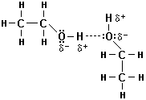
Potassium Iodide Ethanol (C₂H₅OH)
KI

- Identify the 6 strong acids and rule for determining strong bases.

- Relate strong acids and bases to solubility.

- Predict the products of and balance the following reactions. If no reaction occurs, write “no rxn”.
- ____ NaBr + ____ H₃PO₄
Type of reaction: ____________________

- ____ Ca(OH)₂ + ____ Al₂(CO₃)₃
Type of reaction: ____________________

- ____ Mg + ____ Fe₂O₃
Type of reaction: ____________________

- ____ C₂H₄ + ____ O₂
Type of reaction: ____________________

- ____ PbSO₄
Type of reaction: ____________________
- ____ NH₃ + ____ I₂
Type of reaction: ____________________

- ____ H₂O + ____ SO₃
Type of reaction: ____________________

- ____P₄O₆ + ____ H₂O
Type of reaction: ____________________

- ____ H₂SO₄ + ____ NH₄OH
Type of reaction: ____________________

- ____ Fe + ____ H₂O
Type of reaction: ____________________

- ____ (NH₄)₂CO₃
Type of reaction: ____________________

- ____ Na₂O + ____H₂O
Type of reaction: ____________________

- ____ C₃H₈ + ____O₂
Type of reaction: ____________________

- For the following problems, write the molecular, total ionic and net ionic equations for the reaction described. Solve for the requested value.
- 13.9g of ammonia gas is bubbled through 1.80M hydrochloric acid.

- How many milliliters of acid would be required to completely react the ammonia?

- How many grams of salt would be produced if the ammonia is completely reacted?

- 25.0mL of 1.44M sodium hydroxide is spilled on the lab bench and neutralized with 0.885M sulfuric acid.

- If 13.4 mL of sulfuric acid are used to neutralize the spill, how many grams of water will be produced?

- If the 13.4 mL of sulfuric acid were used, is the final solution neutral? If yes, use a calculation to show neutrality. If no, support with a calculation that shows how many mL of the limiting reagent should be added to get to neutral.

- 15.0 g of magnesium is placed into a solution of silver nitrate.

- If the volume of solution is 130.0mL, what would be the minimum concentration required to completely react the magnesium?

- If the concentration of the solution is actually 0.015M silver nitrate, how much solid product will be produced?

- A lab procedure requires 500.0mL of a 0.350M sodium acetate solution. Describe the steps you would take to make this solution from a 3.00M sodium acetate solution.

- Discuss and relate the following concepts: standard curve, absorbance, concentration.

- Reference the following absorption spectrum to answer questions a & b.
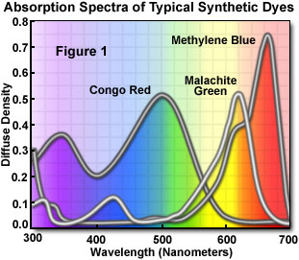
  - What wavelength would you choose to analyze the Congo Red?

  - Explain why a solution of malachite green and methylene blue would be difficult to analyze.

- Use the following standard curve to answer questions a & b.
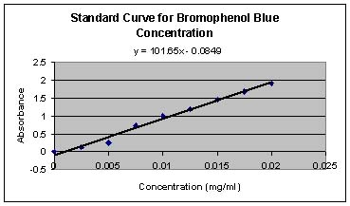
- Identify 2 “flags” that would cause you to not trust the standard curve.
R² = 0.879

- Assuming the curve is reliable, what concentration would an unknown bromothemal blue solution have if it elicits an absorbance of 1.40?

- An unknown bromothemal blue solution gives an absorbance of 2.45. What could be done to determine the concentration of the solution?

