Unit 2 Notes Name ____________________
Measurement, Atoms, Date ____________ Block ____ Molecules & Ions

Knowledge/Understanding Goals:

Recall definitions of atoms, subatomic particles, ions, etc.
- Understand the theoretical structure of the atom.
- Recall the rules for naming compounds and writing chemical formulas.

Skills:
- Solve average atomic mass problems
- Be able to properly name and write the chemical formula for any binary compound
- Identify the atomic components to any atom/ion/isotope

Notes:

Atomic Structure
- All matter is composed of particles called atoms, which give matter mass.
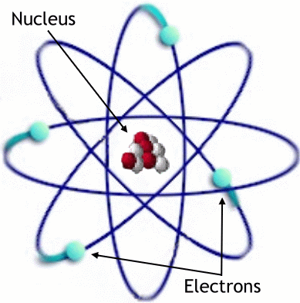
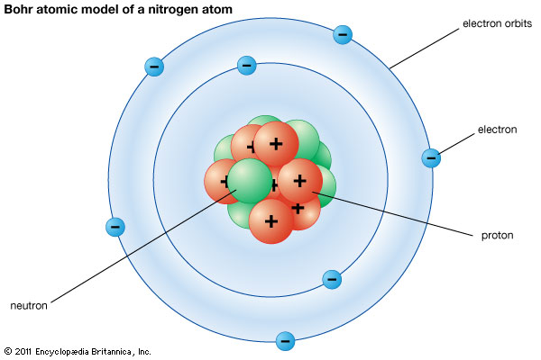

atom: the smallest piece of an element that retains the properties of that element.
nucleus: a dense region in the center of an atom. The nucleus is made of protons and neutrons, and contains almost all of an atom’s mass.
proton: a subatomic particle found in the nucleus of an atom. It has a charge of +1, and a mass of 1 atomic mass unit (amu).
neutron: a subatomic particle found in the nucleus of an atom. It has no charge (is neutral), and has a mass of 1 amu.
electron: a subatomic particle found outside the nucleus of an atom. It has charge of −1 and a mass of 0 amu (really about ¹/₂₀₀₀ amu). Atoms can gain, lose, or share electrons in chemical reactions.
charge: positive and negative charges cancel each other out, so the ionic charge of an atom is the difference between the number of positive charges (protons) and negative charges (electrons) it has.
For example, a chlorine atom with 17 protons (+17) and 18 electrons (−18) would have a charge of 1-. (It’s negative because it has more negatives than positives.)

neutral atom: an atom with a charge of zero (positives = negatives). All elements as written on the periodic table are neutral.
ion: an atom or molecule that has a positive or negative charge, because it has either more negatives (electrons) than positives (protons), or more positives (protons) than negatives (electrons).
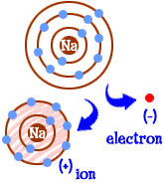
- Remember, the ONLY way to form an ion is to gain or lose electrons! If you change the number of protons, you change the element!

- Atoms usually form ions to become isoelectric with the nearest noble gas, giving them 8 valence electrons. This is commonly referred to as the “octet rule” and is not applicable to transition metals.

Periodic Table
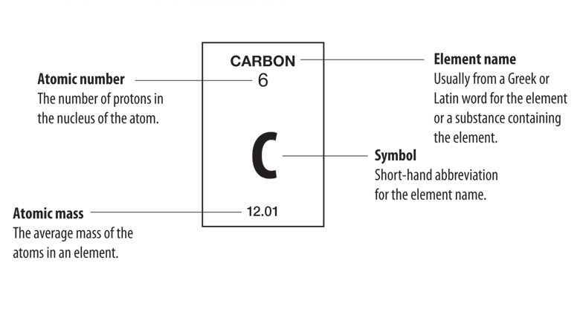
element symbol: a one- or two-letter abbreviation for an element. (New elements are given temporary three-letter symbols.) The first letter in an element symbol is always capitalized. Other letters in an element symbol are always lower case. This is important to remember.
For example, Co is the element cobalt, but CO is the compound carbon monoxide, which contains the elements carbon and oxygen.
atomic number: the identity of an atom is based on the number of protons in its nucleus. (This works because the nucleus cannot be given to or shared with another atom.) The atomic number is the number of protons in the nucleus. Each element has a unique atomic number.
mass number: the mass of an atom is essentially the mass of its nucleus. (The electrons are so small that we can ignore their mass.) Because protons and neutrons each have a mass of 1 amu, the mass number for the atom is just the number of protons + neutrons that the atom has.
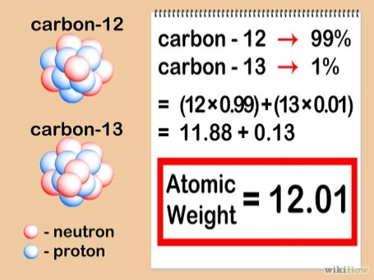
  - The mass number reported on the periodic table is the average mass of all of that element’s isotopes.

  - That is why we see most elements having a mass number with values out the thousandths place, even though the proton/neutron masses are whole numbers (1 amu).
isotopes: atoms of the same element (same atomic number = same # of protons), but that have different numbers of neutrons (and therefore different mass numbers) from each other.
  - Isotopes are described by their mass numbers.
    - For example, carbon-12 has 6 protons and 6 neutrons, which gives it a mass number of 12.
    - Carbon-14 has 6 protons and 8 neutrons, which gives it a mass number of 14.

Isotopes = same element, different number of neutrons
Ions = same element, different number of electrons

isotopic symbol: a shorthand notation that shows information about an element, including its element symbol, atomic number, mass number, and charge. For example, the symbol for a sodium-23 ion with a 1+ charge would be:
*Note: the charge should read 1+
Ionic Charge: 1+
Oxidation State: +1

This notation shows the element symbol for sodium (Na) in the center, the atomic number (11, because it has 11 protons) on the bottom left, the mass number (23, because it has 11 protons + 12 neutrons = 23 amu) on the top left, and the charge (1+, which means it lost one of its electrons in a chemical reaction) on the top right.

Let’s explore atomic composition and what determines which isotopes occur naturally.
Building Atoms Activity: http://phet.colorado.edu/en/simulation/build-an-atom

Isotope Stability: The nuclear stability of an isotope describes the interaction of two competing forces in the nucleus: strong force vs electromagnetic force.
  - Four basic forces in nature:
    - Gravity, electromagnetic force, strong nuclear force and the weak nuclear force
    - Strong force is the strongest of the four. However, it also has the shortest range, meaning that particles must be extremely close before its effects are felt.
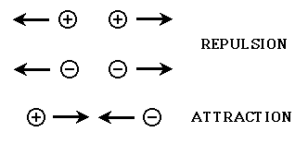
  - Strong force holds together the subatomic particles of the nucleus (protons and neutrons). These particles are collectively called nucleons).
    - Like charges repel and unlike charges attract.

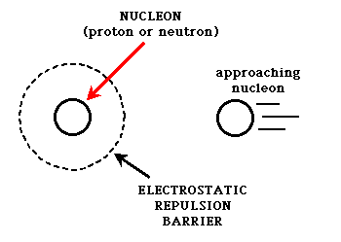
If you consider that the nucleus of all atoms except hydrogen contain more than one proton, and each proton carries a positive charge, then why would the nuclei of these atoms stay together? The protons must feel an electromagnetic repulsive force from the other neighboring protons.

This is where the strong nuclear force comes in. The strong nuclear force is created between nucleons by the exchange of particles called mesons.
  - If a proton or neutron can get close enough to another nucleon, the exchange of mesons can occur, and the particles will stick to each other.
  - If they can't get that close, the strong force is too weak to make them stick together, and other competing forces (usually the electromagnetic force) can influence the particles to move apart.
  - This explains…
    - Why larger nuclei tend to be unstable (tend to decay / are radioactive)
    - Why particles/nucleons must be sped up to force fusion (Hadron Collider)
Nuclear Stability Video: https://youtu.be/yTkojROg-t8
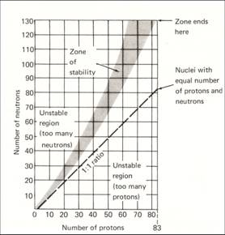
There also appears to be a relationship between stability and the ratio of protons and neutrons in the nucleus.
- For smaller elements (up to about calcium), the most stable nuclear composition appears to be a 1:1 ratio of protons to neutrons.

- Larger elements gradually start to move towards a 1:1.5 ratio of protons and neutrons. (50% more neutrons)

- Unstable nuclear ratios are typically radioactive because they are likely to undergo decay until they reach a more stable configuration. (We will discuss alpha/beta/gamma decay in a later unit)

A complete understanding of the importance of a specific ratio is still unclear, however the instability caused by increasing the number of neutrons to unbalance the ratio can be attributed to the nuclear radius increasing to a size where neighboring nucleons are too far apart to allow strong force attraction.

Try It! Work on the Ions/Isotopes Practice Worksheet

Atomic Theory
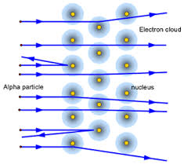
- Rutherford: Prior to Rutherford’s gold foil experiment, it was believed that all of the components of an atom were occupying the same space (Plum-Pudding Model, Thomson) that we now refer to as the nucleus.
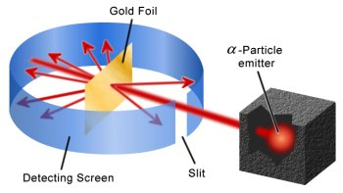

Gold Foil Animation: http://www.mhhe.com/physsci/chemistry/essentialchemistry/flash/ruther14.swf
http://phet.colorado.edu/en/simulation/rutherford-scattering

Experiment Results Summary
  - The complete refraction of the positively charged alpha particles (2p,2n) shows a dense nuclear core to the atom.
  - The deflections indicate a like-charged nucleus.
  - Most particles passing through indicates a majority an atom is composed of a less dense outer region (electron cloud).
  - The positive charge of the nucleus shows the negatively charged particles must be found elsewhere (electron cloud).

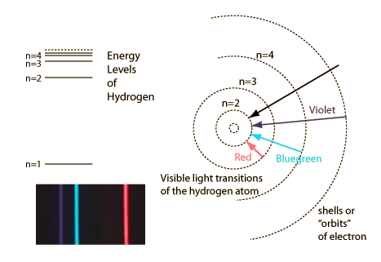
- Bohr: Experiments showed quantized amounts of energy were absorbed and emitted from atoms when they were exposed to electromagnetic energy. His model depicts quantized energy levels as circular orbitals that electrons occupy, rather than an electron cloud.

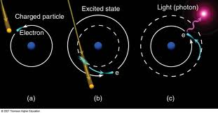

Emission Animation: http://spiff.rit.edu/classes/phys301/lectures/spec_lines/Atoms_Nav.swf

Experiment Results Summary
  - The same, repeatable amount of energy was always emitted from atoms as visible light waves. This was evidence for electrons occupying quantized energy levels.
  - The same amount of energy is absorbed and emitted when electrons jump up and drop down these energy levels.
  - Energy levels increase the further you get from the nucleus.
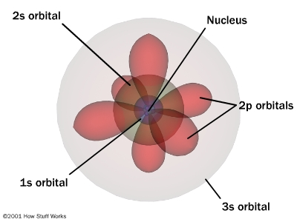
- Quantum Mechanical Model: Experiments and accredited scientists will be discussed at a later time.
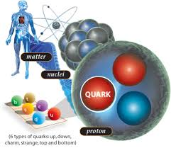

Theory Summary
  - Electrons occupy cloud orbitals rather than defined circular orbitals as in the Bohr Model
  - Nucleons (protons and neutrons) are composed of smaller particles of matter called quarks and are held together by the exchange of mesons / strong nuclear force.
  - Quarks are held together by particles named gluons and can change from one type into another (and therefore change the nucleon) via weak nuclear force interactions.

**Nucleon and quark knowledge is not required knowledge for the AP test, it’s just awesome and the forefront of chemistry/quantum physics.**

Hadron Collider: http://home.web.cern.ch/topics/large-hadron-collider

Compounds
Formulas: A chemical formula gives the elemental composition of a compound. There are several ways of writing chemical formulas:
molecular formula: gives the number and type of each atom but no structural information. E.g., the molecular formula for acetone is:
C₃H₆O
structural formula: shows how the atoms are connected. E.g., the structural formula for acetone is:

condensed structural formula: a shorthand version of the structural formula; assumes understanding of Lewis structures and bonding. E.g., some condensed structural formula for acetone are:
CH₃COCH₃ or
Condensed structural formulas are commonly used in organic chemistry.

Ions: Ions of the s and p block* gain or lose electrons to end up with a noble gas configuration. E.g., halogens (F, Cl, Br, I) gain an electron, and alkali metals (Li, Na, K, Rb, Cs) lose an electron.
  - Ions that gain electrons have a negative charge (anions). Ions that lose electrons have a positive charge (cations).
  - Polyatomic ions consist of covalently bonded atoms. You need to memorize the names, formulas, and charges of common polyatomic ions.

*Common charges formed by transition metals (oxidation states) will be discussed later.

Ionic compounds: Made of cations (positive ions) and anions (negative ions).
- Every compound has a ratio of cations to anions that result in a net charge of zero (balanced charges!).
  - For example, the compound formed from calcium (Ca²⁺) and phosphate (PO₄³⁻) ions would have the formula Ca₃(PO₄)₂. The 3 ions of Ca²⁺ have a total charge of +6, and the two ions of PO₄³⁻have a total charge of −6.

The formula of every neutral ionic compound must always have balanced charges.

- If an ionic compound is soluble in water, it will dissociate into individual ions. E.g., there is no such thing as NaCl (aq). When NaCl dissolves in water, it splits into Na⁺ ions and Cl⁻ ions. This solution of positive and negative ions conducts electricity, and is called an electrolyte.

- Ionic compounds are soluble in water if the sum of all of their attractions to the water molecules is greater than their attraction to each other. A good rule of thumb (though there are exceptions) is that almost all compounds with alkali metal and halogen ions are soluble. Most (but not all) compounds that contain ions with charges greater than +/-1 typically form precipitates.

Molecular Compounds: made of all non-metal elements.
- Molecular formulas for compounds can vary greatly since non-metals can take-on multiple different charges. Therefore, the formula must be derived from the name (covered below) rather than simple ion charge balancing.
  - Overall charge (oxidation state) should still be neutral, just like with ionic compounds…unless it’s a polyatomic ion group.
- Complex molecular compound formulas are usually written out as structural formulas (ie CH₃OH or CH₃COCH₃) to help discern the atomic arrangement.

Nomenclature (Naming Compounds)
Ionic Compounds: The name of an ionic compound is simply the name of the cation (positive ion) followed by the name of the anion (negative ion).
- polyatomic ions already have names; use them
- the cation of an element has the same name as the element (e.g., the Na⁺ ion is named “sodium”). If the element has more than one possible charge, add a Roman numeral in parentheses to tell which one it is. (E.g., Cu⁺ is “copper (I)”, and Cu²⁺ is “copper (II)”.)
- the anion of an element is the name of the element, but with the ending changed to “—ide”. (E.g., Cl⁻ is made from chlorine, so the ion is named “chloride”.)

Acid Nomenclature: Chemically, acids behave like ionic compounds in which the cation is H⁺. (Ionic compounds dissociate; acids are covalent compounds that ionize. However, in both cases the result is ions in solution.) Acid names are based on the name of the anion.
- If the anion name ends in “—ide”, put “hydro—” in front of the ion, and change the ending to “—ic acid”. (E.g., Br⁻ is bromide, so HBr is hydrobromic acid.)
- If the anion name ends in “—ate”, just change the ending to “—ic acid”. (E.g., ClO₃⁻ is chlorate, so HClO₃ is chloric acid.)
- If the anion name ends in “—ite”, change the ending to “—ous acid”. (E.g., NO₂⁻ is nitrite, so HNO₂ is nitrous acid.

Molecular (Non-metal) Nomenclature: Molecular compounds (made of all non-metals) are named by describing the molecular formula, using prefixes for the numbers.

You will need to memorize the number prefixes for the numbers 1–10.
- E.g., P₂O₅ is diphosphorus pentoxide.
**Note that the prefix “mono—“ is never used with the first element. SO₃ is simply sulfur trioxide. However, “mono—“ is always used when there is only one of the latter element. E.g., N₂O is dinitrogen monoxide.
- CO (carbon monoxide) is an easy-to-remember example that shows when to use “mono—“ and when not to.
Formulas and names are always listed from lowest to highest electronegativity (electropositive to electronegative), except in the case of organic compounds (carbon compounds other than oxides and carbonates), which have their own rules.

Organic Nomenclature: Organic compounds (molecular compounds containing carbon) have their own naming system, which will be addressed later in this course.

