Unit 2 Notes Name ____________________
Measurement, Atoms, Date ____________ Block ____ Molecules & Ions

Knowledge/Understanding Goals:

Recall definitions of atoms, subatomic particles, ions, etc.
- Understand the theoretical structure of the atom.
- Recall the rules for naming compounds and writing chemical formulas.

Skills:
- Solve average atomic mass problems
- Be able to properly name and write the chemical formula for any binary compound
- Identify the atomic components to any atom/ion/isotope

Notes:

Atomic Structure
- All matter is composed of particles called atoms, which give matter ______________.
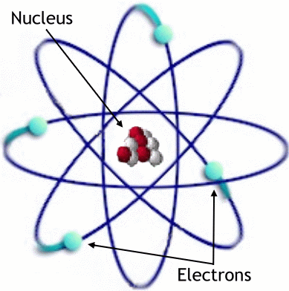
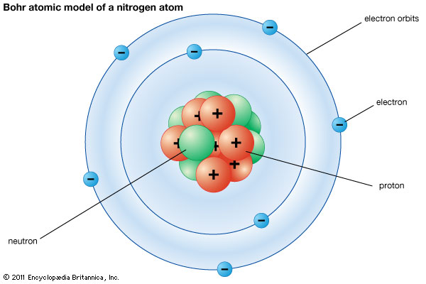

atom:
nucleus:
proton: a subatomic particle found in the nucleus of an atom.

neutron: a subatomic particle found in the nucleus of an atom.

electron: a subatomic particle found outside the nucleus of an atom.

charge: positive and negative charges cancel each other out, so the ____________ charge of an atom is the difference between the number of positive charges (____________) and negative charges (_____________) it has.
For example,

neutral atom:

ion:

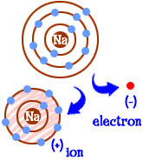
- Remember, the ONLY way to form an ion is to gain or lose _______________! If you change the number of protons, you change the element!

- Atoms usually form ions to become ___________ with the nearest noble gas, giving them 8 valence electrons. This is commonly referred to as the “____________________” and is not applicable to transition metals.
Periodic Table
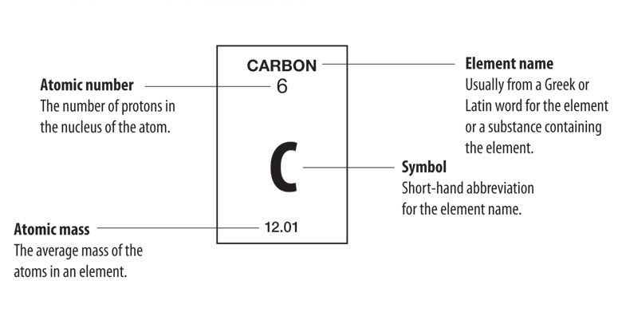
element symbol: a one- or two-letter abbreviation for an element. (New elements are given temporary three-letter symbols.) The first letter in an element symbol is always capitalized. Other letters in an element symbol are always lower case. This is important to remember.
For example, Co is the element cobalt, but CO is the compound carbon monoxide, which contains the elements carbon and oxygen.
atomic number:

mass number:

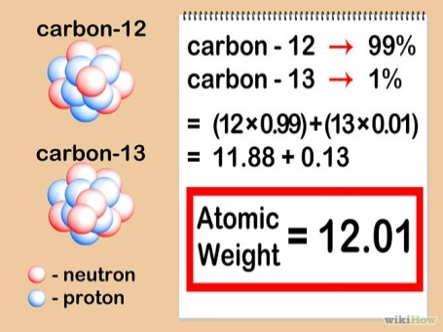
  - The mass number reported on the periodic table is the _____________ mass of all of that element’s _______________.

  - That is why we see most elements having a mass number with values out the thousandths place, even though the proton/neutron masses are whole numbers (1 amu).
isotopes:

  - Isotopes are described by their mass numbers.
    - For example, carbon-12 has 6 protons and 6 neutrons, which gives it a mass number of _____.
    - Carbon-14 has 6 protons and 8 neutrons, which gives it a mass number of ____.

Isotopes =
Ions =

isotopic symbol: a shorthand notation that shows information about an element, including its ______________________, _____________________, _______________________, and _____________. For example, the symbol for a sodium-23 ion with a 1+ charge would be:
*Note: the charge should read 1+
Ionic Charge: 1+
Oxidation State: +1

This notation shows the element symbol for sodium (Na) in the center, the atomic number (11, because it has 11 protons) on the bottom left, the mass number (23, because it has 11 protons + 12 neutrons = 23 amu) on the top left, and the charge (1+, which means it lost one of its electrons in a chemical reaction) on the top right.

Let’s explore atomic composition and what determines which isotopes occur naturally.
Building Atoms Activity: http://phet.colorado.edu/en/simulation/build-an-atom

Isotope Stability: The nuclear stability of an isotope describes the interaction of two competing forces in the nucleus:
  - Four basic forces in nature:

    - Strong force is the strongest of the four. However, it also has the shortest ______________, meaning that particles must be extremely close before its effects are felt.
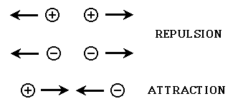
  - Strong force holds together the subatomic particles of the _________________ (protons and neutrons). These particles are collectively called ___________).
    - Like charges repel and unlike charges attract.

If you consider that the nucleus of all atoms, except hydrogen, contain more than one proton, and each proton carries a positive charge, then why would the nuclei of these atoms stay together? The protons must feel an _______________________ repulsive force from the other neighboring protons.
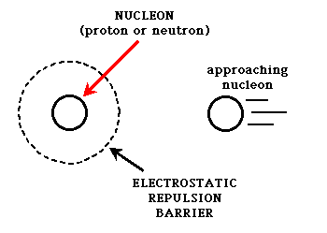

This is where the strong nuclear force comes in. The strong nuclear force is created between nucleons by the exchange of particles called _______________.
  - If a proton or neutron can get ___________ enough to another nucleon, the exchange of mesons can occur, and the particles will stick to each other.
  - If they can't get that close, the strong force is too _________ to make them stick together, and other competing forces (usually the ______________________ force) can influence the particles to move apart.
  - This explains…

Nuclear Stability Video: https://youtu.be/yTkojROg-t8
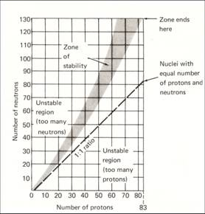
There also appears to be a relationship between stability and the ________ of protons and neutrons in the nucleus.
- For smaller elements (up to about calcium), the most stable nuclear composition appears to be a _______ ratio of protons to neutrons.

- Larger elements gradually start to move towards a _______ ratio of protons and neutrons. (50% more neutrons)

- Unstable nuclear ratios are typically ___________________ because they are likely to undergo __________ until they reach a more stable configuration. (We will discuss alpha/beta/gamma decay in a later unit)

A complete understanding of the importance of a specific ratio is still unclear; however the instability caused by increasing the number of neutrons to unbalance the ratio can be attributed to the nuclear _____________ increasing to a size where neighboring nucleons are too far apart to allow _______________________________ attraction.

Try It! Work on the Ions/Isotopes Practice Worksheet

Atomic Theory
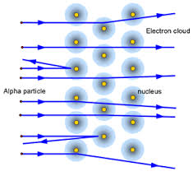
- Rutherford: Prior to Rutherford’s gold foil experiment, it was believed that all of the components of an atom were occupying the _________________ (Plum-Pudding Model, Thomson) that we now refer to as the nucleus.
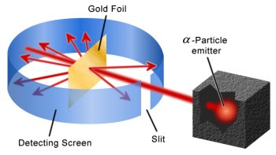

Gold Foil Animation: http://www.mhhe.com/physsci/chemistry/essentialchemistry/flash/ruther14.swf
http://phet.colorado.edu/en/simulation/rutherford-scattering

Experiment Results Summary

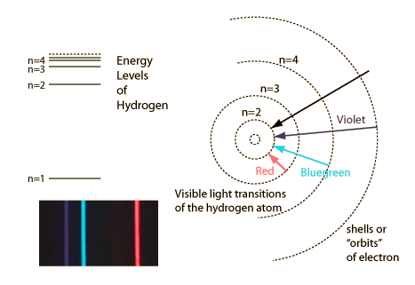
- Bohr: Experiments showed _________________ amounts of energy were ______________ and ________________ from atoms when they were exposed to electromagnetic energy. His model depicts quantized energy levels as circular orbitals that electrons occupy, rather than an electron cloud.

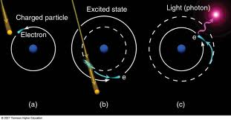

Emission Animation: http://spiff.rit.edu/classes/phys301/lectures/spec_lines/Atoms_Nav.swf

Experiment Results Summary

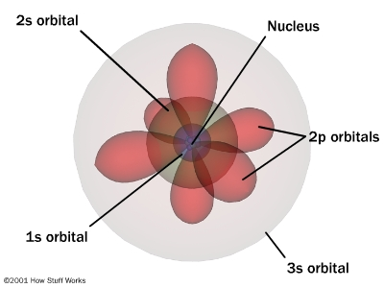
- Quantum Mechanical Model: Experiments and accredited scientists will be discussed at a later time.
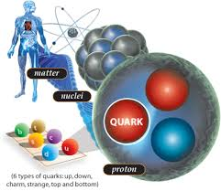

Theory Summary

**Nucleon and quark knowledge is not required knowledge for the AP test, it’s just awesome and the forefront of chemistry/quantum physics.**

Hadron Collider: http://home.web.cern.ch/topics/large-hadron-collider

Compounds
Formulas: A chemical formula gives the elemental composition of a compound. There are several ways of writing chemical formulas:
molecular formula:

E.g., the molecular formula for acetone is:

structural formula:

E.g., the structural formula for acetone is:

condensed structural formula:

E.g., some condensed structural formula for acetone are:

Condensed structural formulas are commonly used in organic chemistry.

Ions: Ions of the s and p block* gain or lose ________________ to end up with a noble gas configuration. E.g., halogens (F, Cl, Br, I) ________ an electron, and alkali metals (Li, Na, K, Rb, Cs) _______ an electron.
  - Ions that gain electrons have a negative charge (____________). Ions that lose electrons have a positive charge (______________).
  - Polyatomic ions consist of covalently _____________ atoms. You need to memorize the names, formulas, and charges of common polyatomic ions.

*Common charges formed by transition metals (oxidation states) will be discussed later.

Ionic compounds: Made of cations (positive ions) and anions (negative ions).
- Every compound has a _________ of cations to anions that result in a net charge of __________ (balanced charges!).
  - For example, the compound formed from calcium (Ca²⁺) and phosphate (PO₄³⁻) ions would have the formula ______________. The 3 ions of Ca²⁺ have a total charge of +6, and the two ions of PO₄³⁻have a total charge of −6.

The formula of every neutral ionic compound must always have balanced charges.

- If an ionic compound is _____________ in water, it will ________________ into individual ions. E.g., there is no such thing as NaCl (aq). When NaCl dissolves in water, it splits into ______ ions and ______ ions. This solution of positive and negative ions conducts electricity, and is called an ___________.

- Ionic compounds are soluble in water if the sum of all of their attractions to the __________ molecules is greater than their attraction to _____________. A good rule of thumb (though there are exceptions) is that almost all compounds with alkali metal and halogen ions are ___________. Most (but not all) compounds that contain ions with charges _____________ than +/-1 typically form _________________.

Molecular Compounds: made of all _________________ elements.
- Molecular formulas for compounds can vary greatly since non-metals can take-on multiple different _______________. Therefore, the formula must be derived from the _________ (covered below) rather than simple ion charge balancing.
  - Overall charge (______________________) should still be neutral, just like with ionic compounds…unless it’s a polyatomic ion group.
- Complex molecular compound formulas are usually written out as structural formulas (ie CH₃OH or CH₃COCH₃) to help discern the atomic arrangement.

Nomenclature (Naming Compounds)
Ionic Compounds: The name of an ionic compound is simply the name of the cation (positive ion) followed by the name of the anion (negative ion).

Acid Nomenclature: Chemically, acids behave like ionic compounds in which the cation is H⁺. (Ionic compounds ______________; acids are covalent compounds that ____________. However, in both cases the result is ions in solution.) Acid names are based on the name of the ___________.
- If the anion name ends in “—ide”,

- If the anion name ends in “—ate”,

- If the anion name ends in “—ite”,

Molecular (Non-metal) Nomenclature: Molecular compounds (made of all non-metals) are named by describing the molecular formula, using ________________ for the numbers.

You will need to memorize the number prefixes for the numbers 1–10.
- E.g., P₂O₅ is _______________________________
**Note that the prefix “mono—“ is never used with the ___________ element. SO₃ is simply ______________________. However, “mono—“ is always used when there is only one of the latter element. E.g., N₂O is __________________________________.
- CO (carbon monoxide) is an easy-to-remember example that shows when to use “mono—“ and when not to.
Formulas and names are always listed from lowest to highest ________________________ (electropositive to electronegative), except in the case of organic compounds (carbon compounds other than oxides and carbonates), which have their own rules.

Organic Nomenclature: Organic compounds (molecular compounds containing carbon) have their own naming system, which will be addressed later in this course.

