Unit 1 Notes Name ____________________
Matter and Measurements Date ____________ Block ____

Knowledge/Understanding Goals:
- Recall definitions of element, compound & mixture
- Understand how instrumentation determines the accuracy that can be reported for measurements

Skills:
- Report measurements with appropriate precision
- Round numbers to appropriate precision using significant figures use significant figures to estimate precision
- Identify common types of matter and understand techniques to separate mixtures.

Notes:

Matter
- Everything in the universe is composed of matter (minus vacuums, blackholes, etc.).
- All matter is composed of particles called atoms, which give matter mass.
- Matter can be categorized as either a pure substance or a mixture.
  - See Classification of Matter Concept Map

element: only one kind of atom (e.g., Cu, Fe, H₂, etc.)
*What atomic characteristic determines the element?
molecule: multiple atoms of one type of element or multiple elements bound together; has
a specific chemical formula (e.g., H₂, Cl₂, C₁₂H₂₂O₁₁,)

compound: more than one element; has a specific chemical formula (e.g., H₂O, CaCl₂,
C₁₂H₂₂O₁₁,)

mixture: more than one compound or molecule with different chemical formulas, not
chemically bound to each other. Includes aqueous solutions or ions in aqueous
solutions, such as NaCl (aq), Mg²⁺ (aq), etc.

homogeneous: a mixture whose components are not distinguishable from one another
(e.g., soda, air, metal alloys, etc.)

heterogeneous: a mixture whose components are distinguishable from one another (e.g.,
soup, granite, milk, etc.)

solutions: homogeneous mixtures that can be composed of matter in gaseous, liquid, or
solid phases.

Separation of Mixtures
- Physical separation of the compounds/molecules that make up a mixture typically is accomplished by exploiting differences in the compounds’ size, melting or boiling temperature, or polarity.
Condensation/Distillation: Exploits the difference in boiling temperatures between the mixed compounds. The compound with the lower BT is evaporated out of the mixture and collected in a condensation tube, which is cooled with flowing tap water, causing the compound to condense back to a liquid in a separate container.
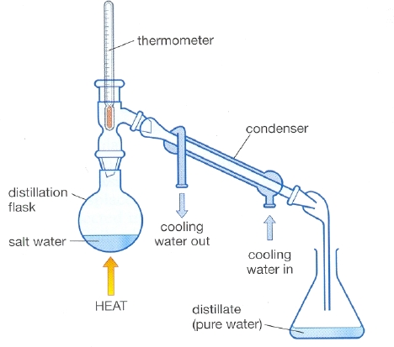

Chromatography: A method of separation that exploits either differences in molecular size, polarity, or charge.
Size Exclusion Chromatography (SEC): Particles of different sizes are able to move
through a column packed with silicon beads at different rates. Smaller particles are able
to enter the matrix within the beads and take a longer route through the column,
causing them to elute later than large molecules.

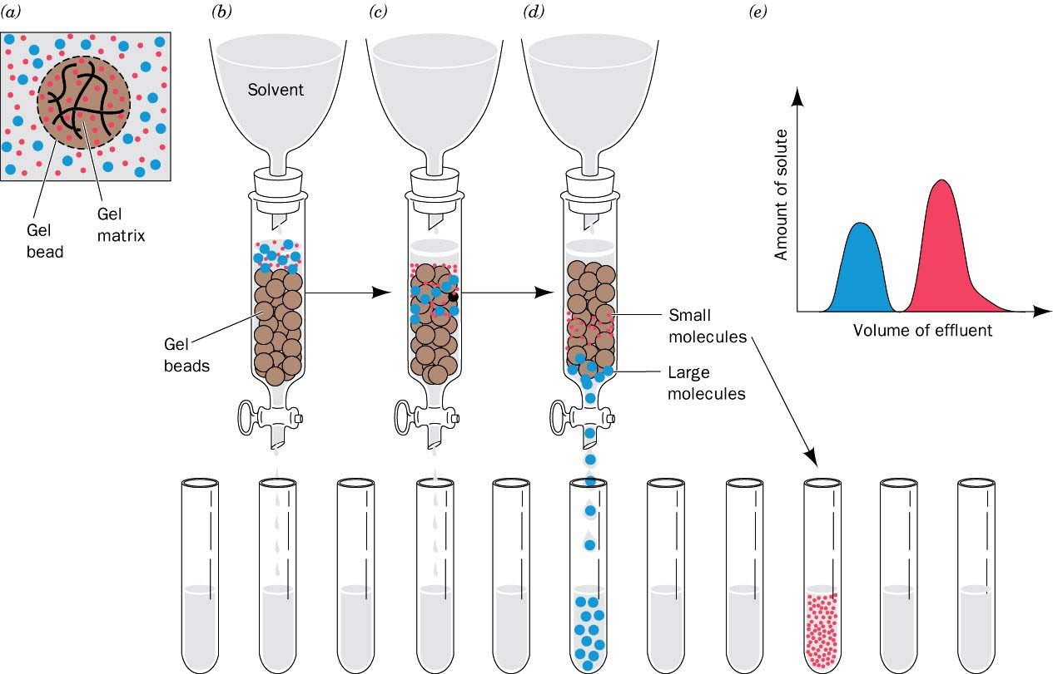

SEC Animation: https://www.youtube.com/watch?v=rPRbqYWlSEo

High Performance Liquid Chromatography (HPLC): Particles of differing polarity are separated
out in a column lined/packed with either a polar or non-polar stationary surface. If the lining is polar, polar molecules in the mixture will be attracted to it, causing them to move through the column more slowly and elute later. Visa versa for a non-polar lining. Often times, a gradient of mobile phase of increasing strength must be applied to force the mixture molecules to release from the stationary phase.
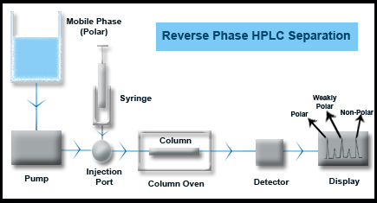

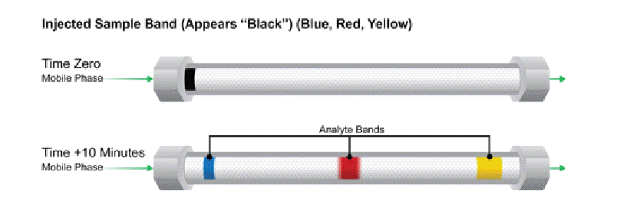

HPLC Animation: https://www.youtube.com/watch?v=-ajxqELsCFM
GC Animation: https://www.youtube.com/watch?v=q0pM-k0SvOQ
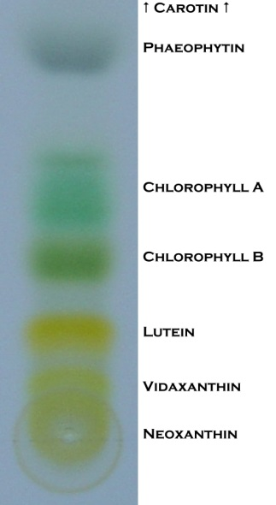

Paper Chromatography: A method that utilizes the cellulose fibers of the paper pulp as a stationary phase. As a liquid mobile phase travels up the paper via diffusion, it interacts with and carries sample molecules with it at different rates, depending upon the amount of attraction between the mobile phase and sample.
Paper Chromatography: https://www.youtube.com/watch?v=4I9065A_6UY

Measurement
- Every measurement has a value, units, and a limit of precision. In general, always report both. (e.g., 2.75 g ± 0.03 g, 23.5°C ± 0.1°C, etc.)
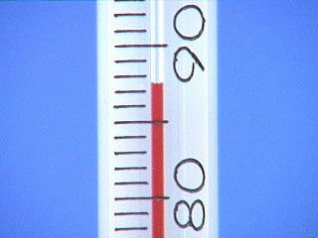
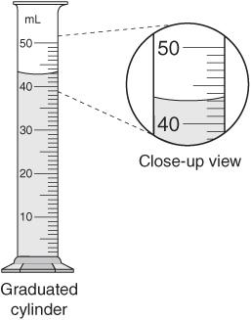
- For an analog measurement, the last reported decimal place should be your best estimation between the graduated lines. (*Remember to measure from the bottom of the meniscus for liquids*)

Thermometer (°C) _____________ Graduated Cylinder (mL) _____________

- For a digital measurement (such as a balance reading), if the measurement is drifting, the limit of precision (plus or minus) is from the average reading to the highest or lowest value when it drifts. If the measurement is stable, assume the precision is as stated by the manufacturer.

In labs, always give the estimated uncertainty (± value) for all measurements.
- For example, if a measurement made with a metric ruler is 5.6 cm and the ruler has a precision of 0.1 cm, then the tolerance interval in this measurement is 5.6 ± 0.05 cm, or from 5.55 cm to 5.65 cm. Any measurements within this range are "tolerated" or perceived as correct.

Significant Figures
In any number that represents a measured value:
- The first significant digit is the first one that is not zero
- The last significant digit is the last digit before the place the number was rounded off.
  - If there is no decimal point, it’s the last digit that’s not a zero.
  - If there is a decimal point, it’s the last digit shown.
- All digits between the first significant digit and the last significant digit are significant.
- For a number that does not have an explicit uncertainty listed, assume the uncertainty is ±1 in the last digit.
Examples:
- 13,500
The first three digits are significant (13,500). The uncertainty is ± 100 (because we assume that the number was rounded to the nearest 100).
- 0.000 265 00
The last five digits are significant (0.000 265 00). The uncertainty is ± 0.000 000 01.

Sig Figs and Calculations
Sig Figs represent the limit of accuracy you can guarantee in your measurements. That limitation should be carried out through your calculations.
Ex: You weigh out 50 mL of a sulfuric acid solution in a beaker and take its mass (52.32
g). What density (g/mL) would you report for the solution?

*** For the AP Test, the test readers no longer give you a 2 digit cushion for your sig figs! Always report them properly, you never know which free response will be chosen as a sig fig point.***

Dimesional Analysis (Factor Label Conversion Method)

In conversions, treat units like variables in an algebraic expression.
- Get rid of unwanted units in the numerator by multiplying by something that has the unit in the denominator.
- Get rid of unwanted units in the denominator by multiplying by something that has the unit in the numerator.
- Any number with two units that make a fraction (one over the other) can be used as a conversion factor. (E.g., if the density of a substance is , then for that substance you can use the conversion factor 2.75 g = 1 cm³ to convert between grams and cm³.)

Conversion values to memorize:
- 1 g = 1000 mg, 1 L = 1000mL, etc.
- 1 mole = 6.02x10²³ atoms or molecules
- To go between moles and grams: use the molar mass of the compound or element
- To go between moles and molecules/atoms: use Avogadro’s number

Practice Conversion/Sig Fig Problems
- What is 50.0 mL in liters?

- How many grams does 0.250 L of a solution with a density of 1.15 g/mL weigh?

- How many moles of Ca(C₂H₃O₂)₂ are present in a 3980 mg of the compound?

- (a) A solution of AlCl₃ has a concentration of 0.4405 mol/L, how many grams of aluminum chloride are dissolved in 150 mL of the solution?

(b) How many atoms of chlorine are in the same 150 mL AlCl₃ solution?

