Unit 1 Notes Name ____________________
Matter and Measurements Date ____________ Block ____

Knowledge/Understanding Goals:
- Recall definitions of element, compound & mixture
- Understand how instrumentation determines the accuracy that can be reported for measurements

Skills:
- Report measurements with appropriate precision
- Round numbers to appropriate precision using significant figures use significant figures to estimate precision
- Identify common types of matter and understand techniques to separate mixtures.

Notes:

Matter
- Everything in the universe is composed of _____________ (minus vacuums, blackholes, etc.).
- All matter is composed of particles called ________, which give matter _________.
- Matter can be categorized as either a ________________________ or a _________________.
  - See Classification of Matter Concept Map

element:
*What atomic characteristic determines the element?
molecule:

compound:

mixture:

homogeneous:

heterogeneous:

solutions:

Separation of Mixtures
- _______________ separation of the compounds/molecules that make up a mixture typically is accomplished by exploiting differences in the compounds’ ________, ________________________________ temperature, or _______________.
Condensation/Distillation: Exploits the difference in ____________ temperatures between the mixed compounds. The compound with the __________ BT is evaporated out of the mixture and collected in a ___________________ tube, which is cooled with flowing tap water, causing the compound to ____________ back to a liquid in a separate container.
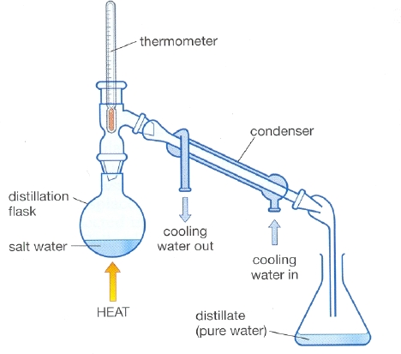

Chromatography:

Size Exclusion Chromatography (SEC): Particles of different _______ are able to move
through a ____________ packed with silicon beads at different _______. Smaller
particles are able to enter the matrix ___________ the beads and take a ____________ route through the column, causing them to _________ later than large molecules.

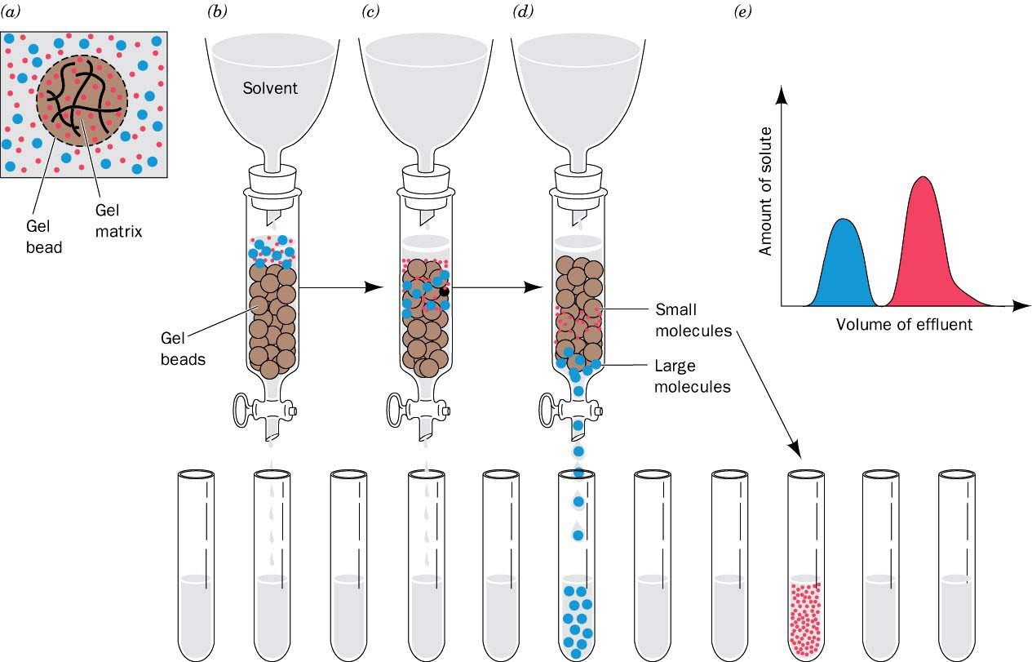

SEC Animation: https://www.youtube.com/watch?v=rPRbqYWlSEo

High Performance Liquid Chromatography (HPLC): Particles of differing ______________ are
separated out in a column lined/packed with either a polar or non-polar __________________
surface. If the lining is polar, ____________ molecules in the mixture will be attracted to it,
causing them to move through the column more __________ and elute _________. Visa versa
for a non-polar lining. Often times, a ______________ of _____________________ of increasing
strength must be applied to force the mixture molecules to release from the _______________.
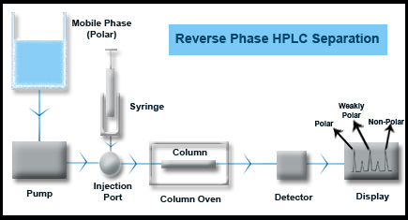

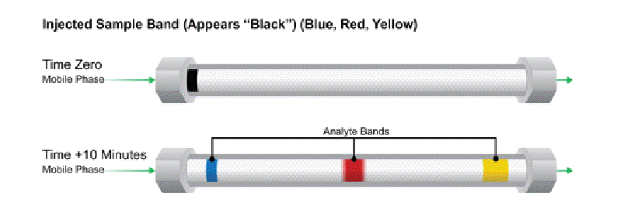

HPLC Animation: https://www.youtube.com/watch?v=-ajxqELsCFM
GC Animation: https://www.youtube.com/watch?v=q0pM-k0SvOQ
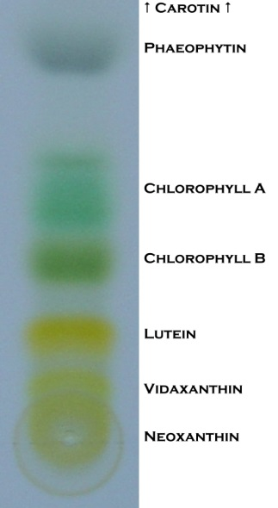

Paper Chromatography: A method that utilizes the cellulose fibers of the paper pulp as a _______________ phase. As a liquid ____________ phase travels up the paper via _________________, it interacts with and carries sample molecules with it at different rates, depending upon the amount of __________________ between the mobile phase and sample.
Paper Chromatography: https://www.youtube.com/watch?v=4I9065A_6UY

Measurement
- Every measurement has a __________, ____________, and a limit of ________________. In general, always report both. (e.g., 2.75 g ± 0.03 g, 23.5°C ± 0.1°C, etc.)
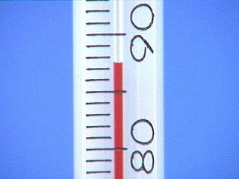
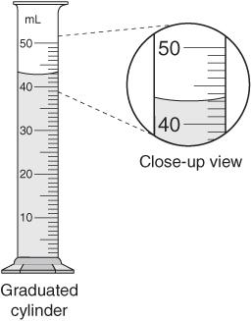
- For an analog measurement, the last reported decimal place should be your best _____________________ between the graduated lines. (*Remember to measure from the bottom of the meniscus for liquids*)

Thermometer (°C) _____________ Graduated Cylinder (mL) _____________

- For a digital measurement (such as a balance reading), if the measurement is drifting, the limit of precision (plus or minus) is from the ________________ reading to the highest or lowest value when it drifts. If the measurement is stable, assume the precision is as stated by the manufacturer.

In labs, always give the estimated uncertainty (± value) for all measurements.
- For example, if a measurement made with a metric ruler is 5.6 cm and the ruler has a precision of 0.1 cm, then the ______________________ in this measurement is 5.6 ± 0.05 cm, or from 5.55 cm to 5.65 cm. Any measurements within this range are "tolerated" or perceived as correct.

Significant Figures
In any number that represents a measured value:
- The first significant digit is the first one that is not __________
- The last significant digit is the last digit before the place the number was ____________.
  - If there is no decimal point, it’s the last digit that’s not a zero.
  - If there is a decimal point, it’s the last digit shown.
- All _______ between the first significant digit and the last significant digit are significant.
- For a number that does not have an explicit uncertainty listed, assume the uncertainty is ±1 in the ________ digit.
Examples:
- 13,500

- 0.000 265 00

Sig Figs and Calculations
Sig Figs represent the ________ of accuracy you can guarantee in your measurements. That limitation should be carried out through your calculations.
Ex: You weigh out 50 mL of a sulfuric acid solution in a beaker and take its mass (52.32
g). What density (g/mL) would you report for the solution?

*** For the AP Test, the test readers no longer give you a 2 digit cushion for your sig figs! Always report them properly, you never know which free response will be chosen as a sig fig point.***

Dimesional Analysis (Factor Label Conversion Method)

In conversions, treat units like variables in an algebraic expression.
- Get rid of unwanted units in the numerator by ________________ by something that has the unit in the ___________________.
- Get rid of unwanted units in the denominator by _______________ by something that has the unit in the ___________________.
- Any number with two units that make a fraction (one over the other) can be used as a ___________________________. (E.g., if the density of a substance is , then for that substance you can use the conversion factor 2.75 g = 1 cm³ to convert between grams and cm³.)

Conversion values to memorize:
- 1 g = ________ mg, 1 L = ________ mL, etc.
- 1 mole = _________________ atoms or molecules
- To go between moles and grams: use the _________________ of the compound or element
- To go between moles and molecules/atoms: use _____________________________

Practice Conversion/Sig Fig Problems
- What is 50.0 mL in liters?

- How many grams does 0.250 L of a solution with a density of 1.15 g/mL weigh?

- How many moles of Ca(C₂H₃O₂)₂ are present in a 3980 mg of the compound?

- (a) A solution of AlCl₃ has a concentration of 0.4405 mol/L, how many grams of aluminum chloride are dissolved in 150 mL of the solution?

(b) How many atoms of chlorine are in the same 150 mL AlCl₃ solution?

