AP Chemistry
Types of Reactions Practice Packet

Synthesis
- ___Mg (s) + ___O₂ (g)

- ___SO₃ (g) + ___H₂O (l)

- ___MnO (s) + ___ H₂O (l)

- ___P₂O₃ (g) + ___ H₂O (l)

- ___Fe₂O₃ (s) + ___ P₄O₁₀ (s)

- ___K₂O (s) + ___ H₂O (l)

- ___CuO (s) + ___ CO₂ (g)

- ___O₂ (g) + ___ H₂ (g)

- ___NO₂ (g) + ___ BCl₃ (s)

- ___ H₂ (g) + ___ F₂ (g)

Decomposition
- ___CaO (s)

- ___HNO₃ (aq)

- ___Na₂CO₃ (aq)

- ___H₂SO₃ (aq)

- ___RbI(s)

- ___CsClO₃ (aq)

- ___NH₄OH (aq)

- ___MgCO₃ (aq)

- ___(NH₄)₂CO₃ (aq)

- ___H₂O (l)

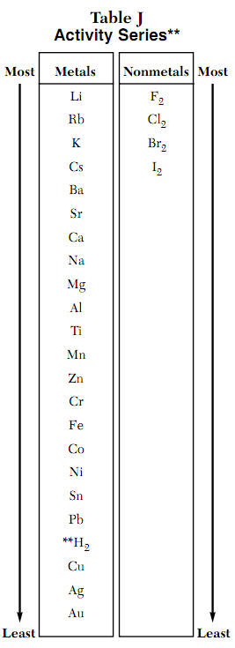
Single Displacement (could be no rxn)
- ___Ca(s) + ___NaCl(aq)

- ___Zn(NO₃)₂(aq) + ___Cu(s)

- ___Ba(s) + ___Al₂(SO₄)₃(aq)

- ___Cl₂(g) + ___SrBr₂(aq)

- ___Fe(s) + ___SnI₄(aq)

- ___K(s) + ___H₂O(l)

- ___CoCl₂(aq) + ___F₂(g)

- ___Cr(s) + ___HCl(aq)

- ___PbSO₃(s) + ___H₂(g)

- ___Ti(s) + ___H₂SO₄(aq)

Double Displacement (could be no rxn)
- ___NaOH(aq) + ___MgCl₂(aq)

- ___K₃PO₄(aq) + ___FeBr₃(aq)

- ___NH₄ClO₃(aq) + ___Mn(NO₃)₂(aq)

- ___RbSO₄ (aq) + ___AgNO₃(aq)

- ___NaI(aq) + ___HgClO₃(aq)

- ___CsC₂H₃O₂(aq) + ___ZnCl₂(aq)

- ___K₂CO₃ (aq) + ___CuBr(aq)

- ___Al(C₂H₃O₂)₃ (aq) + ___(NH₄)₃PO₄(aq)

- ___Li₂CrO₄ (aq) + ___SrI₂(aq)

- ___K₂O (aq) + ___HBr(aq)

Acid-Base
- ___Na₂CO₃ (aq) + ___KOH(aq)

- ___H₂SO₄ (aq) + ___Ca(OH)₂(aq)

- ___Ba(OH)₂ (aq) + ___HBr(aq)

- ___K₂CO₃ (aq) + ___HCl(aq)

- ___LiOH (aq) + ___HI(aq)

- ___NH₃ (aq) + ___HBr(aq)

- ___HNO₃ (aq) + ___NaOH(aq)

- ___HI (aq) + ___NH₃(aq)

- ___HClO₃ (aq) + ___LiOH(aq)

- ___H₂SO₃ (aq) + ___KOH(aq)

Combustion
- C₃H₈ (g) + O₂ (g)

- CH₄ (g) + O₂ (g)

- C₄H₉OH (aq) + O₂ (g)

- C₂H₂ (g) + O₂ (g)

- O₂ (g) + CH₃OH (aq)

- C₈H₁₈ (g) + O₂ (g)

- C₄H₉OH (aq) + O₂ (g)

- O₂ (g) + C₅H₁₀ (g)

- C₂H₅OH (g) + O₂ (g)

- C₃H₆ (g) + O₂ (g)

Net-Ionic Equations
- Write the chemical, full ionic, and net ionic equations for a reaction between barium hydroxide and hydrobromic acid.

- Write the chemical, full ionic, and net ionic equations for a reaction between sodium acetate and zinc chloride.

- Write the chemical, full ionic, and net ionic equations for a reaction between ammonium carbonate and iron (III) nitrate.

