Heat & Thermochemistry
Unit 8A: Thermodynamics

Knowledge/Understanding:
- heat as energy
- principles of heat flow
- state functions/variables
- calorimetry

Skills:
- solve calorimetry (specific heat) problems

Notes:
Heat, just like electromagnetic waves, is a form of ____________. During __________________, energy is typically transferred in the form of heat.

system:
surroundings:

E.g., if a chemical reaction takes place in a 10 L tank, the ___________ is everything inside the tank, and the __________________ are the physical walls of the tank and everything outside of them.
We will use the variable ___ to represent the heat that is being transferred during a chemical reaction.

Heat vs Temperature
Heat and temperature are often used interchangeably in everyday conversation by muggles, which is inaccurate.
Heat:

Temperature:

So, when we start talking about the “heat of formation” during the breaking/formation of bonds, we are talking about a _______________ quantity of energy (J or cal).

Sign of Heat Flow
Energy transfer is always in relation to the _____________, meaning the chemical reaction that is taking place, or more specifically, the ______________ involved in the reaction.

Endothermic:

Exothermic:

“Positive” heat (___) means heat flows _________ the reaction. Because the heat energy is coming into of the reaction, it is taken from the surroundings’ molecules, reducing their ____________________. I.e., positive heat of reaction means heat is being pulled out of the surroundings, and the temperature goes ________. (the system would feel cold because it is taking in energy from your hand).

“Negative” heat (___) means heat flows _________ the reaction. Because the heat energy is coming out of the reaction, it is absorbed by the surroundings’ molecules, adding to their __________________. I.e., negative heat of reaction means heat is being released into the surroundings, and the temperature goes _____. (the system would feel warm because it is giving energy to your hand).

Heat Flow | Sign of q | Type of Reaction | Products | Surroundings
from surroundings
to system
from system
to surroundings

So what can we learn from heat/temperature?
Now that we can relate the concepts of heat energy and temperature, we can quantify any changes in energy that occur within a system by measuring changes in __________________.
- Measuring the change in temperature of a solution during ________________ or other physical changes should tell us whether or not and how much energy was ____________________________ for that process to occur.
- Measuring the temperature change of a system due to a __________________________ should tell us the amount of energy _______________ or ____________ during the reaction.

In order to quantify heat energy values, we must be able to correlate the temperature (___) and heat energy (___) of a system/surroundings.

q = heat (J) m = mass (g)
C_{p} = heat capacity
ΔT = temperature change (°C)
Specific Heat Capacity
specific heat capacity: a measure of the amount of heat energy required to _____________________________________________________.
C_{p}: specific heat capacity measured at constant pressure. For gases, this means the measurement was taken allowing the gas to expand as it was heated.
C_{v}: specific heat capacity measured at constant volume. For gases, this means the measurement was made in a sealed container, allowing the pressure to rise as the gas was heated.
For solids and liquids, C_{p} ≈ C_{v}. For gases, C_{p} > C_{v} (always). For ideal gases, C_{p} − C_{v} = R (the gas constant).
When there is a choice, ____ is more commonly used than ____ because it is easier to measure.
q = m C_{p} ΔT *
q = heat (J) m = mass (g)
C_{p} = heat capacity
ΔT = temperature change (°C)

*This is the equation provided on the AP test
Calorimetry
calorimetry:
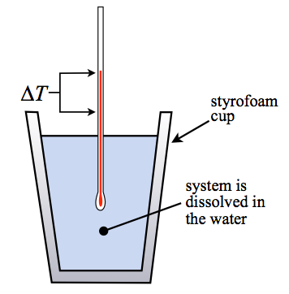
calorimeter:

coffee cup calorimeter: a calorimeter that is only an insulated container—often containing your system (reactants) _______________ directly in water. Can be made from a styrofoam coffee cup.

bomb calorimeter: a calorimeter for measuring the heat produced by a chemical reaction. The calorimeter contains a mass of water. The heat from the reaction makes the temperature of the _________ change.
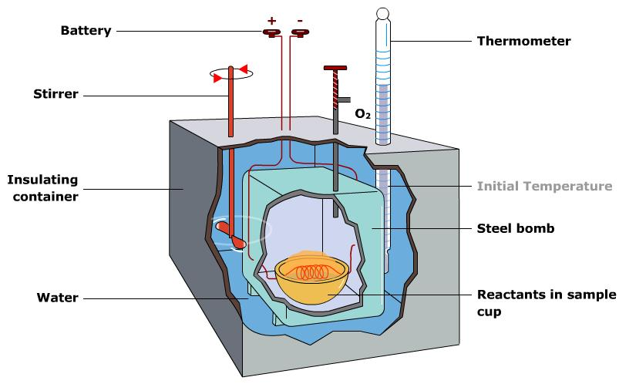
In a calorimeter, the heat of reaction is _________ and _____________ to the heat of the calorimeter. This is because any heat coming _________ the reaction is going _______ the calorimeter system. (Assuming no energy loss from the closed system)

Most calorimeters are calibrated with a published heat capacity for the calorimeter C_{cal}, measured in , to account for energy lost to the calorimeter due to imperfect _________________. This means:

Example Calorimetry Problem: Melting ice
Determine an experimental value for the heat of fusion of ice (heat energy required to melt 1 gram of ice).
- Assemble a coffee cup calorimeter.
- Add 100.0g of di-water to your calorimeter. Record the initial temperature. (C_{water} = 4.18 j/gºC or 1 cal/ºC)
- Mass out ~3 cubes of ice and place it into the calorimeter containing 100.0 g of water. Insert a temperature probe and record the lowest temperature obtained once all of the ice has melted.
- What is the experimental value for the specific heat of fusion of ice?
Q_{calorimeter} = m_{water}•C_{water}•ΔT
Q_{ice} = m_{ice}•ΔH_{fusion-ice}

- Draw an energy flow diagram for your calorimeter experiment.

The basis for the solution to this problem is the recognition that the quantity of energy lost by the water when cooling is _________ and _______________ to the quantity of energy required to melt the ice. In equation form, this could be stated as
q_{ice} = -q_{water/calorimeter}

- The positive q_{ice} indicates that the system is __________ energy
- The negative q_{water/calorimeter} indicates the surroundings are _____________ energy

Actual heat of fusion (∆H) for ice is __________ or _____________, how close were you?
What are some possible sources of error?

