Polarity, IMF, & Phase Changes

Note that the phase diagram has three general areas corresponding to the three states of matter—solid, liquid, and gas. The line from A to C represents the solid's change in vapor pressure with changing temperature, for the sublimation equilibrium. The A-to-D line represents the variation in the melting point with varying pressure. The A-to-B line represents the variation of a liquid's vapor pressure with varying pressure. The B point shown on this phase diagram is called the critical point of the substance, the point beyond which the gas and liquid phases are indistinguishable from each other. At or beyond this critical point, no matter how much pressure is applied, the gas cannot be condensed into a liquid. Point A is the substance's triple point, the combination of temperature and pressure at which all three states of matter can exist together.

The phase diagram for water is shown in Figure 12.5. For each of the phase transitions, there is an associated enthalpy change or heat of transition. For example, we have studied and calculated the heats of vaporization and fusion during the thermochemistry unit.
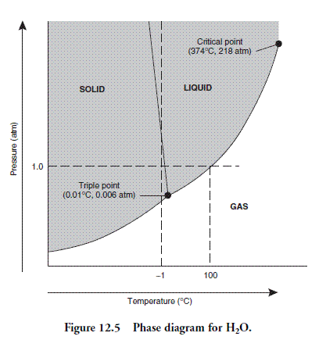
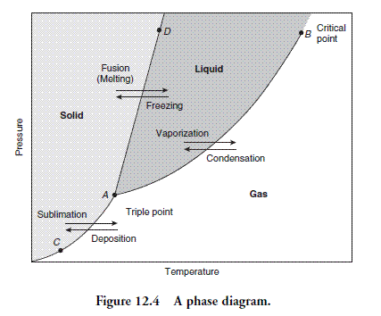

Relationship of Intermolecular Forces to Phase Changes
The intermolecular forces can affect phase changes to a great degree. The stronger the intermolecular forces present in a liquid, the more kinetic energy must be added to convert it into a gas. Conversely, the stronger the intermolecular forces between the gas particles, the easier it will be to condense the gas into a liquid. In general, the weaker the intermolecular forces, the higher the vapor pressure. The same type of reasoning can be used about the other phase equilibria, in general, the stronger the intermolecular forces, the higher the heats of transition.
Intermolecular forces are attractive or repulsive forces between molecules, caused by partial charges. The attractive forces are the ones that work to overcome the randomizing forces of kinetic energy. The structure and type of bonding of a particular substance have quite a bit to do with the type of interaction and the strength of that interaction. Before we start examining the different types of intermolecular forces, recall from the Bonding chapter that those molecules that have polar covalent bonding (unequal sharing of the bonding electron pair) may possess dipoles (having positive and negative ends due to charge separation within the molecule). Dipoles are often involved in intermolecular forces.

Ion–Dipole Intermolecular Forces
These forces are due to the attraction of an ion and one end of a polar molecule (dipole). This type of attraction is especially important in aqueous salt solutions, where the ion attracts water molecules and may form a hydrated ion, such as Al(H₂O)₆³⁺. This is one of the strongest of the intermolecular forces.
It is also important to realize that this intermolecular force requires two different species—an ion and a polar molecule.

Dipole–Dipole Intermolecular Forces
These forces result from the attraction of the positive end of one dipole to the negative end of another dipole. For example, in gaseous hydrogen chloride, HCl(g), the hydrogen end has a partial positive charge and the chlorine end has a partial negative charge, due to chlorine's higher electronegativity. Dipole–dipole attractions are especially important in polar liquids. They tend to be a rather strong force, although not as strong as ion–dipole attractions.

Hydrogen Bond Intermolecular Forces
Hydrogen bonding is a special type of dipole–dipole attraction in which a hydrogen atom is polar-covalently bonded to one of the following extremely electronegative elements: N, O, or F. These hydrogen bonds are extremely polar bonds by nature, so there is a great degree of charge separation within the molecule. Therefore, the attraction of the positively charged hydrogen of one molecule and the negatively charged N, O, or F of another molecule is extremely strong. These hydrogen bonds are in general, stronger than the typical dipole–dipole interaction.
Hydrogen bonding explains why HF(aq) is a weak acid, while HCl(aq), HBr(aq), etc. are strong acids. The hydrogen bond between the hydrogen of one HF molecule and the fluorine of another "traps" the hydrogen, so it is much harder to break its bonds and free the hydrogen to be donated as an H+. Hydrogen bonding also explains why water has such unusual properties—for example, its unusually high boiling point and the fact that its solid phase is less dense than its liquid phase. The hydrogen bonds tend to stabilize the water molecules and keep them from readily escaping into the gas phase. When water freezes, the hydrogen bonds are stabilized and lock the water molecules into a framework with a lot of open space. Therefore, ice floats in liquid water. Hydrogen bonding also holds the strands of DNA together.

Ion-Induced Dipole and Dipole-Induced Dipole Intermolecular Forces
These types of attraction occur when the charge on an ion or a dipole distorts the electron cloud of a nonpolar molecule and induces a temporary dipole in the nonpolar molecule. Like ion–dipole intermolecular forces, these also require two different species. They are fairly weak interactions.

London (Dispersion) Intermolecular Force
This intermolecular attraction occurs in all substances, but is significant only when the other types of intermolecular forces are absent. It arises from a momentary distortion of the electron cloud, with the creation of a very weak dipole. The weak dipole induces a dipole in another nonpolar molecule. This is an extremely weak interaction, but it is strong enough to allow us to liquefy nonpolar gases such as hydrogen, H₂, and nitrogen, N₂. If there were no intermolecular forces attracting these molecules, it would be impossible to liquefy them.

Questions
- Based on intermolecular forces, predict which will have the higher vapor pressure and higher boiling point, water or dimethyl ether? Draw Lewis Dot structures of each and indicate polarity as necessary with formal charges and dipoles labeled.

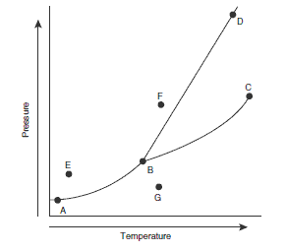
- The above figure shows a typical phase diagram for a one-component system. Use this diagram to answer the following questions.
- What is point C called? List the characteristics of this point.
- What happens to a substance at point E if the temperature is increased at constant pressure?
- Assume point F is at 0°C and 1 atm. Describe the changes that would occur when moving directly from point F to point G (still at 0°C).
- Solid bismuth is less dense than liquid bismuth. How would this change the appearance of the diagram? Explain.

Choose from the following descriptions of solids for questions 3–6.
  - composed of macromolecules held together by strong bonds
  - composed of atoms held together by delocalized electrons
  - composed of positive and negative ions held together by electrostatic attractions
  - composed of molecules held together by intermolecular dipole–dipole interactions
  - composed of molecules held together by intermolecular London forces
- Fe(s)
- KNO₃(s)
- SiO₂(s)
- HCl(s)

For questions 7 and 8 choose from the following.
  - an ionic solid
  - a metallic solid
  - a molecular solid containing nonpolar molecules
  - a covalent network solid
  - a molecular solid containing polar molecules
- Diamond, C(s)
- Solid sulfur dioxide, SO₂(s)

- The approximate boiling points for hydrogen compounds of some elements in the nitrogen family are: (SbH₃ 15°C), (AsH₃ –62°C), (PH₃ –87°C), and (NH₃ –33°C). The best explanation for the fact that NH₃ does not follow the trend of the other hydrogen compounds is
  - NH₃ is the only one to exhibit hydrogen bonding
  - NH₃ is the only one that is water-soluble
  - NH₃ is the only one that is nearly ideal in the gas phase
  - NH₃ is the only one that is a base
  - NH₃ is the only one that is nonpolar

- The critical point is
  - the highest temperature and pressure where the substance may exist as discrete liquid and gas phases
  - the temperature and pressure where the substance exists in equilibrium as solid, liquid, and gas phases
  - the highest temperature and pressure where a substance can sublime
  - the highest temperature and pressure where the substance may exist as discrete liquid and solid phases
  - the highest temperature and pressure where the substance may exist as discrete solid and gas phases

- For all one-component phase diagrams, choose the correct statement from the following list.
  - The line separating the gas from the liquid phase may have a positive or negative slope.
  - The line separating the solid from the liquid phase may have a positive or negative slope.
  - The line separating the solid from the liquid phase has a positive slope.
  - The temperature at the triple point is the same as at the freezing point.
  - The triple point is at a pressure above 1 atm.

Choose the appropriate answer from the following list for questions 12 and 13.
  - London dispersion forces
  - covalent bonding
  - hydrogen bonding
  - metallic bonding
  - ionic bonding
- This is the reason why argon may be solidified at a sufficiently low temperature.
- This is the reason why diamond is so hard.

- The triple point
  - represents the highest pressure at which the liquid can exist
  - is the lowest pressure at which the liquid can exist
  - represents the lowest temperature at which the vapor can exist
  - is 0.15 K higher than the melting point of the solid
  - is at a pressure of 1 atm
- A sample of a pure liquid is placed in an open container and heated to the boiling point. Which of the following may increase the boiling point of the liquid?
  - The size of the container is increased.
  - The container is sealed.
  - A vacuum is created over the liquid.
  - II and III
  - and III
  - III only
  - II only
  - I only

- Which of the following best explains why 1-butanol, CH₃CH₂CH₂CH₂OH, has a higher surface tension than its isomer, diethyl ether, CH₃CH₂OCH₂CH₃?
  - the higher density of 1-butanol
  - the lower specific heat of 1-butanol
  - the lack of hydrogen bonding in 1-butanol
  - the higher molecular mass of 1-butanol
  - the presence of hydrogen bonding in 1-butanol

- Pick the answer that most likely represents the substances' relative solubilities in water.
  - CH₃CH₂CH₂CH₃ < CH₃CH₂CH₂OH < HOCH₂CH₂OH
  - CH₃CH₂CH₂OH < CH₃CH₂CH₂CH₃ < HOCH₂CH₂OH
  - CH₃CH₂CH₂CH₃ < HOCH₂CH₂OH < CH₃CH₂CH₂OH
  - HOCH₂CH₂OH < CH₃CH₂CH₂OH < CH₃CH₂CH₂CH₃
  - CH₃CH₂CH₂OH < HOCH₂CH₂OH < CH₃CH₂CH₂CH₃

- What is the energy change that accompanies the conversion of molecules in the gas phase to a liquid?
  - heat of condensation
  - heat of deposition
  - heat of sublimation
  - heat of fusion
  - heat of vaporization

- Which of the following explains why the melting point of sodium chloride (NaCl 801°C) is lower than the melting point of calcium fluoride (CaF₂ 1423°C)?
  - The chloride ion is smaller than the fluoride ion.
  - The ratio of anions to cations is lower in sodium chloride.
  - The charge on a sodium ion is less than the charge on a calcium ion.
  - I and II
  - I, II, and III
  - III only
  - II only
  - I only

- Which point on the diagram below might represent the normal melting point?
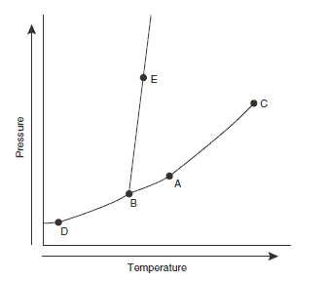
  - C
  - B
  - E
  - A
  - D
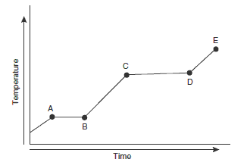
- The above diagram represents the heating curve for a pure crystalline substance. The solid is the only phase present up to point
  - C
  - B
  - E
  - A
  - D

- Draw the Lewis Dot Structures for the following compounds. Indicate which would be more polar and include formal charges, dipoles (if applicable), and the type of intra & intermolecular forces present.

a) carbon disulfide OR sulfur difluoride

b) nitrogen trichloride OR oxygen dichloride

c) boron trihydride OR ammonia

d) chlorine OR phosphorus trichloride

e) silicon dioxide OR carbon dioxide

f) methane OR CH₂Cl₂

g) silicon monofluoride triodide OR silicon monobromide triodide

h) nitrogen trifluoride OR phosphorus trifluoride

Answers and Explanations
  - Answer: Dimethyl ether will have the higher vapor pressure and the lower boiling point.

Explanation: Water is a polar substance with strong intermolecular hydrogen bonds. Dimethyl ether is a polar material with weaker intermolecular forces (dipole–dipole). It will take much more energy to vaporize water, thus, water has a lower vapor pressure and higher boiling point.

  - a. Point C is the critical point. Give yourself 1 point if you gave this answer. This is the highest temperature and pressure where the liquid and gas phases can be distinguished. This answer is worth 1 point.
- At point E the substance is a solid. Increasing the temperature, at constant pressure, will cause a horizontal movement to the right. When line AB is reached, the solid will sublime. After line AB is passed, only the vapor is present. You get 1 point for noting a movement to the right. You get 1 point for discussing the change from solid to gas.
- The substance is a solid at point F, and it will remain a solid until line BD is reached. When it reaches line BD, it melts. This is worth 1 point. The substance then passes through the liquid phase until line BC is reached. The substance boils when it reaches line BC. This is worth 1 point.
- The line from B to D would have a negative slope instead of a positive slope. This answer is worth 1 point. The denser phase is more stable at higher pressures. An increase in pressure will cause a change to the denser phase (liquid). The BD line must "lean" to the left so that an increase in pressure will cause a change from solid to liquid. This explanation is worth 1 point.

Answers and Explanations
- B—This answer describes a metallic solid.
- C—This answer describes an ionic solid.
- A—This answer describes a covalent network solid.
- D—This answers describes a solid consisting of discrete polar molecules.
- D—Each of the carbon atoms is covalently bonded to four other carbon atoms.
- E—Sulfur dioxide molecules are polar.
- A—Hydrogen bonding occurs when hydrogen is directly bonded to F, O, and in this case N.
- A— This is the definition of the critical point.
- B—The gas–liquid line always has a positive slope. B negates C. The triple point is below the freezing point. The triple point may be above or below 1 atm.
- A—Argon is a noble gas; none of the bonding choices are options.
- B—Diamond is a covalent network solid with a large number of strong covalent bonds between the carbon atoms.
- B—The bottom of the liquid region on the phase diagram is the triple point.
- D—The size of the container is irrelevant. Sealing the container will cause an increase in pressure that will increase the boiling point. A decrease in pressure will lower the boiling point.
- E—The compound with the higher surface tension is the one with the stronger intermolecular force. The hydrogen bonding in 1-butanol is stronger than the dipole–dipole attractions in diethyl ether.
- A—The sequence for these similar molecules is nonpolar, then one hydrogen bond, then two hydrogen bonds.
- A—This change is condensation, so the energy is the heat of condensation.
- C—The only applicable factor listed is the charge difference. The chloride ion is larger than the fluoride ion. The ion ratio is not important.
- E—The point must be on the line separating the solid from the liquid phase.
- D—The solid begins to melt at A, and finishes melting at B.

22.
a) carbon disulfide OR sulfur difluoride
carbon disulfide is nonpolar

b) nitrogen trichloride OR oxygen dichloride
both are polar, but oxygen dichloride is less symmetric than nitrogen trichloride, making it more polar.

c) boron trihydride OR ammonia
boron trihydride is nonpolar.

d) chlorine OR phosphorus trichloride
chlorine is nonpolar

e) silicon dioxide OR carbon dioxide
It’s a tie, because both are nonpolar

f) methane OR CH₂Cl₂
methane is nonpolar

g) silicon monofluoride triodide OR silicon monobromide triodide
Both are polar and equally symmetric, but the difference in electronegativity between Si-F is more than that between Si-Br, causing stronger partial charges

h) nitrogen trifluoride OR phosphorus trifluoride
Both are polar and equally symmetric, but the difference in electronegativity between N-F is less than that between P-F, causing weaker partial charges

