AP CHEMISTRY
Separation Technique Analysis
(110 Points)

Name, Date and Lab Partner (5 Points)

Procedure (30 Points)
Complete, step-by-step account
of actions performed

Data (25 Points)
Observation Table (10 Points)
Reagent Masses (10 Points)
Reagents Volumes (5 Points)

Calculations (10 Points)

Conclusion (30 Points)

Overall Neatness and Organization (5 Points)

Safety (5 Points)

This part is determined by proper lab safety which includes having your goggles and lab coat on properly at all times. Each reminder by the instructor will result in a deduction of 3 or 5 points. This component of the grade can be negative.

__________________________________________________________________
INTRODUCTION TO ANALYTICAL CHEMISTRY – LAB
__________________________________________________________________
EXPERIMENT I
ANALYTICAL SEPARATION OF MIXTURES

INTRODUCTION
Matter can be categorized based upon its composition according to the classification of matter flowchart below.

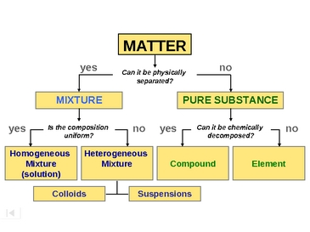

Note that one of the distinguishing characteristics of a substance’s classification is whether or not it can be physically separated into unique components. Any substance that can be physically separated into unique compounds or elements is a mixture of pure substances. Most naturally produced and synthesized substances on our planet are mixtures of some kind. The pure elements/compounds we use in lab must be isolated and purified using various separation techniques.

THEORY

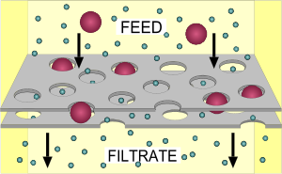
Filtration is a separation technique which can exploit differences in molecular size and polarity, but results in the retention of a targeted molecule rather than altering the speed of its movement. During filtration, a filter impedes the movement of some molecules completely by either physically preventing them from passing through the space in the filter or because of extreme charge attraction due to polarity. The particles collected by the filter are referred to as the feed, while the rest of the solution that passes through the filter is called the filtrate. Depending on the solution being separated, the filtrate sometimes is of more importance than the feed.
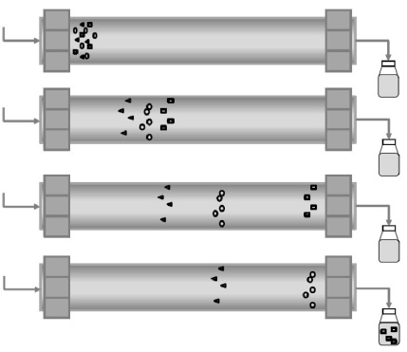
Chromatography is a separation technique based upon the notion that the molecules that make up a sample mixture will interact differently when exposed to the same media. For example, when a solution mixture is run though a polar media, polar molecules in the mixture will be attracted to the media and will travel more slowly, thus separating them from the mixture. Different chromatography techniques try to utilize different molecular characteristics (usually polarity or size) to separate a mixture by altering the speed at which they travel through the media.

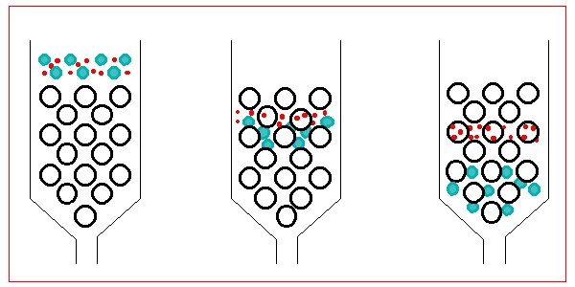
Solutions (homogenous mixtures) are typically sent through a column that is packed with a specialized silica media called the stationary phase. The column lining and/or beads are called the stationary phase as they are secured to the column itself and do not move. The sample solution is then sent through the column and separates based upon how its components interact with the stationary phase. Since the solution is free to move through the column, it is referred to as the mobile phase.

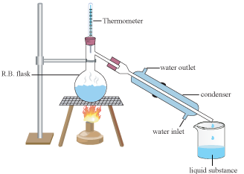
Distillation is a separation technique that exploits differences in molecules’ boiling points and is often the only way to separate homogenous mixtures of similar polarity. As a solution is heated in a controlled fashion, the substance with the lower BP will evaporate out of solution first. If the molecule of interest is the one with the lower BP, the gaseous molecule must be collected and allowed to cool and condense in a separate vessel. If the lower BP substance is not desired, it may simply be allowed to evaporate out of the mixture.

In this experiment you will utilize these separation techniques to isolate desired components in a mixture. You will four mixtures; a homogeneous salt solution, a heterogeneous salt solution, a homogeneous pigment solution, or a homogeneous alcohol solution. Upon inspecting the mixtures, you and your partner must decide how to best separate each mixture to isolate the desired molecule.

PROCEDURE

Preparation of Sample Mixtures
Follow the instructions provided to produce the four assigned mixtures.

Mixture #1: Potassium Chloride Mixture.
Obtain your sample of unknown mass of potassium chloride from the desiccator. Quantitatively transfer into a 100-mL beaker and add di-H₂O until the total volume is approximately 50mL. Stir until the salt is dissolved.

Separation Goal: Figure out how many grams of salt were in your original sample.

Separation Technique: ___________________________ Walsh Initials:______

Mixture #2: Black Dye Mixture
Obtain a black washable marker. Extract the dye solution from the marker as you see fit (without destroying it) to accomplish your analysis.

Separation Goal: Determine how many different dye molecules (colors) make-up the black dye mixture.

Separation Technique: ___________________________ Walsh Initials:______

Mixture #3: Magnesium Nitrate/Sodium Carbonate Mixture.
Obtain your solutions of unknown concentration of magnesium nitrate and sodium carbonate from the center lab table. Quantitatively transfer each into the same 250-mL beaker swirl for 1 minute to mix.

Separation Goal: Figure out how many grams of precipitate were produced during the reaction.

Separation Technique: ___________________________ Walsh Initials:______

Mixture #4: Ethanol Mixture.
Obtain your sample of unknown concentration of ethanol from the center lab table. Quantitatively transfer to a 50mL volumetric flask and bring to volume with diH₂O.

Separation Goal: Figure out the volume of ethanol in your original sample.

Separation Technique: ___________________________ Walsh Initials:______

Separation Techniques Available:
Distillation, Paper Chromatography, and Filtration
DATA ANALYSIS

Write the complete chemical formulas for each reactant and product present in each experiment and identify the classification of matter for each.

Mixture #1:

Mixture #2: Formulas are N/A

Mixture #3:

Mixture #4:

Calculations

Mixture #1: Calculate the grams and molecules of salt present in the original mixture.

Mixture #2: Document the colors observed in the black ink mixture and list them in order of increasing polarity.

Mixture #3: Calculate the grams and molecules of precipitate created in the mixture.

Mixture #4: Calculate the concentration (% volume/volume) of the original ethanol solution.

CONCLUSION

A proper conclusion should contain the following components:
- A discussion of the results of the experiment
- Analysis of those results, using both data and observations to support any conclusions made
- Any potential sources of error should be noted
- Ways the procedure or your execution could be improved upon or areas for future research

For this lab, write a conclusionary paragraph that highlights the results of each of your experiments and why/how each separation technique you used was successful. Discuss possible sources of error and ways you could improve upon the procedure in the future.

Analytical Separation of Mixtures Guided Lab Report

Name: Partner:
Lab Title: Date:
______________________________________________________________________________

Objective:

Materials:

Procedure:

Mixture #1

Mixture #2:

Mixture #3:

Mixture #4:

Data Table

Observations Table

Data Analysis/Calculations:

Conclusion:

