# Periodic Trends

**Unit 7:** Periodicity

### Knowledge/Understanding Goals:

* ionization energy, electronegativity, electron affinity, atomic radius, ionic radius

### Notes:

## Atomic Radius

atomic radius:

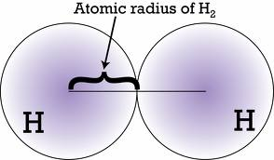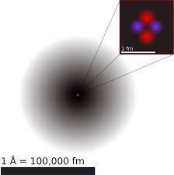

Factors Influencing Radius:

___________________: The more energy levels _____________ by electrons, the ____________ the radius as you are increasing the physical ________________ from the nucleus to the valence level.

_________________: The larger the nuclear charge (greater # of _____________), the _____________ your radius as electrons are pulled in tightly due to high _______________________ (charge) attraction.

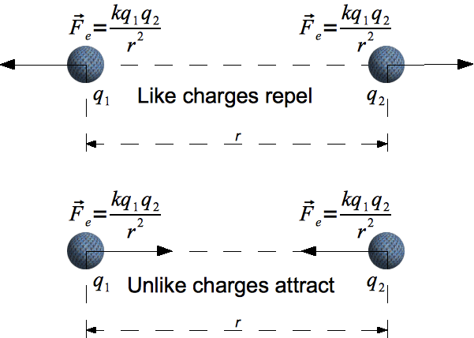

_____________: when _________ electrons in the lower energy levels (closer to the nucleus) shield (block) some of the nucleus’ _________________. This causes the outer electrons to be held ________ tightly by the nuclear charge, and the atom gets ____________.

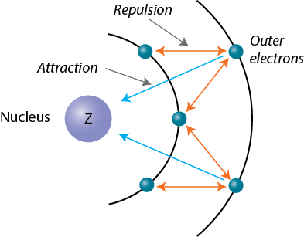

* Shielding and nuclear charge can be combined into the term ***______________________________***; which is the charge electrons actually feel from the nucleus after shielding.

Example calculations:

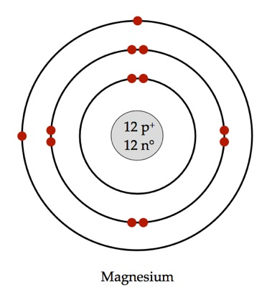

**Radius Trend**

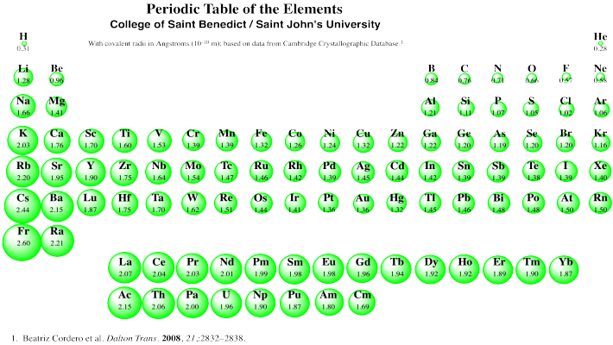

* Atoms of elements get larger as you move down a column, Why?
* Atoms of elements get smaller as you move to the right within the same period, Why?



* periodic trend: any measurable property that increases or decreases according to the element’s position on the ____________________.
* Atomic radius tends to get ____________ as you move up and to the right on the periodic table, and ____________ as you move down and to the left.

*Make sure you can explain why using effective nuclear charge and occupied energy levels in your discussion.

* Nearly all of the other periodic trends can be tied back to ___________, and thus effective nuclear charge and energy levels.

**Ionic Radius**

Because most of the space that an atom takes up is outside the nucleus (where the electrons are), changing the number of ______________ (making an ion) changes the size of the atom.

***Cations:*** If you take away electrons, the ion gets ___________. This means ions with a _____________ charge are smaller than the neutral atom and also smaller than an atom of the neutral element with the same number of electrons. This is because the positive ions have more unshielded positive charge, which pulls the electrons closer.

***Anions:*** If you add electrons, the ion gets _________. This means ions with a _____________ charge are larger than the neutral atom and also larger than an atom of the neutral element with the same number of electrons.

|  |  |  |  |
| --- | --- | --- | --- |
| **Element** | **Radius of neutral atom (pm)** | **Charge of ion** | **Radius of ion (pm)** |
| O | 73 | −2 | 126 |
| F | 72 | −1 | 119 |
| Ne | 71 | 0 | — |
| Na | 186 | +1 | 116 |
| Mg | 160 | +2 | 86 |

## Electronegativity

electronegativity: (χ)

The concept of electronegativity was first proposed by Linus Pauling. Originally, Pauling assigned the elements in period 2 the values of Li = 1.0; Be = 1.5; B = 2.0; C = 2.5; N = 3.0; O = 3.5; and F = 4.0.

Pauling later defined the electronegativity difference (_____) in terms of the bond dissociation energies (energy required to break a bond):



Where DAB, DAA, and DBB are the bond dissociation energies (expressed in ) of an A−B bond, an A−A bond, and a B−B bond, respectively. (The 96.485 comes from the fact that electronegativity is defined in terms of electron volts (eV). 1 eV = 96.485 .)

How can EN be related back to radius?



*Note the electronegativity of Noble Gases = 0

## Ionic vs. Covalent Bond Character

The main application of electronegativity values is the prediction of _______________________ between atoms. This will be discussed more in the polarity unit.

***Ionic Bond:***

***Polar Covalent Bond:***

***Non-Polar Covalent:***

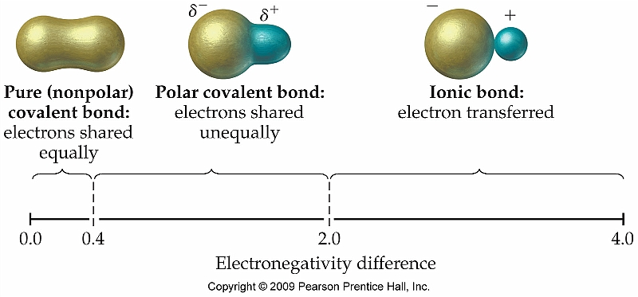Note that this bond characteristic scale does ***NOT*** have finite “cut-offs”, but is more of a continuum or spectrum from “more covalent” to “more ionic”.

All chemical bonds exhibit some ______________ character and all chemical bonds between dissimilar atoms also exhibit some __________ character. We define a bond as being “ionic” or having “ionic character” if the bond character is at least ____ ionic.

The electronegativity difference (Δχ) can be used to predict how a chemical bond ____________. According to another of Pauling’s formulas, the percent ionic character of a chemical bond is given by the formula:



A bond with 50% ionic character corresponds with a Δχ of approximately __.

## Ionization Energy

ionization energy:

How can IE be related back to radius?



In general, as energy sub-levels fill with electrons, they become more __________. This means the total energy of each electron in the sublevel decreases. As the electrons move to lower energy states, _______ energy is required to remove them, resulting in higher ionization energy values.

1st ionization energy: the amount of energy it takes to remove the first electron from an atom.

2nd ionization energy: the amount of energy it takes to remove a second electron from a +1 ion. The 2nd ionization energy is always __________ than the first, because energy must be added to overcome the attraction due to the positive charge as well as the energy of the electrons in the sub-level. (Radius is *always* smaller after removing first e-)

3rd, 4th ionization energy, *etc.*: the amount of energy it takes to remove a third electron from a +2 ion, a fourth electron from a +3 ion, *etc.* As the positive charge of the ion increases, the ionization energy also ________________. (Radius gets smaller and smaller)

There is always a particularly large jump in the _____________________ once the atom or ion has the same electron configuration as a ______________ (a “noble gas core”). This is because removing an electron from a “noble gas core” requires removing an electron from a ________________________ that has additional _________________ (even lower energy) because all of its orbitals are filled.

Consider the following table of ionization energies:

|  |  |  |  |
| --- | --- | --- | --- |
| **Element** | **1st Ionization Energy (kJ/mol)**  (neutral atom) | **2nd Ionization Energy (kJ/mol)**  (+1 ion) | **3rd Ionization Energy (kJ/mol)**  (+2 ion) |
| Ne | 2081 | 3952 | 6122 |
| Na | 496 | 4562 | 6912 |
| Mg | 738 | 1451 | 7733 |

In the above table, neon (Ne) has the largest 1st ionization energy, because filled ___ and ___ sublevels are more stable, meaning it takes more energy to remove electrons from them.

Sodium (Na) has the smallest 1st ionization energy. This is because removing one electron will remove the ____ electron entirely, leaving the remaining electrons are all in lower (lower energy and therefore more stable) sublevels. Also, those sublevels are ___________—the +1 ion has a “noble gas core.” The filled sublevels are more __________ (lower energy), and electrons in them require even more energy to overcome this added stability.

Magnesium (Mg) has the lowest 2nd ionization energy, because removing the second electron gives it a _________________ core. However, because the +2 ion has a noble gas core, the third electron is much more difficult to remove, giving Mg a particularly large 3rd ionization energy.

## Tying Stability to EN and IE

Hopefully at this time, you have noticed the correlation between the “_____________” of the noble gas electron configuration and their inherent electronegativity and ionization energies.

Noble gas configurations are energetically favorable due to the s and p valence sublevels being completely full.

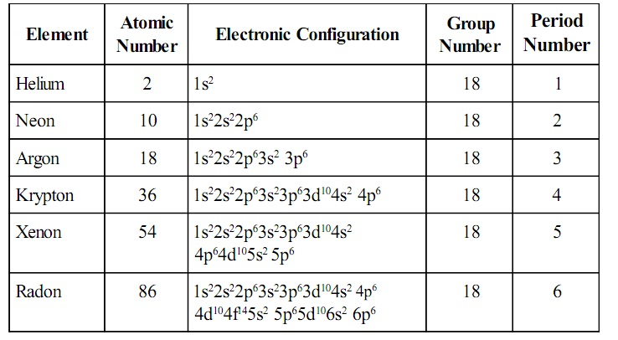

This stability is reflected in the EN and IE values for noble gases:

***Electronegativity =***

* Atom is no longer able to attract (____) more electrons to its valence shell, which would take it out of the _______ noble gas configuration.

***Ionization Energy =***

* Very difficult to remove (_____) electrons from its valence shell, which would take it out of the stable noble gas configuration.

## Electron Affinity

electron affinity: the energy required to remove an electron from a ___ ion. (It is sometimes also expressed as the energy released by the atom when forming the −1 ion. However, because the energy change for the atom is negative, this definition can create confusion over the sign of Eea.)

Higher electron affinities indicate higher _____________ of the negative ion, and therefore a stronger tendency for the atom to attract electrons.

Because the positive nucleus can attract and hold electrons, most atoms can form a stable −1 ion, even if the positive ions are more stable. However, because ________________ and _____________________ energy sublevels are more stable (lower energy), electrons in the middle and end of the p, d, and f blocks of the periodic table tend to be unable (or much less able) to form a stable −1 ion. These atoms have either very low or undefined electron affinities (“< 0” means that the −1 ion is unstable and no value can be measured).

There is a general trend toward ____________ electron affinities as you move to the right, toward the middle or end of each sublevel within a section of the periodic table.

## 