Organic Chemistry
Unit: Organic Chemistry

Skills:
- name and identify basic organic compounds
Organic compounds are named and described based on their functional groups.

Alkanes
An alkane is a compound containing only carbon and hydrogen, with all single bonds. The compound is named based on the number of carbon atoms.
Number | Prefix | Number | Prefix
1 | meth- | 6 | hex-
2 | eth- | 7 | hept-
3 | prop- | 8 | oct-
4 | but- | 9 | non-
5 | pent- | 10 | dec-

Alkenes & Alkynes
Alkenes have at least one double bond. Alkynes have at least one triple bond. The compound is numbered based on the lowest-numbered carbon with the double or triple bond. The number can be placed before the prefix
(Because the molecule is symmetrical, you can start numbering from either end.) It is often easiest to see what’s going on if you draw a skeletal structure:
functional group: a specific set of atoms attached to the carbon “backbone”. The chemical properties of an organic compound are substantially affected by its functional groups.
A carbon chain sticking out from the carbon backbone gets the root “-yl” added to the prefix.
Note that the carbon backbone is the longest chain of carbons. For example:
You can combine functional groups and multiple bonds, functional groups get listed first :

Cyclic Compounds
A cyclic compound gets the prefix “cyclo”:
Note, however, that the following compound is always called “benzene”:

Isomers
isomers: two compounds with the same chemical formula, but different arrangements of the atoms. For example, the following pair of isomers would have very different chemical properties:
Carbon Compounds with Functional Groups
Structure | Compound | Nomenclature | Example
 | alcohol | —ol
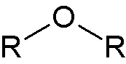 | ether | —yl —yl ether
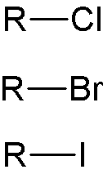 | alkyl halide | —o—ane
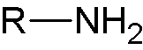 | amine | —an-#-amine

Structure | Compound | Nomenclature | Example
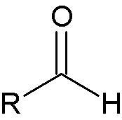 | aldehyde | —al
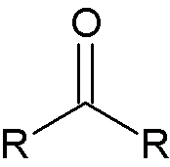 | ketone | —an-#-one
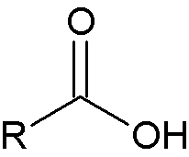 | carboxylic acid | —anoic acid
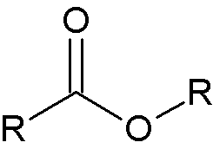 | ester | —yl —anoate
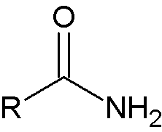 | amide | —anamide

