- Identify the prefix used to describe the following carbon backbones.
- 8 carbon
- 3 carbon
- 2 carbon
- 4 carbon

- Name and draw the following
- CH₃CH₂CH₃

- CH₃CH₂CH₂CH₂CH₃

- Name and draw the following
- CH₃CHCHCH₃

- CH₂CHCH₂CHCH₂

- Name the following and draw in A) simplified stick form and B) 3-D wedge form
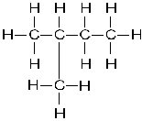

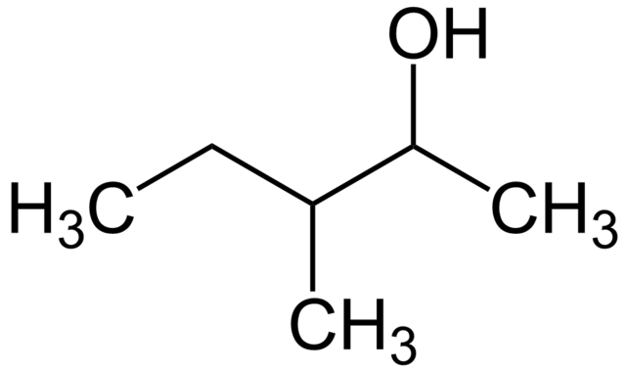

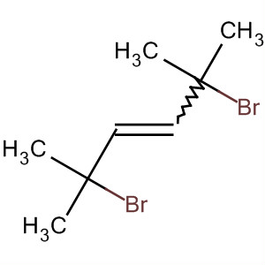

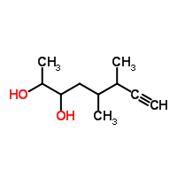

- CH₃OCH₃

- Draw the following
- 1,2,4 trimethylbenzene

- 2-butanol

- pentylethanoate

- Explain the concept of polymerization and identify common uses for polymers.

- Make flashcards for the naming and structure of the following
  - Backbones/Carbon groups: 1-10 carbons, alkane, alkene, alkyne, cyclic
  - Functional groups: amine, amide, alcohol, carboxylic acid, keytone, ester, ether, aldehyde

