# Intermolecular Forces

**Unit 11B:** Molecular Polarity

### Knowledge/Understanding Goals:

* what it means for a molecule to be polar
* dipole moment

### Skills:

* identify polar molecules
* draw polarity arrows indicating polarity of a molecule

### Notes:

## Molecule Polarity

polar molecule:

Note that molecular polarity applies only to _______________ (molecular) compounds. Ionic and metallic compounds generally do not form dipoles.

In order to be polar, a molecule must have both:

1. one or more _____________________
2. an “___________________________,” meaning a way to view the molecule so that there is more partial positive charge on one side (relative to the central atom), and more partial negative charge on the opposite side.

For example, the CH3Cl molecule is polar, because the C-Cl bond is polar (Δχ = 0.61), and because you can view the central atom (carbon) so that the negative charge (towards chlorine) is on one side:

Notice the polarity arrow _____________ running from C to Cl in the molecule. The arrow shows the direction of ___________________ (pointing towards the more ________________ atom), and the “+” at the tail of the arrow indicates the end that has the partial positive (δ+) charge. Polarity arrows are often used with Lewis structures:

Because __________________ of electrons change the symmetry of the molecule, ___________________________ and ____________ molecules that contain polar bonds will usually be polar molecules. For example, NH3 is polarized towards the nitrogen atom:

and water is polarized towards the oxygen atom:

If a molecule has multiple polar bonds that are pulling __________ in _______________ directions, then the forces cancel out and the molecule is not polar. An example of a *_______________ molecule* that does have polar bonds is CCl4.

Each of the C-Cl bonds is polar, but the forces all cancel out, so there is no net force in any direction.

## Ex: SO2 vs CO2

## Ex: BF3 vs CH2O

## Dipole Moment

The polarity of a molecule can be expressed quantitatively as a dipole moment.

dipole moment: a measure of how strongly a dipole will react to an external field, expressed as the moment of inertia caused by a pair of ______________ (+*q* and −*q*) separated by a _________________ *d.*

The dipole moment (*μ*) is expressed by the formula:

*μ*= *qd*

The unit for dipole moment is the debye (D), with values ranging from 0 (homonuclear non-polar: Cl2) to 11 (high ionic bond characteristic: KBr)

______________ charges (or partial charges) and/or ________________ distance between those charges will result in a _____________ dipole moment (and therefore a more polar molecule).

* The affect of distance can seem counter intuitive, but remember that we are referencing the ________ of a dipole, not a coulombic force of attraction. The farther the opposite charges are apart, the bigger the dipole, the more polar the molecule.
  + In other words, if the dipole covers only a small section of the molecule, _____________________________

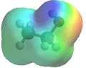

**Momentary Dipoles**

The previous examples were all permanent dipoles formed by ________________________ resulting from polar covalent bonds. However, it is also possible for random, __________________________ to form across any molecule.

Momentary dipoles can theoretically form around any single atom due to random, uneven distribution of _______________ around an atom’s nucleus.

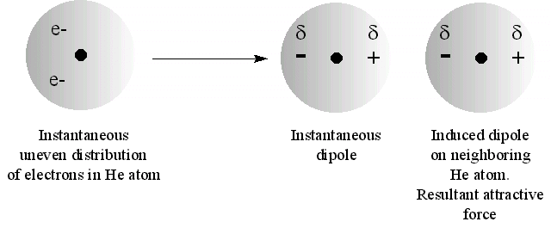

As soon as electrons are unevenly distributed to one side of the atom, weak ________________________ form on either side of the atom. These charges will attract the _________________ of a neighboring atom to one side, causing _______________ partial charges to form on that atom as well.

This linear arrangement of electrons, and therefore partial charges, will result in a momentary, weak ________________ across the molecule.

Ex: Cl2 (non-polar)

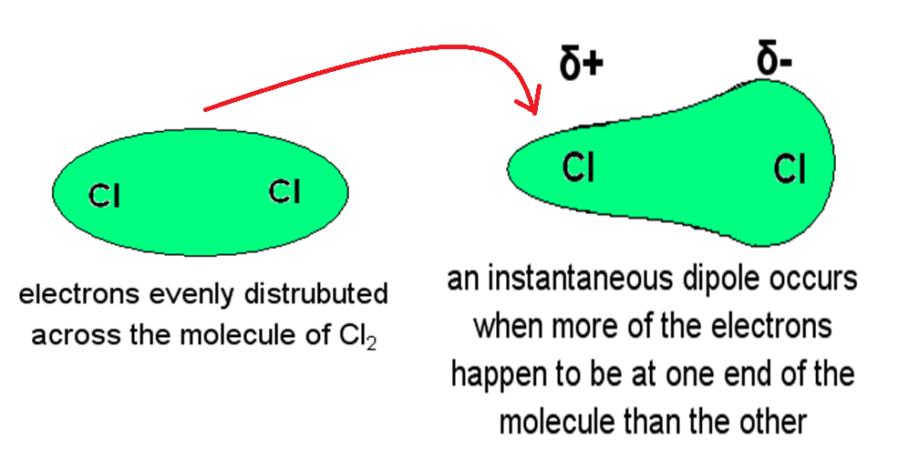

The effects of the momentary dipole can also influence neighboring ____________________ due to the presence of weak partial charges.

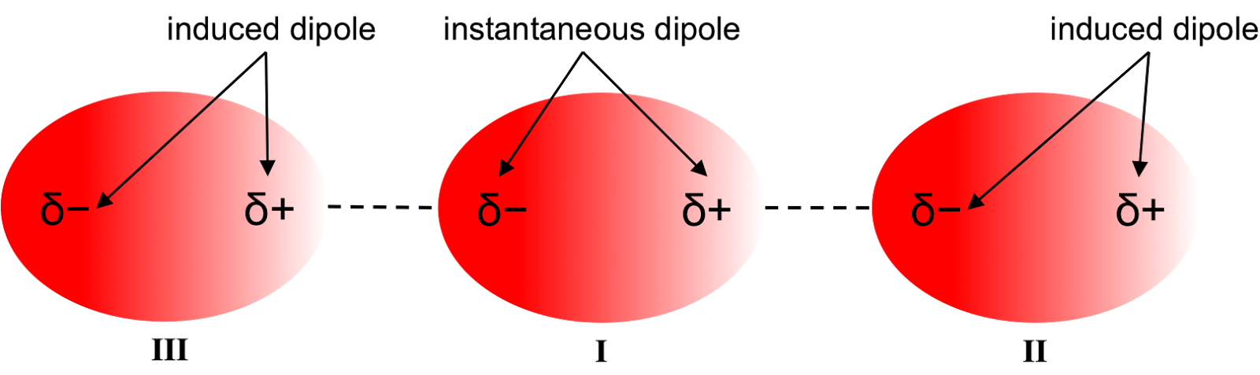

**Organic Molecular Polarity**

As seen, in order for a molecule to be considered polar, there must be an uneven distribution of charge across the molecule. This results in an overall _____________ across the molecule, which can be ________________ or _____________________ depending upon the origin of the charges.

However, the relative “strength” or attractive force applied by the dipole and felt by neighboring molecules is not only dependent upon the _______________________ of the dipole, but also the ________________ of the dipole on the molecule.

Molecular geometry and, more specifically, the relative amount of a molecule that contributes to the dipole determine the extent of a molecules polarity.

There are 4 important trends to consider.

1. ***The relative strength of attractive force of a dipole is directly related to the strength of the _______________ formed on the molecule.***
2. ***The bigger the difference in electronegativity across a bond, the ________________ the partial charges.***
3. ***The strength of dipole attraction increases with the __________ of the molecule.***
4. ***Branching ________________ dipole force.***

Charges become _______________ by the structure (steric hindrance), when they are blocked by branching or are imbedded in the ___________________ of the structure.

For example, compare ethanol (BP = 354 K) and 1-butanol (BP = 391 K).

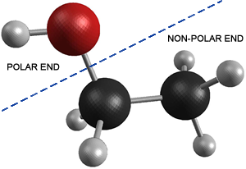

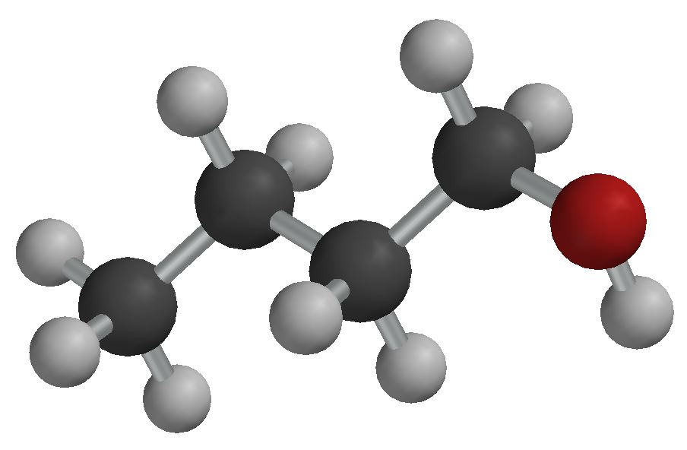

* Both molecules express polarity from an alcohol group on the terminal end of the structure, giving it low _____________________________.
* Since the butanol is a larger molecule, its greater ability for __________________ dipole strength gives it a stronger dipole despite the fact that a greater _________________ of the ethanol molecule is polar.

1-butanol (BP = 391 K) vs isobutanol (BP = 381 K) vs 2-butanol (BP = 371-373 K)



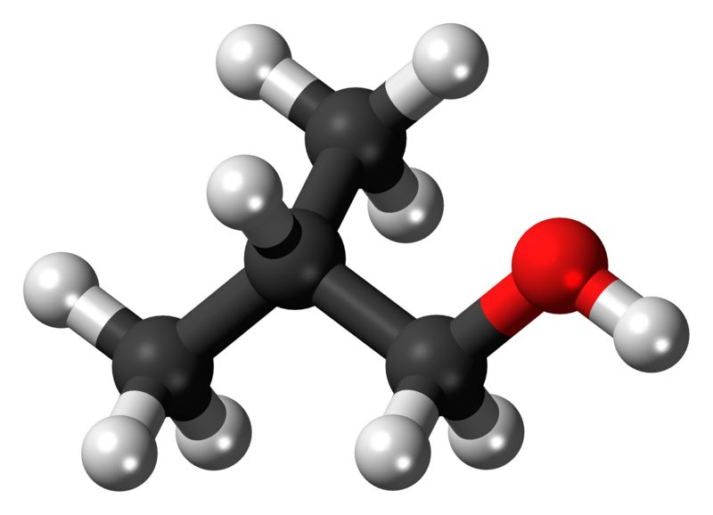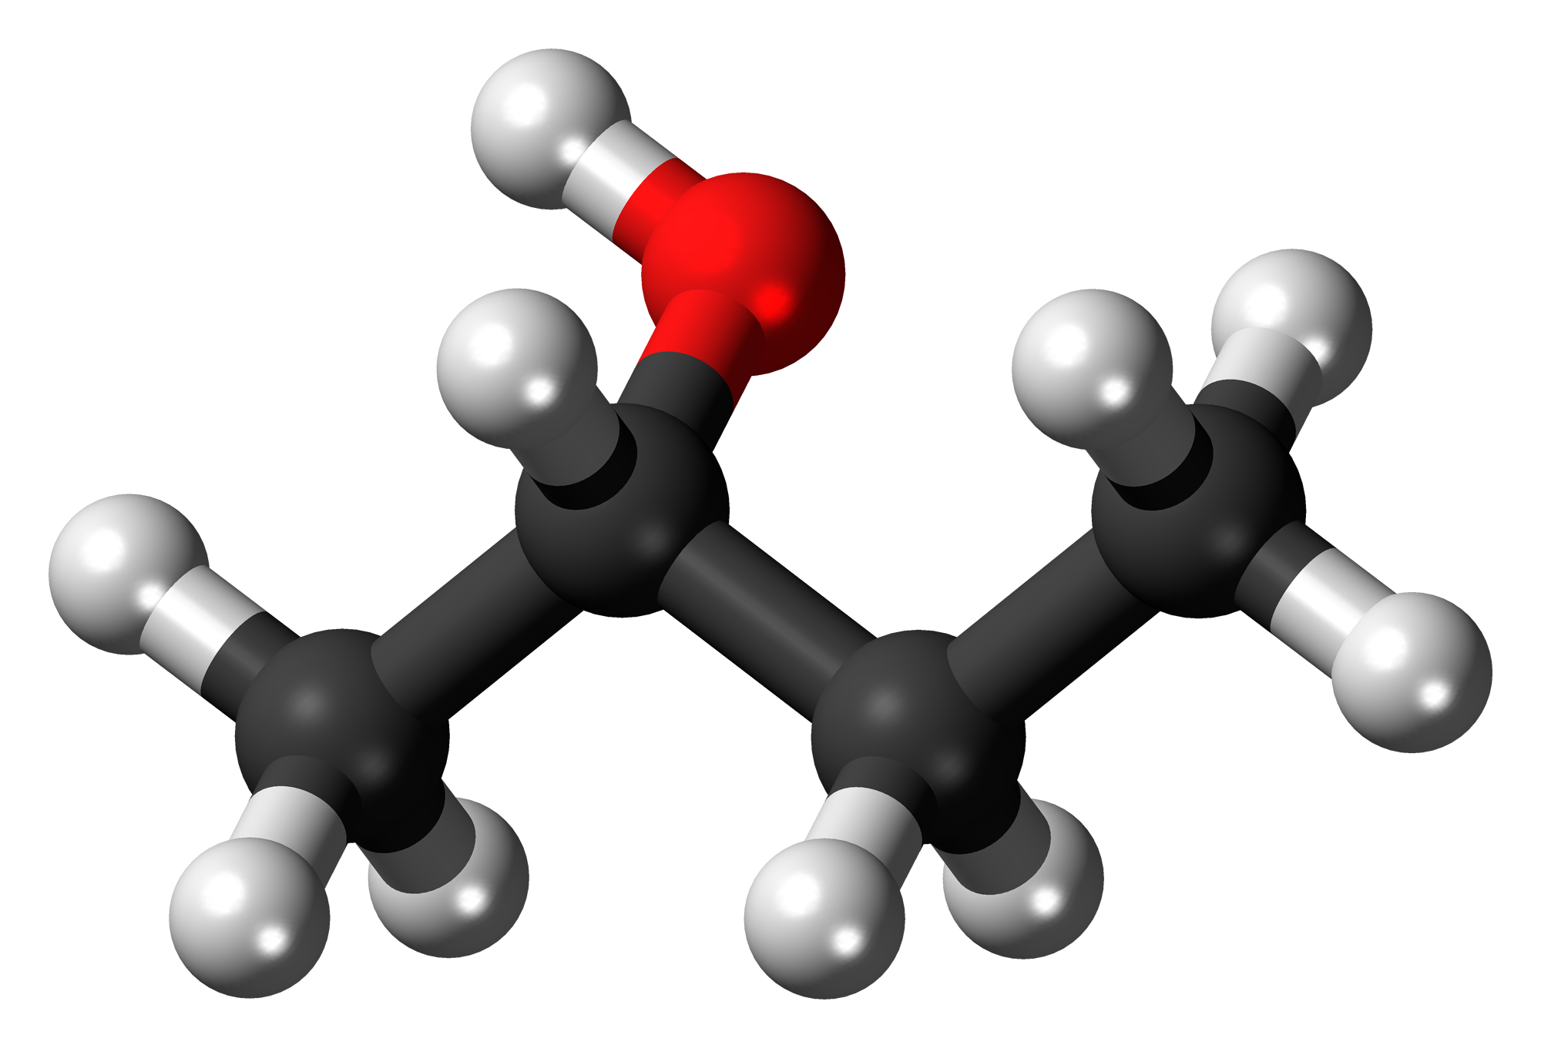

* Same size =
* Placement of polar alcohol group influences its strength