# Intermolecular Forces

**Unit 11B:** Molecular Polarity

### Knowledge/Understanding Goals:

* what it means for a molecule to be polar
* dipole moment

### Skills:

* identify polar molecules
* draw polarity arrows indicating polarity of a molecule

### Notes:

## Molecule Polarity

polar molecule: a molecule that can be turned so that it has opposite partial charges on opposite sides.

Note that molecular polarity applies only to covalent (molecular) compounds. Ionic and metallic compounds generally do not form dipoles.

In order to be polar, a molecule must have both:

1. one or more polar bonds
2. an “axis of asymmetry,” meaning a way to view the molecule so that there is more partial positive charge on one side (relative to the central atom), and more partial negative charge on the opposite side.

For example, the CH3Cl molecule is polar, because the C-Cl bond is polar (Δχ = 0.61), and because you can view the central atom (carbon) so that the negative charge (towards chlorine) is on one side:

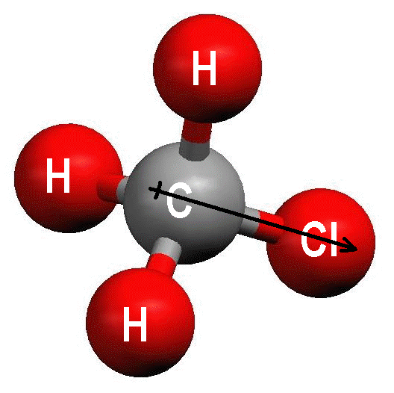

Notice the polarity arrow  running from C to Cl in the molecule. The arrow shows the direction of polarization (pointing towards the more electronegative atom), and the “+” at the tail of the arrow indicates the end that has the partial positive (δ+) charge. Polarity arrows are often used with Lewis structures:



Because lone pairs of electrons change the symmetry of the molecule, trigonal pyramidal and bent molecules that contain polar bonds will usually be polar molecules. For example, NH3 is polarized towards the nitrogen atom:



and water is polarized towards the oxygen atom:



If a molecule has multiple polar bonds that are pulling equally in opposite directions, then the forces cancel out and the molecule is not polar. An example of a *nonpolar molecule* that does have polar bonds is CCl4.



Each of the C-Cl bonds is polar, but the forces all cancel out, so there is no net force in any direction.

## Ex: SO2 vs CO2Dipole Moment

The polarity of a molecule can be expressed quantitatively as a dipole moment.

dipole moment: a measure of how strongly a dipole will react to an external field, expressed as the moment of inertia caused by a pair of charges (+*q* and −*q*) separated by a distance *d.*

The dipole moment (*μ*) is expressed by the formula:

*μ*= *qd*

The unit for dipole moment is the debye (D), with values ranging from 0 (homonuclear non-polar: Cl2) to 11 (high ionic bond characteristic: KBr)

Stronger charges (or partial charges) and/or greater distance between those charges will result in a larger dipole moment (and therefore a more polar molecule).

* The affect of distance can seem counter intuitive, but remember that we are referencing the size of a dipole, not a coulombic force of attraction. The farther the opposite charges are apart, the bigger the dipole, the more polar the molecule.
  + In other words, if the dipole cover only a small section of the molecule, it will not exhibit much polarity

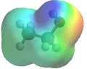

**Momentary Dipoles**

The previous examples were all permanent dipoles formed by partial charges resulting from polar covalent bonds. However, it is also possible for random, momentary dipoles to form across any molecule.

Momentary dipoles can theoretically form around any single atom due to random, uneven distribution of electrons around an atom’s nucleus.

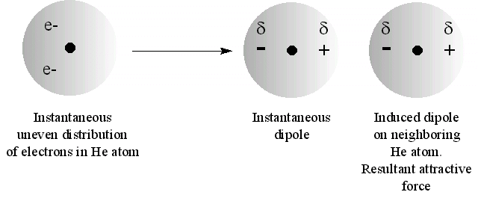

As soon as electrons are unevenly distributed to one side of the atom, weak partial charges form on either side of the atom. These charges will attract the electrons of a neighboring atom to one side, causing induced partial charges to form on that atom as well.

This linear arrangement of electrons, and therefore partial charges, will result in a momentary weak dipole across the molecule.

Ex: Cl2 (non-polar)

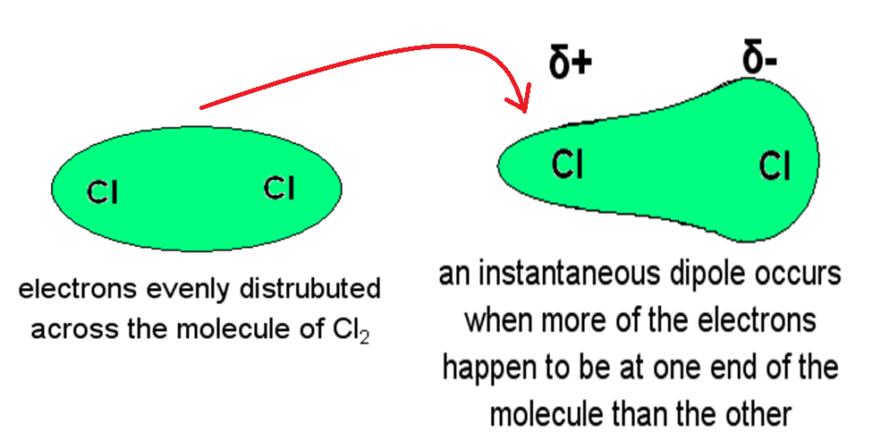

The effects of the momentary dipole can also influence neighboring molecules due to the presence of weak partial charges.

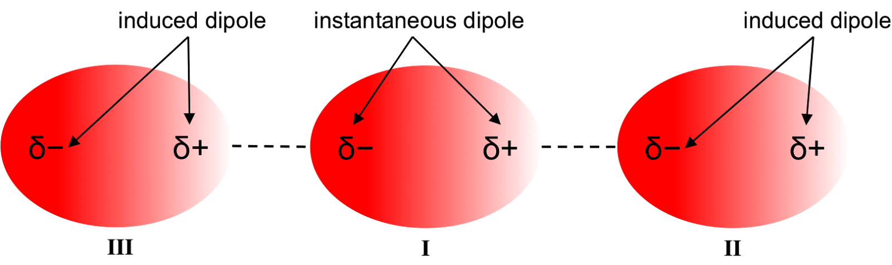

**Organic Molecular Polarity**

As seen, in order for a molecule to be considered polar, there must be an uneven distribution of charge across the molecule. This results in an overall dipole across the molecule, which can be permanent or momentary depending upon the origin of the charges.

However, the relative “strength” or attractive force applied by the dipole and felt by neighboring molecules is not only dependent upon the strength of the dipole, but also the position of the dipole on the molecule.

Molecular geometry and, more specifically, the relative amount of a molecule that contributes to the dipole determine the extent of a molecules polarity.

There are 4 important trends to consider.

1. ***The relative strength of attractive force of a dipole is directly related to the strength of the charges formed on the molecule.***

Full charges > Permanent Partial Charges > Momentary Partial Charges

1. ***The bigger the difference in electronegativity across a bond, the stronger the partial charges.***
2. ***The strength of dipole attraction increases with the size of the molecule.***

Bigger molecule = more e- = greater random uneven distribution

1. ***Branching decreases dipole force.***

Charges become shielded by the structure (steric hinderance), when they are blocked by branching or are imbedded in the back bone of the structure.

For example, compare ethanol (BP = 354 K) and 1-butanol (BP = 391 K).

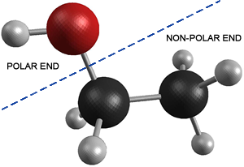

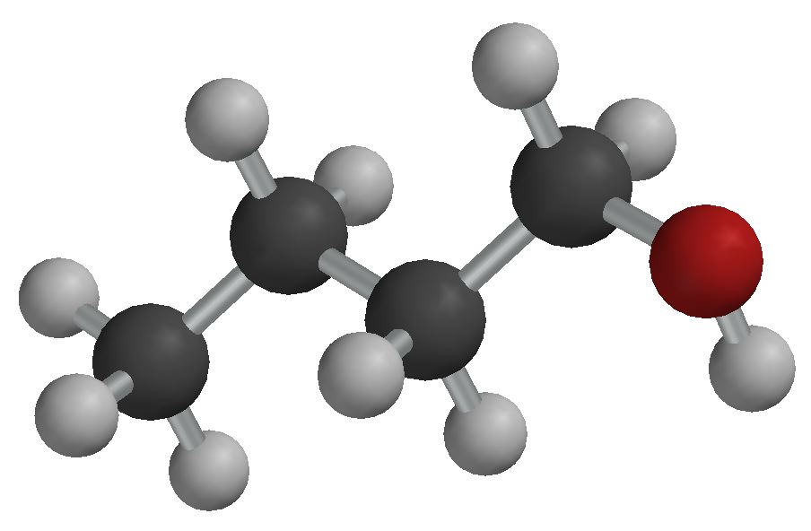

* Both molecules express polarity from an alcohol group on the terminal end of the structure, giving it low steric hinderence.
* Since the butanol is a larger molecule, it’s greater ability for momentary dipole strength gives it a stronger dipole despite the fact that a greater percentage of the ethanol molecule is polar.

1-butanol (BP = 391 K) vs isobutanol (BP = 381 K) vs 2-butanol (BP = 371-373 K)



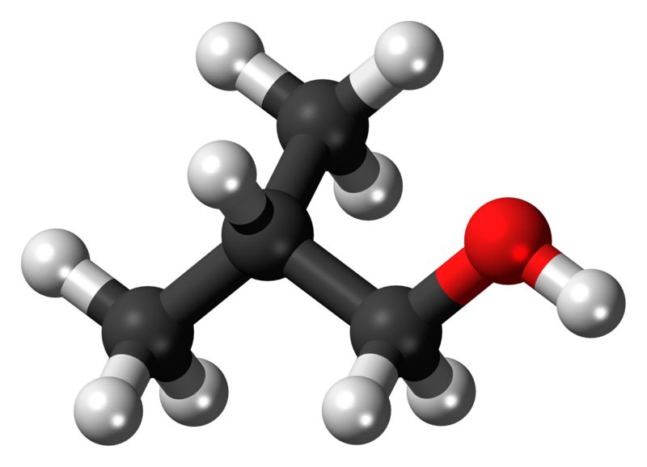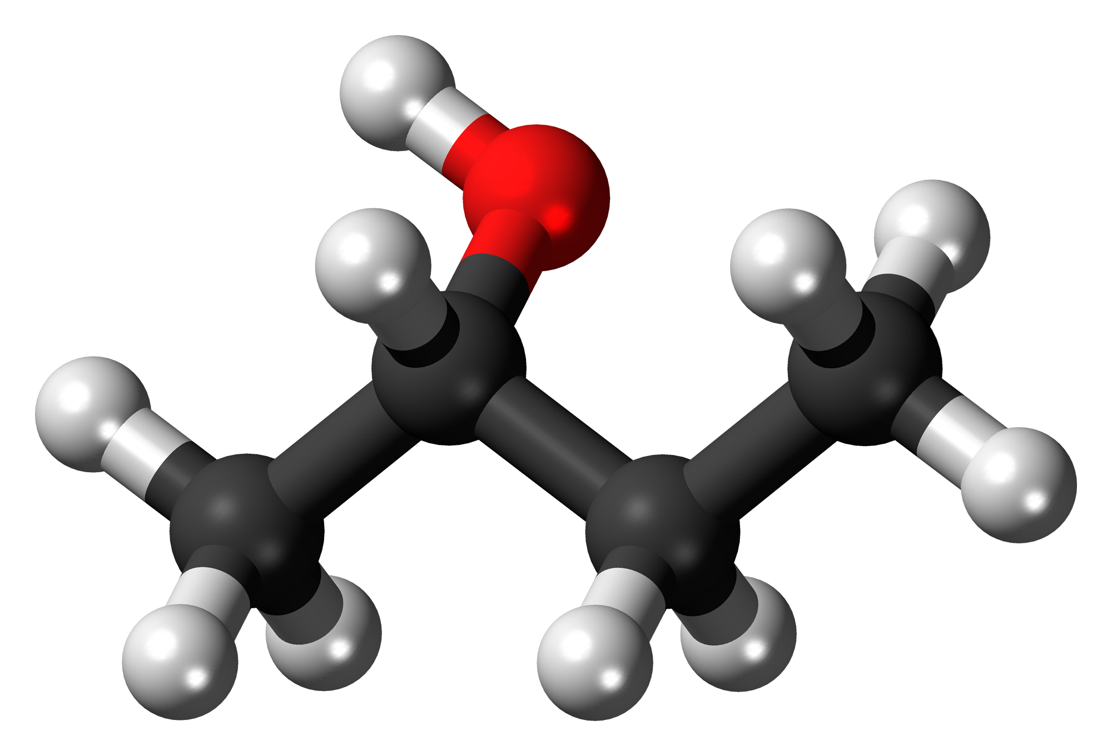

* Same size = same momentary dipole ability
* Placement of polar alcohol group influences its strength
  + Terminal > OH branch