# Molecular Bonding

**Unit 10A:** Bonding Theory and Lewis Dot Structures

### Knowledge/Understanding:

* Purpose of bonding
* Predicting bonding

### Skills:

* Draw proper Lewis Dot structures

### Notes:

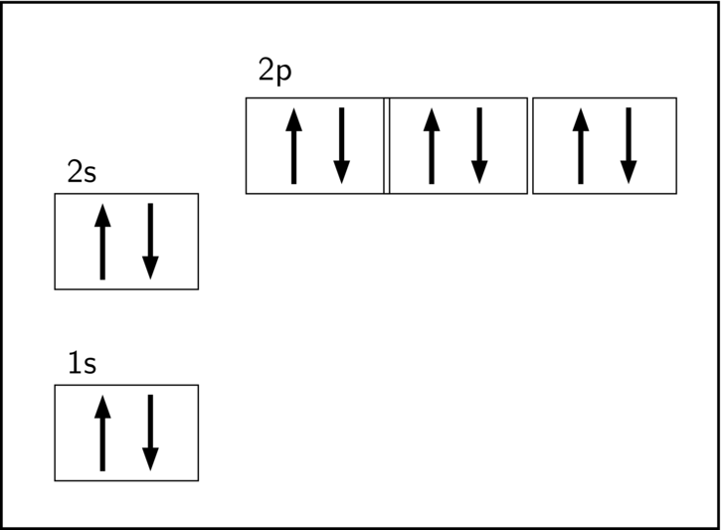As we have seen through electron configurations, ______________ is gained when sublevels are ____________ or ______________ with electrons.

This stability reflects the theory that it is energetically favorable to have electrons of opposing spin (and therefore opposing ________________________) paired in orbitals = full sublevel

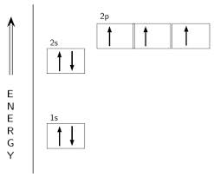

It is also energetically favorable to have electrons of similar spin ____________________ into individual orbitals to avoid electrostatic _________________ = half-full sublevel

Full sublevels offer ________ stability than half-filled sublevels

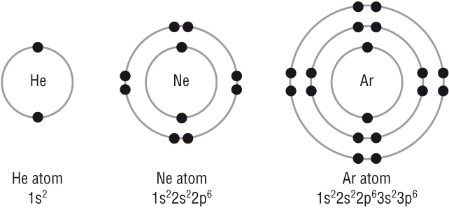

______________________ electron configurations all reflect stability as each of the sublevels containing electrons is full.

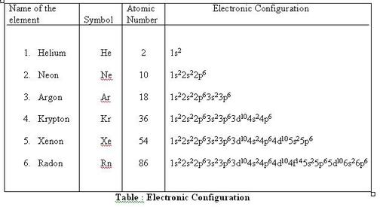Focusing in on the valence electrons, notice that each (other than He) has a full s and p sublevel.

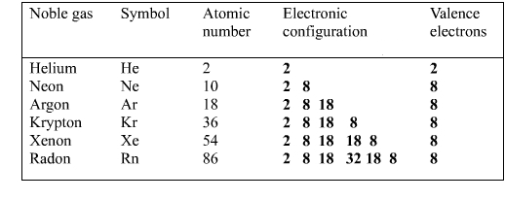This phenomenon is often referred to as the _________________, as each noble gas possesses 8 valence electrons.

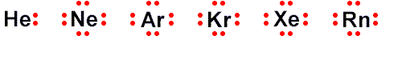

All other elements exhibit less _____________ than the noble gases due to their electron configurations reflecting incomplete pairing of electrons (_______________________). The only way for these elements to achieve the stable noble gas configuration is ___________ or ________________ electrons with other atoms via ________________________.

Whether or not electrons are shared or exchanged is all based upon each atom’s ability to ______________ the electrons of the bonding partner; in other words its _________________________.

Ionic Bonds (Metal & Non-Metal, ΔEN >1.7)

Recall that ionic bonding, or e- ______________, results in ______________________ forming on the e- donor (+) and recipient (-). Complete donation occurs due to the large difference in electronegativity (EN) between the elements.

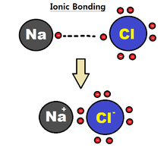

Ionic bonds are not true bonds, however, as the elements in an ionic compound are only held together due to electrostatic ___________________________ (coulombic force) between the ions. No orbitals are overlapping or hybridizing.

Ionic Lewis Dot: Arrows show donation.

Ex: CaCl2

Covalent Bonds (Non-Metal & Non-Metal, ΔEN = 0-1.7)

In the case of **polar covalent** bonding (ΔEN = 0.35-1.7), e- are _______________________ between the two atoms due to a lower difference in EN. The e- are still shared as neither atom has a strong enough EN to completely steal the shared e-.

Uneven sharing results in only ____________ charges forming on each atom involved in the polar covalent bond. The lower-case Greek letter “delta” (δ) is used to mean “partial”. A partially positive charge would be shown as δ+ and a partially negative charge would be shown as δ−, as in the following example:

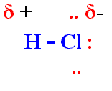

In the above example, hydrogen has a partial positive charge due to its ___________ EN (2.1), and chlorine has a partial negative charge due to its ___________ EN (3.0).

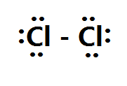**Non-polar covalent** bonds occur when there is ___________________ difference in electronegativity between the bonding atoms (ΔEN = 0-0.35). This even pull on electrons results in ___________ sharing of electrons and therefore _____ charges.

In 1916, Gilbert N. Lewis, one of the most famous American chemists, formulated the idea that a covalent bond consisted of a shared pair of electrons. His ideas on chemical bonding were expanded upon by Irving Langmuir and became the inspiration for the studies on the nature of the chemical bond by Linus Pauling.

Lewis used dots to represent the valence electrons and introduced the concept that when atoms bonded they did so by pairing electrons. He also suggested that one of the driving forces of chemical bonding was the acquisition of eight electrons by each atom in analogy with the very stable noble gases. This is referred to as the octet rule, which is the guiding principle when writing Lewis (electron dot) structures.

Although the structures of molecules as written do not imply a sense of the shape of the molecule or ion considered, they can be used in conjunction with the VSEPR theory (described later) to determine shapes (geometry).

The Lewis dot structures for molecules are developed from the individual atoms.

Examples:

CH4 SiO2

Tips for Drawing Lewis Dot Structures

1. Decide on the sequence/organization of atoms.

(i) The element listed first is typically your central atom. Also, for ABn formulas, the single atom usually is the central atom in the molecule. Exceptions: ___ and ___ are never central and other halogens seldom are.

(e.g., in CH4, NH3 and H2O, the central atoms are _______________ respectively).

(ii) Compounds with symmetrical formulas often adopt corresponding structures.

(e.g., the atomic arrangement in H2O2 is ____________).

2. Determine the number of valence electrons to place around each atom:

(i) Recall the trend to quickly predict the number of valence electrons

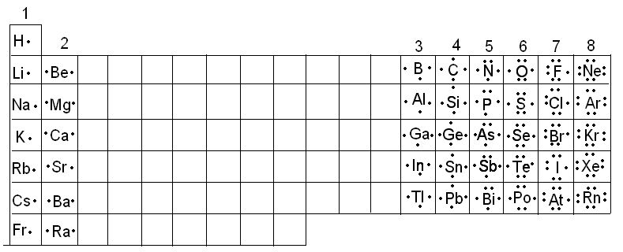

3. Predict how many bonds the atom is likely to make to achieve a stable

octet (___________________ configuration)

H C N F

(i) Bond all perimeter atoms to the central atom once by __________ the pair of electrons to be shared. See who has achieved an octet and who is likely to bond again.

1. Some molecules require more than single bonds to provide each atom with the required octet. Examples include the oxygen molecule O2, which requires a ___________ bond.

:Ö::Ö: or :Ö = Ö:

Nitrogen (N2) requires a __________ bond between the two

nitrogen atoms to provide each nitrogen with an octet of

electrons.

:N:::N: or :N = N:

Multiple bonds are formed primarily by the ____________

____________________and _________ atoms.

4. Know how to alter your structure if an ionic charge is present.

(i) _____________ an extra electron for every -1 charge. For example, the NO3- ion has a total of 24 valence electrons: five from the N and 3 x 6 for the three O’s, plus one for the negative charge.

(iv) _____________ an electron for every +1 charge. For example, the NF4+ ion has a total of 32 electrons: five from the N, 4 x 7 for the four Fs, minus one for the positive charge.

5. Limit the number of electrons to ___________ around any second period element (Li - F). These elements only take on an octet of valence electrons and their Lewis structure must reflect this.

Ex: NO3- NH4+

6. If appropriate, more than eight electrons can be put around elements from the third or higher periods. For example, phosphorus can use its three unpaired electrons to form species such as PCl3, but it can also use all five electrons to form molecules like PCl5, in which there are 10 electrons around the P.

(i) Other elements have a __________ available to bond with and can

therefore have an “______________ octet”

Ex: P can form ___ bonds to have ___ valence e-

S can form ___ bonds to have ___ valence e-

(ii) Common expanded octets: phosphorous, sulfur, selenium, tellurium,

the halogens (except for fluorine) and select noble gases; krypton,

xenon and radon.

Examples:

CHO SiO32- XeF4 C2H2