Equilibrium
Unit 13C: Solubility Product Constants

Knowledge & Understanding
- common ion effect

Skills:
- calculate K_{sp} values and concentrations from K_{sp} values

Notes:

Phases and Equilibrium
Solids and pure liquids do not appear in the equilibrium expression. This is because the moles of a pure solid or liquid per liter of that solid or liquid is really equivalent to the density, which is constant.
For example, in the chemical reaction:
CCl₄ (g) C (s) + 2 Cl₂ (g)
The equilibrium expression would be:

Where does this come from?
Start with the usual products over reactants:

However, [C] is the concentration of carbon (in moles per liter) in solid carbon, which is just the density (a _____________) divided by the molar mass (also a ______________). A constant divided by a constant is just another constant, which we’ll call “K_{carbon}”. This means:

Now, applying the “a constant divided by a constant is just another constant” idea again, we simply adjust K_{c} so that the new K_{c} is the old K_{c} divided by K_{carbon}. Therefore, the equilibrium becomes:

Solubility Product Constant (K_{sp})
Earlier in this course, we defined “insoluble” to mean a saturated solution would have a concentration of less than ____ (or less than 3 g/100 g solvent).
Actually, some amount of any ionic compound _______________ in water, though the amount can be miniscule. For these “____________” compounds, when the compound is placed in water, the precipitate is in equilibrium with the solute.

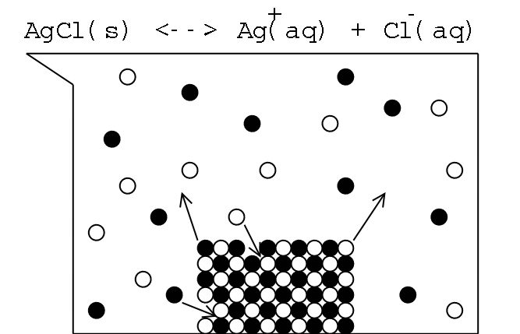
Solubility Simulation: http://phet.colorado.edu/en/simulation/soluble-salts

The solubility product constant (K_{sp}) is an equilibrium constant for the process of the ionic solid ________________ and _______________. (Recall that solubility varies with temperature; K_{sp} values are usually reported at 25°C.)
For example, the chemical equation for the dissolution of Ag₂SO₄ is:

Ag₂SO₄ (s) 2 Ag⁺ (aq) + SO₄²⁻ (aq)

As we saw earlier, solids do not appear in equilibrium constants, so the denominator is omitted. This gives the following equation:
For Ag₂SO₄: K_{sp} =
K_{sp} =

We can solve the above equation, because we know that one Ag₂SO₄ molecule dissolves into 2 Ag⁺ + 1 SO₄²⁻. If we let [SO₄²⁻] = x, then [Ag⁺] = 2x, and:

K_{sp} = 1.2 × 10⁻⁵ =

In other words, a 0.0144 M solution of Ag₂SO₄ would be ________________ (at 25°C).

Common Ion Effect
K_{sp} is a physical constant for a given compound. One useful corollary of this fact is the common ion effect.
As an illustrative example, suppose we start with 1.00 ℓ of a saturated solution of Ag₂SO₄. As we saw on the previous page, [Ag⁺] = 0.0288 M and [SO₄²⁻] = 0.0144 M. However, suppose we now add 1.00 mole of Na₂SO₄. This brings the total [SO₄²⁻] to 1.0144 M.

Notice that [Ag⁺] is substantially lower than the 0.0288 M that resulted when only Ag₂SO₄ was present.
Note that we should really have calculated [SO₄²⁻] as an I.C.E. problem. However, if we assume that all of the [Ag⁺] in solution was removed by precipitation, this would remove all of the 0.0144 M of SO₄²⁻ that was initially in solution. Using 1.00 M instead of 1.0144 M for the [SO₄²⁻] gives [Ag⁺] = 3.46 × 10⁻³ M instead of 3.44 × 10⁻³ M. The difference is less than 1%, which means the simplification was reasonable.
The common ion effect is a common and powerful lab technique—a ______ concentration of a __________________ is added in order to precipitate virtually all of an ion of interest, such as removing toxic Hg²⁺ or Hg₂²⁺ ions from a solution before disposal.

