# Equilibrium

**Unit 13C:** Solubility Product Constants

### Knowledge & Understanding

* common ion effect

### Skills:

* calculate *K*sp values and concentrations from *K*sp values

### Notes:

## Phases and Equilibrium

Solids and pure liquids do not appear in the equilibrium expression. This is because the moles of a pure solid or liquid per liter of that solid or liquid is really equivalent to the density, which is constant.

For example, in the chemical reaction:

CCl4 (g)   C (s) + 2 Cl2 (g)

The equilibrium expression would be:



Where does this come from?

Start with the usual products over reactants:



However, [C] is the concentration of carbon (in moles per liter) *in solid carbon*, which is just the density (a constant) divided by the molar mass (also a constant). A constant divided by a constant is just another constant, which we’ll call “*K*­carbon”. This means:



Now, applying the “a constant divided by a constant is just another constant” idea again, we simply adjust *K*c so that the new *K*c is the old *K*c divided by *K*carbon. Therefore, the equilibrium becomes:



## Solubility Product Constant (*K*sp)

Earlier in this course, we defined “insoluble” to mean a saturated solution would have a concentration of less than 0.1 M (or less than 3 g/100 g solvent).

Actually, some amount of any ionic compound can dissolve in water, though the amount can be miniscule. For these “insoluble” compounds, when the compound is placed in water, the precipitate is in equilibrium with the solute.

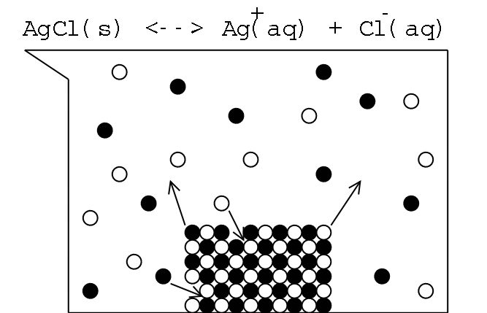

Solubility Simulation: http://phet.colorado.edu/en/simulation/soluble-salts

The solubility product constant (Ksp) is an equilibrium constant for the process of the ionic solid dissociating and dissolving. (Recall that solubility varies with temperature; *K*sp values are usually reported at 25°C.)

For example, the chemical equation for the dissolution of Ag2SO4 is:

Ag2SO4 (s)   2 Ag+ (aq) + SO42− (aq)

As we saw earlier, solids do not appear in equilibrium constants, so the denominator is omitted. This gives the following equation:

For Ag­2SO4: *K*sp = [Ag+]2 [SO42−]

*K*sp = 1.2 × 10−5 = [Ag+]2 [SO42−]

We can solve the above equation, because we know that one Ag2SO4 molecule dissolves into 2 Ag+ + 1 SO­42−. If we let [SO42−] = x, then [Ag+] = 2x, and:

Ksp = 1.2 × 10−5 = [Ag+]2 [SO42−] = (2x)2 (x) = 4x3



In other words, a 0.0144 M solution of Ag2SO4 would be saturated (at 25°C).

## Common Ion Effect

*K*sp is a physical constant for a given compound. One useful corollary of this fact is the common ion effect.

As an illustrative example, suppose we start with 1.00 ℓ of a saturated solution of Ag2SO4. As we saw on the previous page, [Ag+] = 0.0288 M and [SO42−] = 0.0144 M. However, suppose we now add 1.00 mole of Na2SO4. This brings the total [SO42−] to 1.0144 M.



Notice that [Ag+] is substantially lower than the 0.0288 M that resulted when only Ag2SO4 was present.

Note that we should really have calculated [SO42−] as an I.C.E. problem. However, if we assume that *all* of the [Ag+] in solution was removed by precipitation, this would remove all of the 0.0144 M of SO42− that was initially in solution. Using 1.00 M instead of 1.0144 M for the [SO42−] gives [Ag+] = 3.46 × 10−3 *M* instead of 3.44 × 10−3 *M*. The difference is less than 1%, which means the simplification was reasonable.

The common ion effect is a common and powerful lab technique—a high concentration of a common ion is added in order to precipitate virtually all of an ion of interest, such as removing toxic Hg2+ or Hg22+ ions from a solution before disposal.