Kinetics
Unit: Kinetics

Knowledge/Understanding:
- collision theory
- reaction rate
- rate laws
- order of a reaction

Skills:
- determine reaction order
collision theory: molecules must collide in order to react. Collision converts kinetic energy of molecules (temperature) into enthalpy (heat energy), which is used to start the reaction by breaking chemical bonds in the reactants.
reactants: the compounds consumed in the chemical reaction
products: the compounds created by the chemical reaction
intermediates: compounds produced by a reaction and consumed by a later reaction in a multi-step process.
effective collision: leads to formation of products
ineffective collision: does not lead to products
mechanism: the details of how molecules collide with how and in what order and orientation in order for the reaction to take place.
enthalpy: the sum of the kinetic and potential energy of the molecules. (Kinetic energy is the energy due to motion and is measured by temperature. Potential energy is the energy of the chemical bonds.) Enthalpy can be converted to heat, and vice-versa.
reaction coordinate: a diagram that shows energy vs. progress of a chemical reaction.

activation energy (ΔE_{act}): minimum kinetic energy needed for a collision to produce the transition state (and therefore proceed to form products).

enthalpy of reaction (ΔH_{rxn}): the difference between the enthalpy of the products and the enthalpy of the reactants. The enthalpy change is what produces or consumes heat in a chemical reaction.
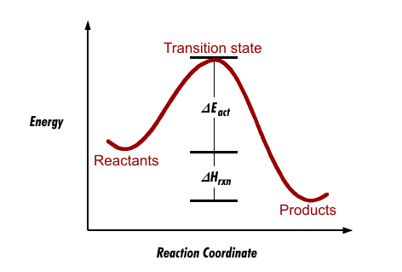

(Potential)

(Progression of Reaction)

In order for a reaction to initiate, molecular collision must occur between the reactants. Not every collision will result in a successful reaction occurring however, as two requirements must be met.

Ex: H₂ (g) + I₂ (s) → 2HI (s)

Variables that influence reaction kinetics:

- Catalysts:

- Reactant Concentrations:

- Temperature:

- Strength of Intramolecular Forces:

- Molecular Shape:

- Surface Area:

