AP Chemistry Name: ___________________
Ion/Isotope Practice Date: ____________ Blk: ____

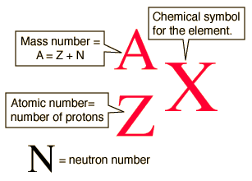

Complete the following table using the clues provided.

Element Name | Element  Symbol | Protons  (Z) | Neutrons | Atomic Mass (A) | Electrons | Charge | Isotopic Symbol
 | K |  |  |  | 18
 |  | 31 | 40
Chlorine |  |  |  |  | 18
 | Ni |  | 32 |  | 26
 |  | 78 | 119 |  |  | 2+
Selenium |  |  |  | 81 |  | 2-
 |  |  |  |  |  |  | 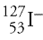

Knowledge Check
- Which is more likely to be a naturally occurring isotope of magnesium: Mg-25 or Mg-30? Explain.

- If a Martian sample of pure silver is found have a new 3rd isotope (Ag-111), what would be the new atomic mass for the element given the following percent abundance values?
Ag-107 (50.86%), Ag-109 (48.04%), Ag-111 (1.10%)

- What are the two general periodic trends we see for the formation of ions? (Hint: one has to do with cations vs anions, the other is a charge value trend)

- What is the common “rule” that most elements follow when forming ions?

