Intermolecular Forces and Name ___________________________
Solution Chemistry Review

- Use the KMT and a discussion on IMFs to explain the molecular activity of matter in its three phases: solid, liquid, and gas.

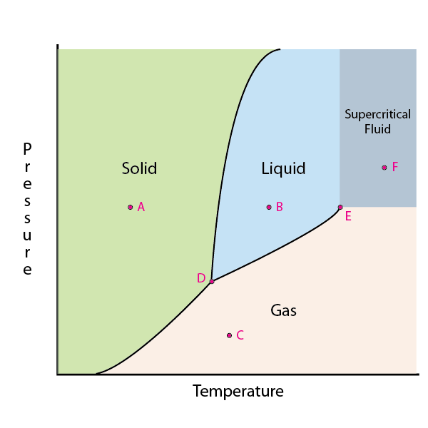
- Explain the shape of the fusion and vaporization curves below using your understandings from #1.

- Assume points A, B, C, D, E, F represent the following temperatures/pressures.
Data Point | Temperature (K) | Pressure (kPa)
A | 150 | 100
B | 325 | 100
C | 275 | 1
D | 250 | 50
E | 450 | 98
F | 550 | 150

Describe what type of matter would be observed under the following conditions:
- A sample of the substance is heated beyond 450K.

- A sample is maintained at 340K and 40kPa.

- A sample is maintained at 100kPa and 255K (assume the data point falls on the curve).

- Use molecular diagrams of H₂O to show what happens at the molecular level during a phase change from solid to liquid and from liquid to gas.

- Identify the type of bond that would occur between the elements in the following molecules and give the ionic characteristic value for the bonds.
(I = 1-exp(-0.25(EN_{A}- EN_{B})²)
- CH₃Cl

- P₂O₅

- CaO

- Explain why polarity arises across polar covalent and ionic bonds. Use a Lewis dot diagram of KBr and ammonia to support your answer.

- Explain the significance of the ΔEN values of 0.35 and 1.7.

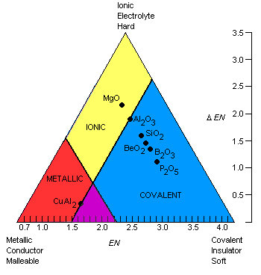
- Determine the type of bond that would occur in the following compounds according to Dr. Bodner’s triangle.

- GaBr₃

- NiPb

- SrS

- SF₂

- List the different types of intramolecular forces. Can you rank them in order of strength? How is their strength determined? If you break intramolecular forces, what type of process is matter undergoing?

- What does it mean for a molecule to be polar? What 2 requirements must be met for a molecule to exhibit polarity?

- Determine whether or not the following molecules are polar. Include Lewis Dot structures, EN calculations, partial charges, and dipoles.

- H₂S b. 2-Butene

- 2-methyl-1-propanol d. Cyclohexane

- NOCl f. Formaldehyde (CH₂O)

- List the intermolecular forces in order of increasing strength and identify the intramolecular force that causes each.

- Which would have the stronger intermolecular force? Explain your reasoning for each.
- CaCl₂ or KBr

- Ethanol or Ethylaldehyde

- Cyclopentane or Cyclohexane

- Explain how intermolecular forces account for the following characteristics:
- Boiling Point

- Surface Tension

- Solubility

- Vapor Pressure

- Explain the concept of Van der Waals forces and their importance to non-polar molecules.

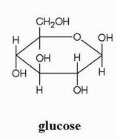
- Show how glucose would be dissolved by water at the molecular level. What intermolecular force is responsible for this dissolving process?

- Explain the phrase “like dissolves like” by discussing what would be observed after the following action takes place:

100.0mL of butane (MW = 58.12 g/mol, d = 2.48 g/mL) and 100.0mL of water (MW = 18.02 g/mol, d = 1.00 g/mL) are combined in a beaker and vigorously mixed.

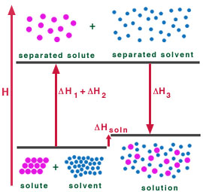
- Describe the diagrams below which depict the process of dissolving a solid solute. Use the concepts of enthalpy and entropy in your explanation.
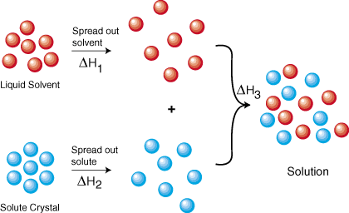

- List the factors that influence the rate of dissolution for a solute and describe why each influences dissolution.

- What factors influence the amount of solute one can dissolve in a solution?

- Define the terms saturated, unsaturated, and supersaturated solutions.

- Use the following solubility curve to determine the type of solution prepared ineach scenario.
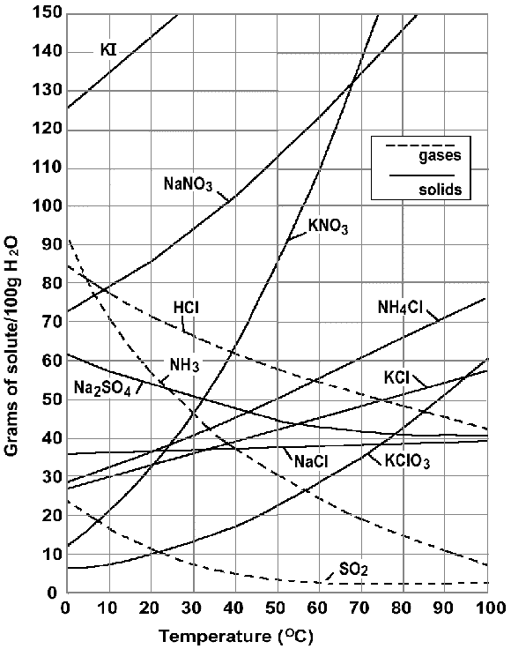
- 55g of potassium nitrate is mixed with 50.0mL of water at 60⁰C.

- 50.0g of sodium sulfate is mixed with 90.0mL of water at 10⁰C.

- 200.0g of sodium nitrate is mixed with 200.0mL of water at 30⁰C.

- 45g of potassium chlorate is dissolved in 150mL of water at 50⁰C.

- Explain why increasing temperature increases solubility of most solid solutes, but decreases solubility of gaseous solutes.

- Using Henry’s Law, determine the partial pressure of ethanol over 1000.0g of a 95% (by weight) ethanol solution. (k_{H} = 111 l•atm/mol) (assume d = 1.0 g/mL)

- Explain the concept of freezing point depression using IMF.

- An ice storm deposits 55.0kg of ice on your concaved driveway.
- Determine the freezing point depression that occurs when a 3.0kg bag of KCl is used to melt the ice. (assume the salt is spread evenly)

- Would all of the salt dissolve? Support with math.

- The salt remains on your driveway until summer, when a rain storm dumps 75.2kg of water, thus dissolving the salt on the driveway. Determine the boiling point elevation that occurs for the rain water. (assume no salt loss and the purity of the rain water)

- What would be the vapor pressure of water above the salt solution in part c?

- Relate the concepts of intramolecular forces, intermolecular forces, boiling point, equilibrium, and vapor pressure.

- What is the osmotic pressure of soda after placing 100.0mL of a 1.0M syrup solution (dissolved sugar; C₆H₁₂O₆) into 900.0mL of water at 25⁰C?

- Go back to #13 and determine which would have a higher vapor pressure and a higher melting point.

