Intermolecular Forces
Unit 11C: Types of Intermolecular Forces

Knowledge/Understanding Goals:
- different types of intermolecular forces and what causes them

Skills:
- rank attractions from strongest to weakest based on the type of intermolecular force

Notes:
intramolecular forces:
intermolecular forces:

soluble:

miscible:
Recall the 3 types of compounds:
_________: compound made of ions (metal + nonmetal), which have charges with integer values (±1 or more)
____________: compound made by sharing of electrons (usually all nonmetals),
____________: compound made of metal atoms with delocalized electrons

Types of intermolecular forces (IMF), strongest to weakest:

ion-ion: force of attraction between ions. Strength of force is based on _____________________:
Bigger charges (larger values of q) mean ________________ forces. (E.g., the attraction between a +2 ion and a −3 ion will produce a force that’s six times as strong as the attraction between a +1 ion and a −1 ion.) If charges are the same, ____________ atoms (smaller value of d) have stronger forces.
metallic bonds: metal atoms that delocalize their electrons and are held together by the “_______” of electrons surrounding them.
dipole-dipole: the force of attraction between opposing ____________ charges of two polar molecules (__________). Recall that the strength of attraction is based on the dipole moment (μ) of the molecule, given by the formula:
μ = qd
The partial charge (q ) is produced by the electronegativity difference (Δχ) between the two atoms of a polar bond.
Hydrogen bonds: The strongest type of ____________________ forces. Occurs in molecules that contain hydrogen (χ = 2.20) plus an element with an electronegativity larger than 3.0 (_____________).
The hydrogen bonds that hold water molecules together are what give water its unusual properties:
  - Water is more __________ as a liquid than as a solid.
  - Water has an unusually high ______________ (specific heat).
  - Water has a relatively high _____________ and boiling point. (Almost all covalent compounds with a molecular weight as light as 18 amu are gases.)
  - Water exhibits high _________________ and ______________________.
  - Water is known as the “______________________”.
London dispersion forces (Van der Waals forces): Random movement of electrons causes _______________ dipoles to form within molecules, causing very _____ attraction. (Named after the chemist Fritz London.)
London dispersion forces exist within all molecules, but they can only be observed when there aren’t any _____________ forces present. The strength of the London dispersion forces is determined both by the average number of intermolecular contacts (a geometric consideration) and by the strength of those contacts (an electrostatic consideration). A rule of thumb that works for questions on the AP exam is that molecules with higher molecular ________ usually have more ____________ and therefore more intermolecular contacts, which produces stronger dispersion forces.
Greater surface area =
IMFs also exist between different types of molecules, such as ion-dipole attraction, or dipole-induced dipole attraction (i.e., attraction between a dipole and a molecule that only experiences dispersion forces).
Each of these interactions would have an __________________ strength between the homogenous IMFs.

Intermolecular Force | Type of Compound | Strength
ion-ion | ionic (metal + nonmetal) | strongest
metal-metal | metallic (all metals) | ↕
hydrogen bonds  (strong dipole-dipole) | H with F, O, Cl, or N
dipole-dipole forces  (other than hydrogen bonds) | polar covalent  (all nonmetals)
dispersion | nonpolar covalent  (all nonmetals) | Weakest

IMF Effect on Physical Properties
Recall that any process that breaks intramolecular forces is a _______________________, as you are breaking chemical bonds and creating new products.
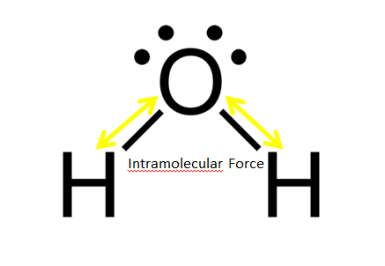
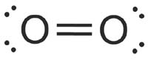
→ +

Altering intermolecular forces influences how neighboring molecules interact with each other without changing the composition of the substance. Therefore, breaking intermolecular forces results in _________________.
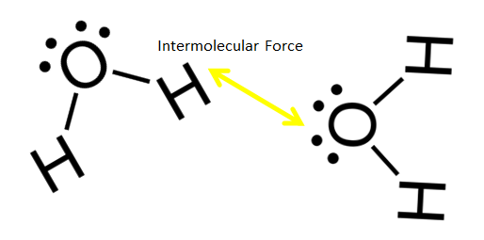

Intermolecular forces are responsible for many of the physical properties of chemical substances.
Phase changes: The only difference between the solid, liquid and gaseous phases of a substance is the ___________ of intermolecular forces keeping the particles of the substance in ___________.
Ex: Ice Water Steam

Increased strength of IMF means more ___________ is required to break the molecules out of ordered attraction =

Boiling Points:

Surface Tension, Cohesion, & Adhesion: Attraction between neighboring molecules accounts for their ability to “____________” each other to support force (________________) or to “_______” other molecules along as they move (_______________).
Ex: Hydrogen bonding of water
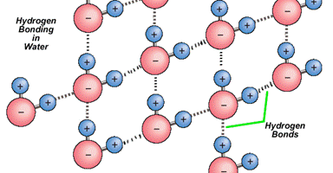
Causes:
Surface tension (sticks to _______________________)
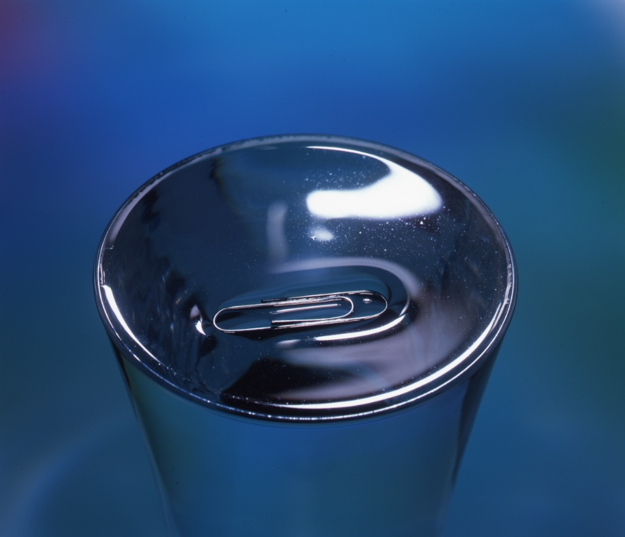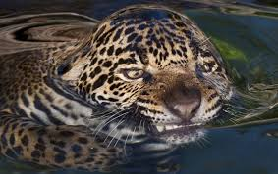

Cohesion (sticks to _________________________)
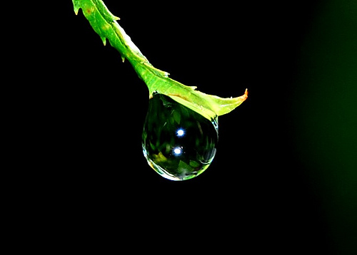
Adhesion (sticks to ______________________)
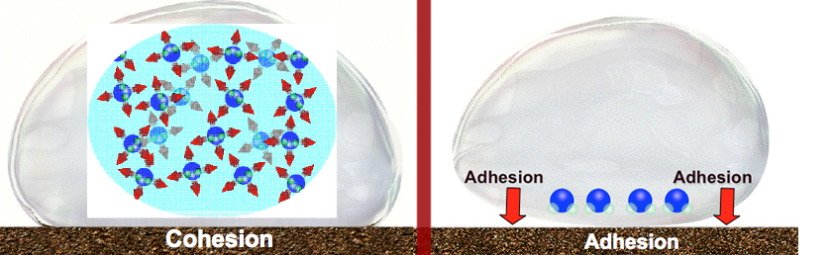
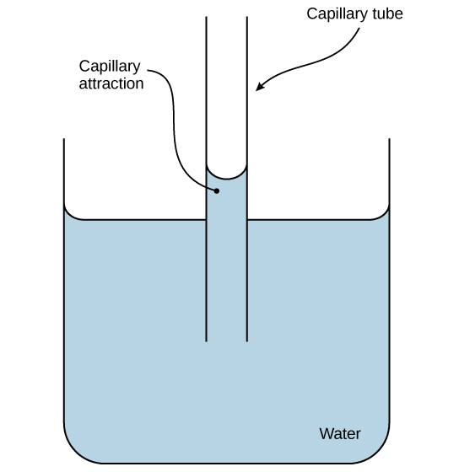

Dissolving: Because the molecules of polar liquids (especially those with hydrogen bonds) attract each other, polar liquids will:
  - _____________ other polar liquids (The two liquids are said to be _____________.)

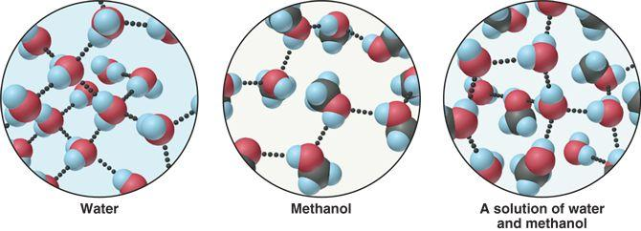

  - ___________ ionic salts (ionic compounds that can dissociate) or polar covalent molecules. E.g., NaCl dissolves in H₂O because the Na⁺ and Cl⁻ ions dissociate.)

Ex: NaCl Glucose

In general, polar liquids can dissolve ionic compounds that have relatively __________ ion-ion forces (such as ions with +1 or −1 charges). Most polar liquids cannot dissolve most ionic compounds that have _______ charges larger than or equal to ±2. (However, note that there are many exceptions to this rule!)
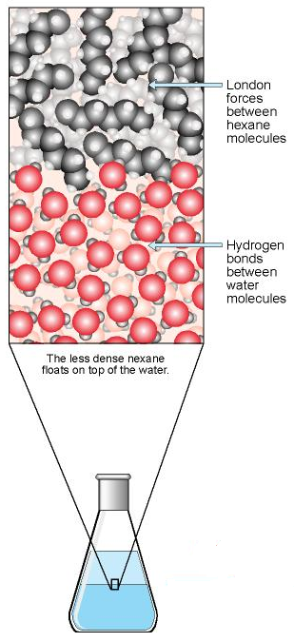
Polar liquids will not dissolve _____________ liquids or other uncharged molecules. This is because polar liquids will form dipole-dipole bonds amongst themselves, pushing non-polar liquids out into a separate _____.

If you mix a nonpolar liquid and a polar liquid (such as oil and water), the liquids will form two separate phases. The popular expression to describe this phenomenon is “_________________________.”

