Names ______________________ ______________________
Block ______ Date __________________

Intermolecular Forces Explorations

Exploration #1: Electrostatic Charge
Exploration #2: Surface Tension
Exploration #3: Evaporation
Exploration #4: Solubility
Exploration #5: Melting Point

Score ___________

Exploration #1: Electrostatic Charge
Utilize an electrostatic charge to infer molecular polarity.
Procedure:
1. Fill a buret to the 50mL mark with di-water.
2. Rub a balloon through your hair to induce an electrostatic charge.
3. Place a beaker under the buret with enough distance between the beaker and buret to fit the side of a balloon.
4. Open the buret so that a constant stream of liquid flows into the beaker.
5. Bring the balloon close to the fluid stream.
6. Repeat this procedure with ethanol and hexane.

Observations

Questions
- Draw Lewis structures for water, ethyl alcohol, and hexane. Indicate the presence of any charges and dipoles.

- Indicate the type of intermolecular force exhibited by each molecule.

- Explain your observations using the concepts of intermolecular forces and polarity.

- Hypothesize how methyl ethyl ether would behave in the presence of an electrostatic charge if analyzed. Support with a Lewis dot structure.

Exploration #2: Surface Tension
Utilize surface tension characteristics to infer molecular polarity.
Procedure:
1. Place a penny face down on the table.
2. CAREFULLY add drops of di-water on top of the penny using a transfer pipette. Your goal is to put as many drops on top of the penny without any water falling onto the table.
3. Count the number of drops that the penny was able to hold. RECORD YOUR DATA.
4. Dry the penny and have your lab partner repeat steps 1-3.
5. Repeat steps 1-4 using isopropyl alcohol.

Observations & Data

Questions
- Draw a Lewis structure for water and isopropyl alcohol. Indicate the presence of any charges and dipoles.

- Identify the types of intermolecular forces present for each molecule.

- Which liquid has a stronger IMF? Support with an explanation molecular geometry and polarity.

- Suppose you were to try this experiment with acetone. How would you expect the result to be in comparison to the water and isopropyl alcohol? Support your answer with reasoning.

- Hypothesize the results of an experiment performed with tap water rather than di-water. Test your hypothesis and explain the results.

- Explain why we don’t see “water scooters” or “water striders” are not found on brackish (salty) bodies of water.

Exploration #3: Evaporation
Utilize evaporation rates to infer molecular polarity.
Procedure:
- Clear bench top of all items. Mentally divide your section of benchtop in half.
- Wipe one half with a moist paper towel while your partner wipes the other half with a paper towel wet with acetone. Time how long it takes for each half to dry.
- Obtain a hot plate, enough aluminum foil to cover the heating surface, a small beaker, a bottle of acetone and a bottle of distilled water. Cover the top of the hot plate with aluminum foil. Crimp the edges so that the foil is secured to the top of the hot plate.
- Turn the hot plate on and wait about 5 minutes for it to warm up. With no overlap, place a small drop each of olive oil, tap water, distilled water and acetone on the foil. Time how long it takes for each drop to evaporate. Stop at 5 minutes. Carefully observe any residue from the drops.

Observations & Data

Questions
- Draw the Lewis dot structures for water, isopropyl alcohol, and olive oil (oleic acid hydrocarbon with a carboxyl group; C₁₈H₃₄O₂ ). Indicate the presence of any charges and dipoles.

- Explain your observations for evaporation from the table top with IMFs.

- Discuss the molecular properties that contribute to the difference in boiling point between olive oil and acetone.

- Explain why hydrocarbons such as hexane and gasoline are stored in air-tight containers.

- Which would be more efficient for usage in cooking mac & cheese, di-water or tap water? Explain your reasoning.

Exploration #4: Solubility
Utilize solubility to infer molecular polarity.
Procedure:
- Add approximately 0.1g of NaCl to approximately 25mL of water, ethanol, acetone, and hexane.
- Stir. Observe.
- Add approximately 0.1 g of salicylic acid to approximately 25mL of water, ethanol, acetone, and hexane.
- Stir. Observe.
Observations & Data

Questions
- Rank the four liquids in terms of molecular size, from smallest to largest.

- Rank the four liquids in terms of strength of IMF from smallest to largest.

- Rank the four liquids in terms of boiling point.

- Which factor seems more important in determining boiling point, size, or IMFs. Explain.

- What force(s) are most important for determining the properties of NaCl?

- Which solvents showed significant NaCl solubility? Why do you believe this is?

- What force(s) are most important for determining the properties of salicylic acid?

- Which solvents showed significant salicylic acid solubility? Why do you believe this is? (hint: This is the structure of salicylic acid)
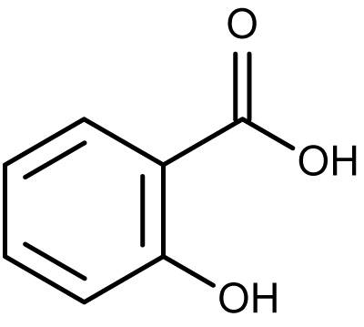

- Consider the structures below:
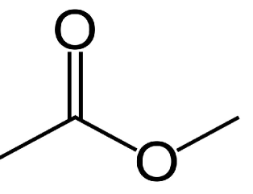
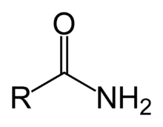

Structure A Structure B

a. Determine the formula and name of these two structures.

b. Which of the two structures would you expect to have a higher boiling point? Explain.

c. Which of the two structures would you expect to have a higher salt solubility? Explain.

Exploration #5: Melting Point
Utilize melting point to infer molecular polarity.
Procedure:
- Obtain bottles of 3 unknown solids.
- Cut three 2x2 squares of aluminum foil and form an umbrella-shaped boat out of each.
- Place a pea-sized scoop of each unknown into separate aluminum boats.
- Heat the boats on a heat screen over the Bunsen burner such that each is receiving equal exposure to the flame.
- Record your observations and data related to melting the unknowns. Remove each boat from the heat source as soon as they melt, DO NOT BURN THEM.
Observations & Data

Questions
- The unknowns are a mixture of ionic compounds, non-polar covalent compounds, and polar covalent compounds. Identify each based upon your experimental results and support your choices with IMF reasoning.

- Which would have a higher boiling point? Explain with Lewis dot structures.
- propyl methyl ether or ethyl methyl ether

- sulfur dibromide or selenium difluoride

- arsenic triiodide or ammonia

- isopropyl alcohol or 1-propanol

