Orbital Hybridization

Knowledge/Understanding:
- the meanings of the terms “hybrid orbital” and “hybridization”

Skills:
- determine the hybridization of the central atom in simple molecules
orbital:

hybrid orbital:

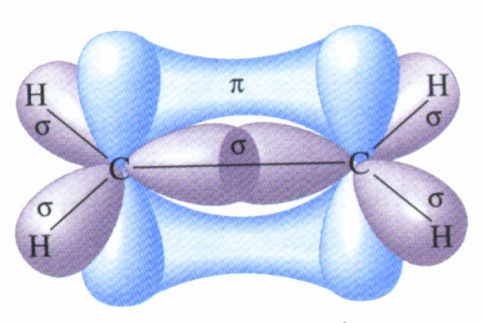
When atoms form covalent bonds, the electrons move to the space between the two atoms. The space where the bonding electrons are is still called an ____________, even though its shape is now _______________from the shapes of the orbitals in the s, p, d, or f sub-levels of a single atom.

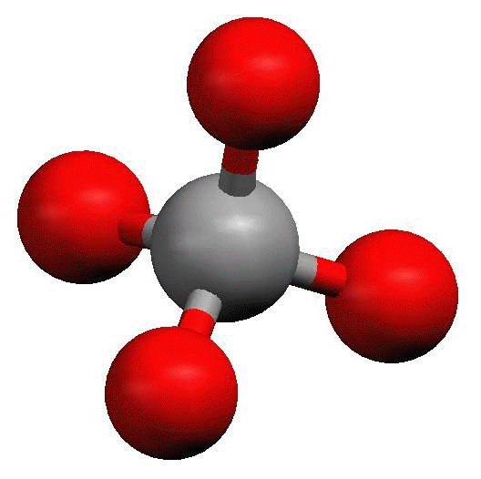
Recall that molecules with _______ electron cloud regions (tetrahedral, trigonal pyramidal, or bent with single bonds, like H₂O), are based on a __________________ VSEPR shape:

The shape of the orbitals is the shape determined by the four electron clouds. It looks like the following:

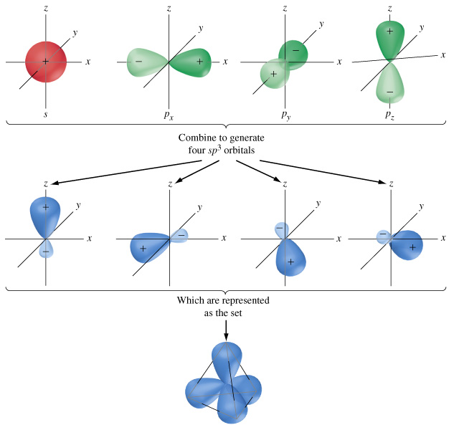
If we wanted to create four orbitals like this one by reshaping the s and p orbitals of an atom’s valence shell, we would need to start with _____ s and _____ p orbitals. We therefore call this bonding orbital an ______________________, because it looks like a hybrid between the one s and three p orbitals.

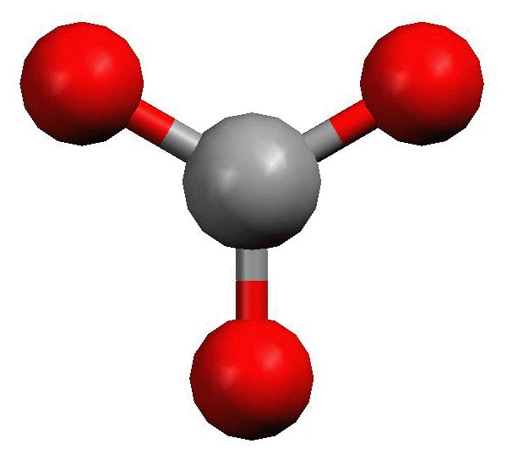
Similarly, molecules with ___________ electron clouds are based on the trigonal planar VSEPR shape:

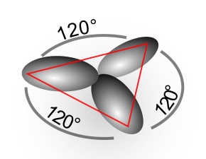
This hybrid orbital would come from ____ s and ____ p orbitals, and would be called an ______________________________:

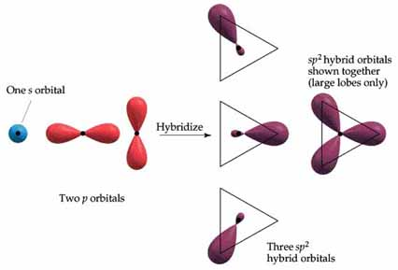
Finally, the hybrid orbital from _____ s and ______ p orbital is indeed called an ____________________________________.

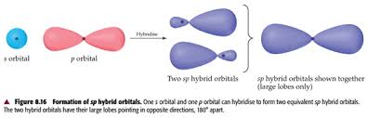

VSEPR Shapes for Hybrid Orbitals
Hybridization | VSEPR Shape(s)
sp³ | tetrahedral,  trigonal pyramidal,  bent (104.5°)
sp² | trigonal planar,  bent (118°)
sp | linear

Ex : What would be the hybridization around carbon in a molecule of ethane
(C₂H₆)?

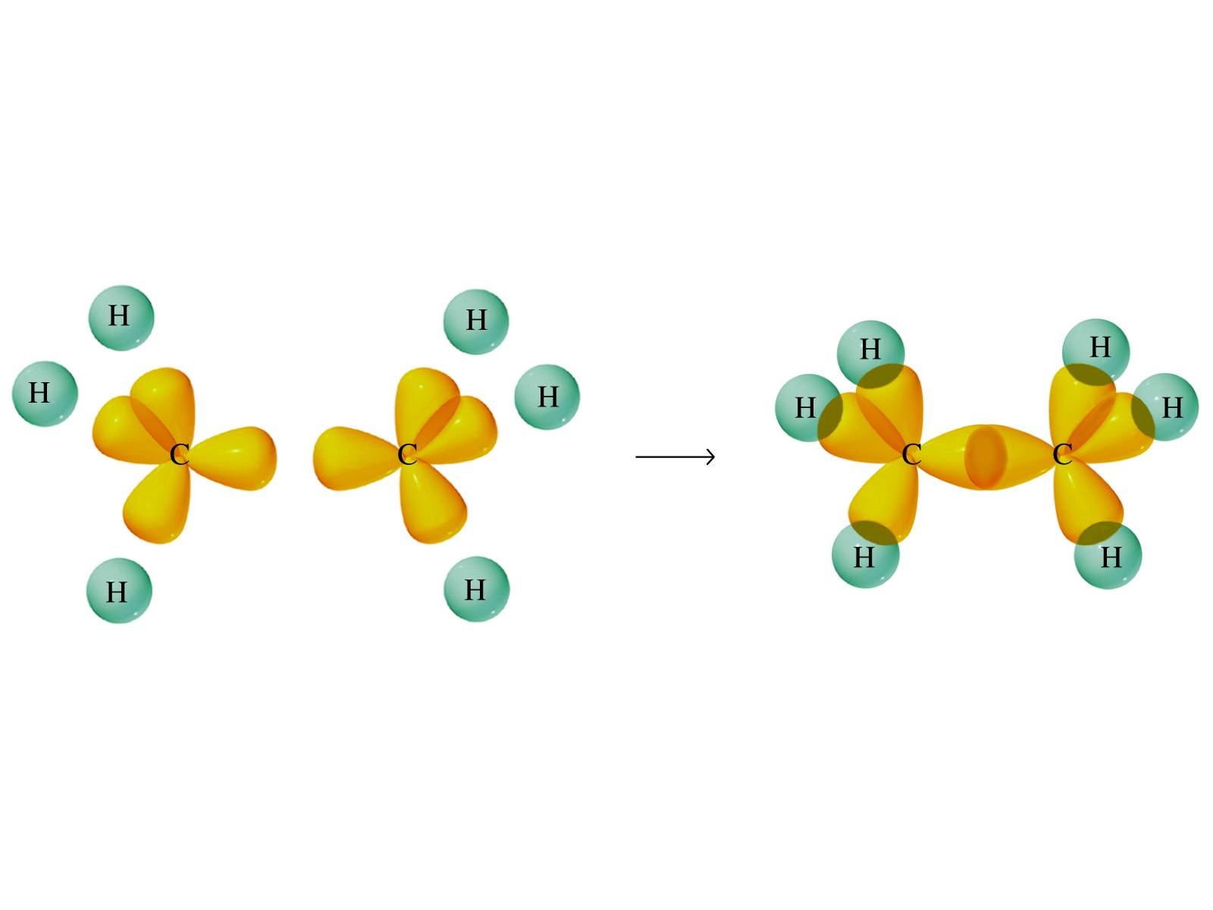

Ex : What would be the hybridization around carbon in a molecule of ethyne
(C₂H₂)?

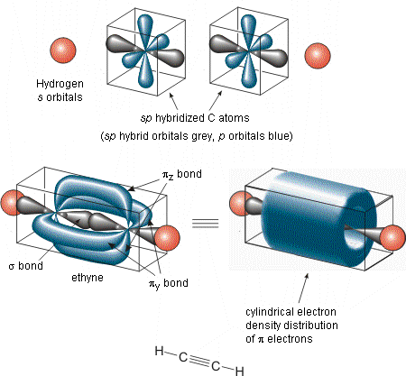

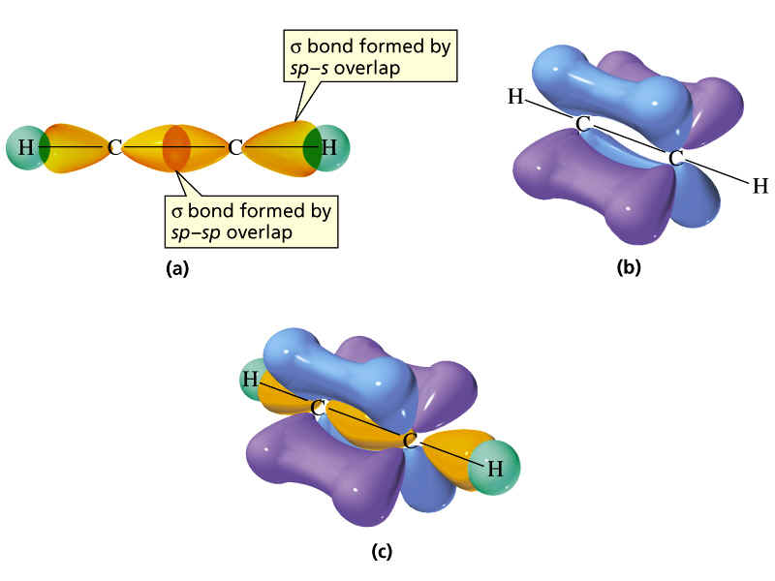

What you need to know about geometry (Notes 10D and 10E):
- Be able to draw Lewis dot structures with proper formal charges
- Identify simple molecular geometry shape:
  - Names (linear, bent, trigonal planar, trigonal pyramidal, tetrahedral)]
  - Hybridization (sp, sp², sp³)
- Identify expanded octet molecular geometry shape:
  - Names (trigonal bipyramidal, see-saw, T-shaped, octahedral, square pyramidal, square planar)
- Relative bond angles
  - Lone pairs repel more than bonded pairs = smaller bond angles

  - 2 sets of lone pairs repel more than 1 set = smaller bond angles

  - Double bond repels more than a single bond = uneven bond angles

- Double/Triple bonds limit bond rotation

