Orbital Hybridization

Knowledge/Understanding:
- the meanings of the terms “hybrid orbital” and “hybridization”

Skills:
- determine the hybridization of the central atom in simple molecules
orbital: the name for one of the theoretical spaces (probability map) around an atom’s nucleus where electrons are.
hybrid orbital: an orbital whose shape is a hybrid of the shapes of different types of orbitals (such as a cross between an s-orbital and a p-orbital).

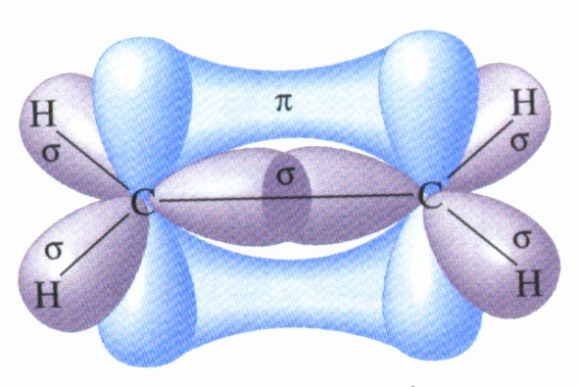
When atoms form covalent bonds, the electrons move to the space between the two atoms. The space where the bonding electrons are is still called an orbital, even though its shape is now different from the shapes of the orbitals in the s, p, d, or f sub-levels of a single atom.

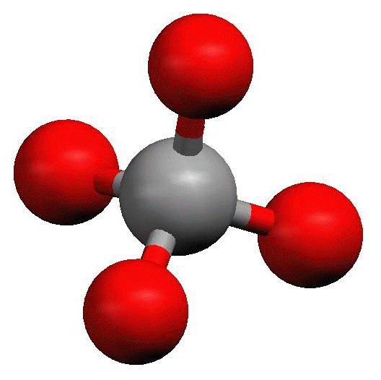
Recall that molecules with four electron cloud regions (tetrahedral, trigonal pyramidal, or bent with single bonds, like H₂O), are based on a tetrahedral VSEPR shape:
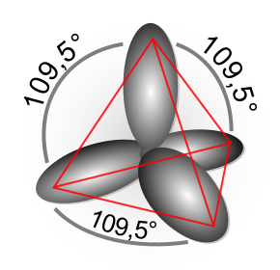

The shape of the orbitals is the shape determined by the four electron clouds. It looks like the following:

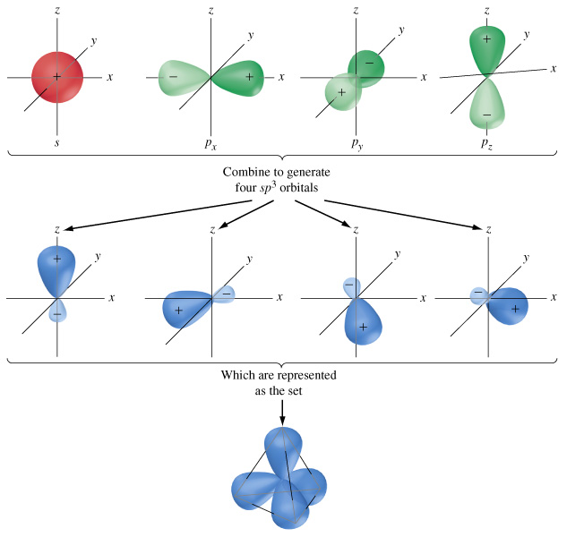
If we wanted to create four orbitals like this one by reshaping the s and p orbitals of an atom’s valence shell, we would need to start with one s and three p orbitals. We therefore call this bonding orbital an sp ³ hybrid orbital, because it looks like a hybrid between the one s and three p orbitals.

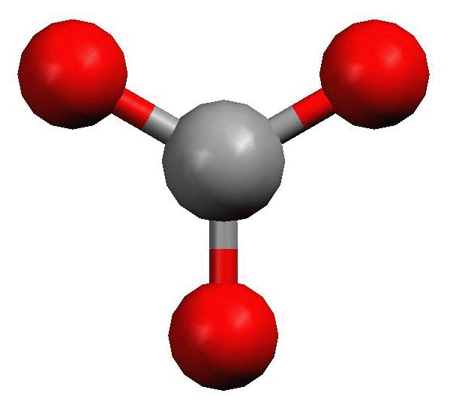
Similarly, molecules with three electron clouds are based on the trigonal planar VSEPR shape:

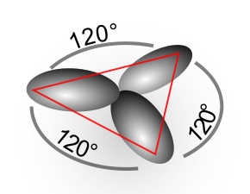
This hybrid orbital would come from one s and two p orbitals, and would be called an sp ² hybrid orbital:

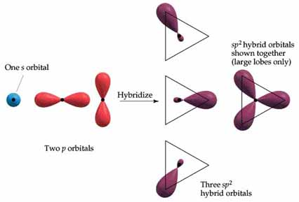
Finally, the hybrid orbital from one s and one p orbital is indeed called an sp hybrid orbital.

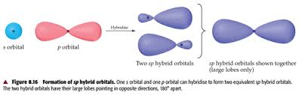

VSEPR Shapes for Hybrid Orbitals
Hybridization | VSEPR Shape(s)
sp³ | tetrahedral,  trigonal pyramidal,  bent (104.5°)
sp² | trigonal planar,  bent (118°)
sp | linear

Ex : What would be the hybridization around carbon in a molecule of ethane
(C₂H₆)?

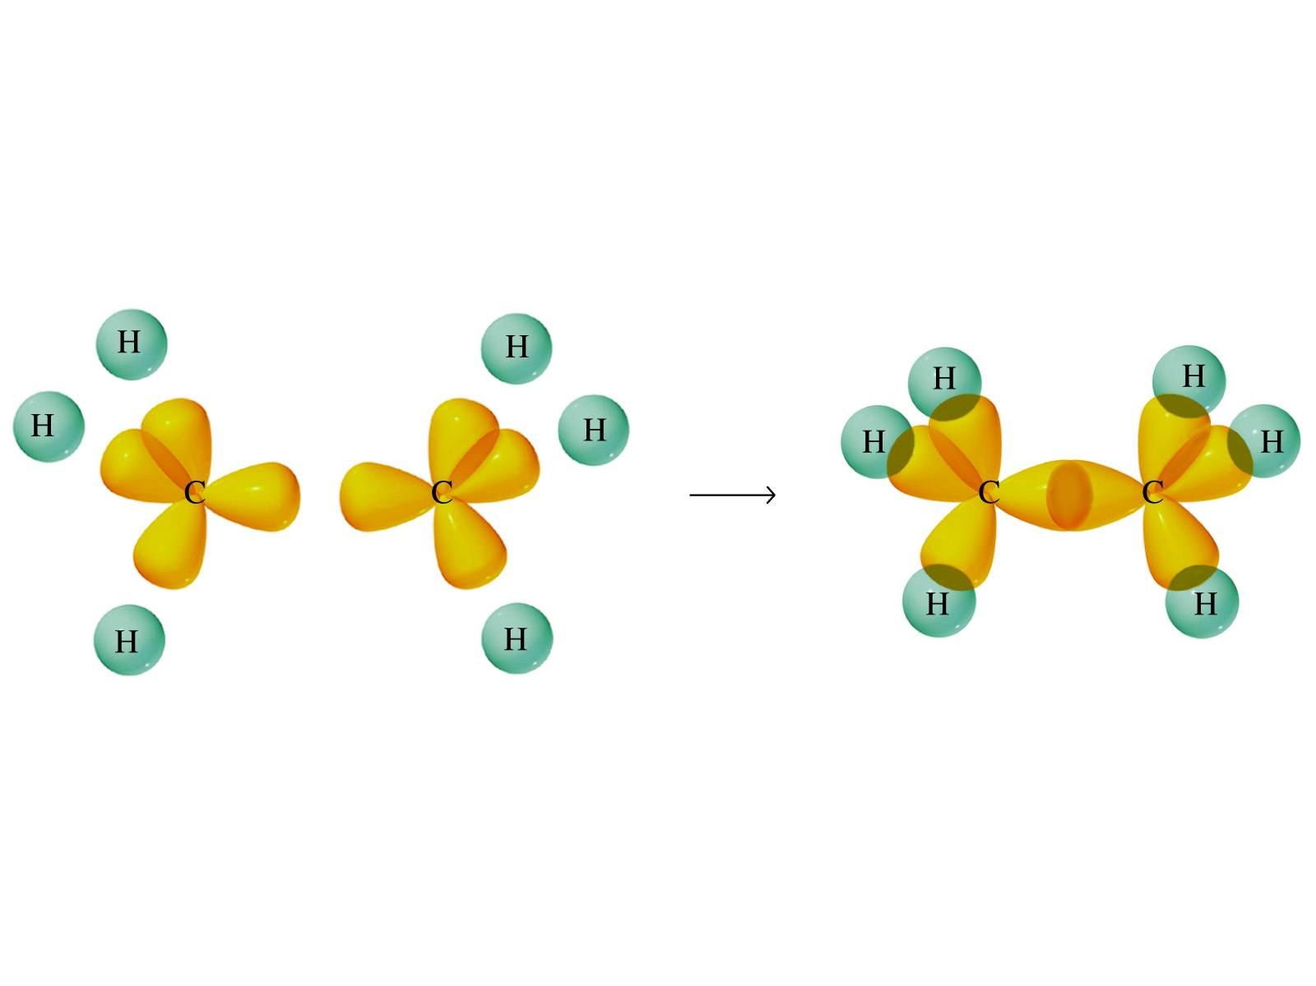

Ex : What would be the hybridization around carbon in a molecule of ethyne
(C₂H₂)?

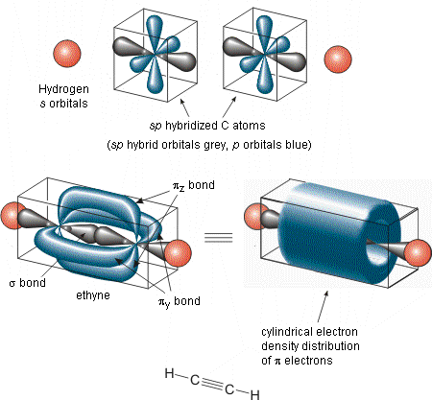

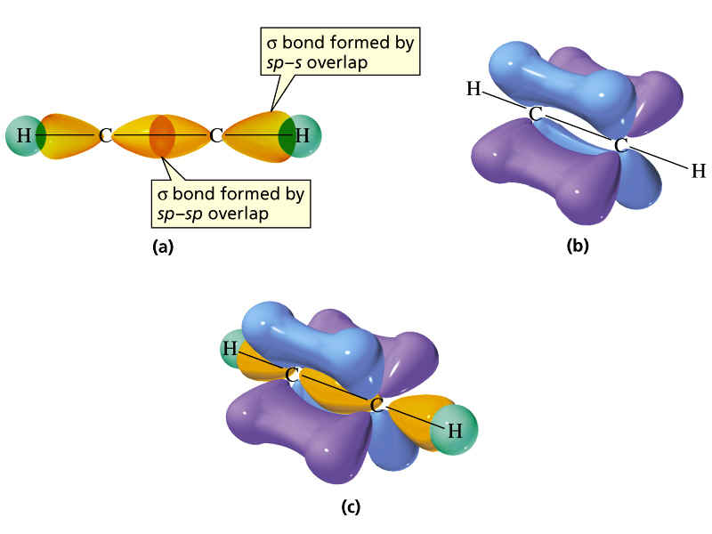

What you need to know about geometry (Notes 10D and 10E):
- Be able to draw Lewis dot structures with proper formal charges
- Identify simple molecular geometry shape:
  - Names (linear, bent, trigonal planar, trigonal pyramidal, tetrahedral)]
  - Hybridization (sp, sp², sp³)
- Identify expanded octet molecular geometry shape:
  - Names (trigonal bipyramidal, see-saw, T-shaped, octahedral, square pyramidal, square planar)
- Relative bond angles
  - Lone pairs repel more than bonded pairs = smaller bond angles

  - 2 sets of lone pairs repel more than 1 set = smaller bond angles

  - Double bond repels more than a single bond = uneven bond angles

- Double/Triple bonds limit bond rotation

