# Thermodynamics

**Unit 16D:** Gibbs Free Energy

### Skills:

* calculate Δ*G* from thermodynamic data

### Notes:

Because chemical energy can exist as enthalpy and entropy, the chemist J. Willard Gibbs defined the total free energy of a system as the combination of enthalpy and entropy. The formula for Gibbs free energy is:



The change in Gibbs free energy is therefore:



At standard state (usually 25°C and 1 atm), this becomes:



Note that because of the *T* in the *T* Δ*S* term, Δ*G°* is very temperature-dependent. This means that unless your system is at the same temperature as the standard state in your thermodynamic tables (*i.e.,* 25°C and 1 atm), *you must calculate ΔG° using ΔH°, ΔS°, and the actual temperature!*

Also, remember that S° values are usually expressed in , whereas  values are usually expressed in . Therefore, when plugging the values into Gibbs’ equation, you will have to convert J to kJ for your entropy value.

As with enthalpy and entropy, 

## Spontaneity

A reaction is spontaneous if Δ*G* < 0, and is not spontaneous if Δ*G* > 0.

Note that “spontaneous” does not necessarily mean that the reaction will start by itself—many reactions need a certain amount of activation energy to get them started. However, once a spontaneous reaction has started, it will proceed on its own to equilibrium. Furthermore, spontaneous reactions are those that go **downhill** in energetic terms. In other words, *the final state has a lower energy content than the initial state*

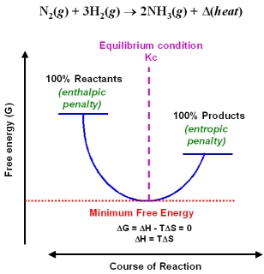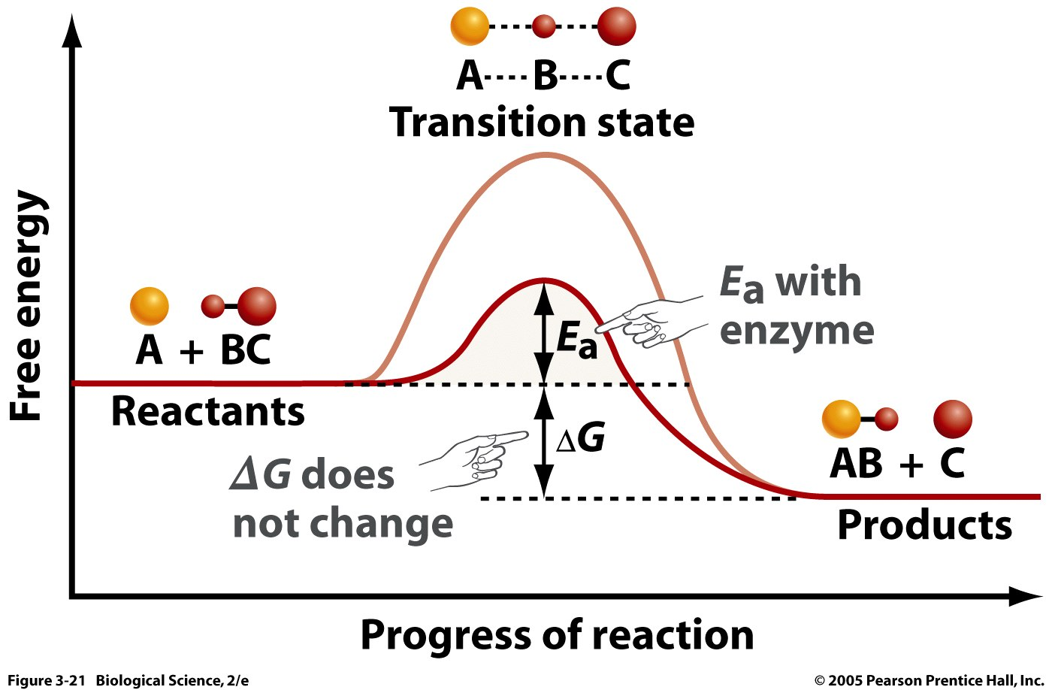

If Δ*G* = 0, that means the reaction is at equilibrium.

A common type of AP question is a qualitative evaluation of spontaneity based on the signs of Δ*H* and Δ*S* :

|  |  |  |
| --- | --- | --- |
| Δ*H* | Δ*S* | Spontaneous? |
| negative | positive | always |
| positive | negative | never |
| positive | positive | only at high temperatures |
| negative | negative | only at low temperatures |

For reactions in which Δ*H* and Δ*S* are either both positive or both negative, spontaneity is dependent upon the temperature of your system. You can solve for the temperature at which the reaction becomes spontaneous by setting Δ*G* = 0, which means Δ*H* =*T*Δ*S* .

## Free Energy and Equilibrium

As you may recall, for a chemical reaction of the form:



the equilibrium constant  where [A], [B], *etc.* are the equilibrium concentrations of substances A, B, *etc.*

When the concentrations of products and reactants are roughly equal, *Keq* = 1 and Δ*G* = 0.



The relationship between *Keq* and Δ*G* is:

*ΔG°* = −*RT* ln *Keq (Only applicable at equilibrium)*

where *T* is the temperature (Kelvin), and *R* is the gas constant. (If *ΔG°* is in kJ/mol, then the value of .)

Note that a *ΔG°*  value of −20 kJ would correspond to a *Keq* of over 3,000 at 25°C, which would mean that less than 0.03% of the reactants would remain. From this, we obtain a rule of thumb that allows us to assume that any reaction with *ΔG*  ≤ −20 kJ goes to completion, and any reaction with *ΔG*  ≥ +20 kJ does not occur.

For the same reaction, when not at equilibrium, we define the reaction quotient  where [A], [B], *etc.* are the instantaneous (non-equilibrium) concentrations of substances A, B, *etc.*

For this non-equilibrium reaction:

*ΔG* = *ΔG°* + *RT* ln *Q*

## Coupled Reactions

Under some circumstances, a reaction with a positive *ΔG* (i.e., a nonspontaneous reaction) can be coupled with another reaction with a negative *ΔG.* When this happens, the *ΔG* for the overall process is the sum of the *ΔG* values for each of the steps. (This is exactly like a Hess’s Law calculation.)

Biological organisms have evolved to take advantage of these coupled reactions in order to carry out processes for which a significant step has a positive *ΔG.* One example is that the energy produced by oxidation of glucose is coupled with the reaction to produce ATP from ADP and phosphate.

1. C6H12O6 (aq) + 6 O2 (g) → 6 CO2 (g) + 6 H2O (ℓ) *ΔG°* = −2,870 kJ
2. ADP (aq) + HPO42− (aq) + 2 H+ (aq) → ATP (aq) + H2O (ℓ) *ΔG°* = +31 kJ

You may remember from biology that oxidation of 1 mole of glucose is coupled with production of 38 moles of ATP from ADP.

*ΔG°* = −2,870 + 38 (+31) = -1,692 kJ

When the cells need energy later, the ATP is converted back to ADP and HPO42− releasing 31 kJ of energy per mole of ATP consumed.

ATP (aq) + H2O (ℓ) → ADP (aq) + HPO42− (aq) + 2 H+ (aq)  *ΔG°* = -31 kJ