Electrochemistry Practice Name ________________________

Block _____

1. Using the half-reactions given, answer the questions below:

Half – Reaction E° (V)

* + - 1. Ce+4(aq) + e- 🡪 Ce+3(aq) +1.61
      2. Ag+(aq) + e- 🡪 Ag(s) + .80
      3. Hg2+2(aq) + 2e- 🡪 2Hg(l) + .79
      4. Sn+2(aq) + 2e- 🡪 Sn(s) - .14
      5. Ni+2(aq) + 2e- 🡪 Ni(s) - .25
      6. Al+3(aq) + 3e- 🡪 Al(s) - 1.66

a. Which metal in the table is most likely to be oxidized in a galvanic cell? ___________

b. Which metal in the table is most likely to be reduced in a galvanic cell?__________

c. Will Sn spontaneously reduce Ag+ to Ag? _________

d. Will Hg spontaneously reduce Sn+2 to Sn? _________

2. Using the reduction table in #1, answer the following:

a. If reactions (1) and (2) are added together as a redox reaction, which do you think will proceed as a reduction and which as an oxidation? Support with a standard potential calculation.

b. If reactions (4) and (5) are added together as a redox reaction, which do you think will proceed as a reduction and which as an oxidation? Support with a standard potential calculation.

c. Explain your reasoning behind your answers to a & b.

d. Write a balanced equation for the reaction leading to the maximum positive potential.

3. Assume that you assemble an electrochemical cell based on the half reactions:

Ce3+(aq) / Ce4+(aq) and Sn(s) / Sn2+(aq).

Answer the following questions:

1. Write the balanced equation for the reaction that occurs spontaneously.
2. Which species was oxidized? ___________________
3. Which species was reduced? ______________________
4. Diagram the cell. Label all parts.
5. You want to plate tin onto the Sn electrode, explain how you could allow for this to happen using the cell above.





4. Which electrode will lose mass and which one will gain mass. Explain.

5. Does oxidation or reduction occur at the cathode?

6. Which of the following statements is/are correct.

(a) Electrons flow through the wire towards the zinc electrode

(b) Electrons flow through the wire towards the tin electrode

(c) Na+ ions flow through the salt bridge towards the zinc half-cell

(d) Na+ ions flow through the salt bridge towards the tin half-cell

(e) The standard potential of the cell is -0.90V

(f) The standard potential of the cell is +0.62V

7. Nicotine adenine dinucleotide (NAD) is involved in redox chemistry during cellular respiration. The reduced form of NAD is written as NADH and the oxidized form is written as NAD+. The standard reduction reaction and potential of NAD is given by:



The NAD redox reaction occurs with each of the following reactions, as shown:



Write the overall reaction for the spontaneous change of NAD. Is NAD reduced or oxidized in this reaction?

2015 Exam Question





Metal-air cells are a relatively new type of portable energy source consisting of a metal anode, an alkaline electrolyte paste that contains water, and a porous cathode membrane that lets in oxygen from the air. A schematic of the cell is shown above. Reduction potentials for the cathode and three possible metal anodes are given in the table.

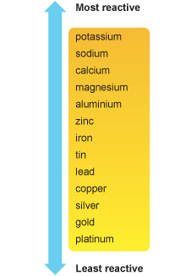9. Electrolysis

1. Use the half-reactions and the reactivity series provided to write a balanced equation for the reaction that would occur if aluminum is placed into a silver nitrate solution. Explain your reasoning.

Half – Reaction E° (V)

1. Ag+(aq) + e- 🡪 Ag(s) + .80
2. Al+3(aq) + 3e- 🡪 Al(s) - 1.66
3. 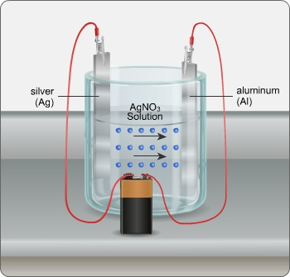A cell is constructed as shown. If a piece of aluminum is placed into the silver nitrate solution, will it be plated by silver? If yes, explain why. If no, explain what must be done to cause plating to occur in the silver nitrate cell.
4. Calculate the following for the plating of 100.0 g of silver onto the aluminum electrode.
5. Coulombs of electricity necessary to deposit the silver from the AgNO3.

1. How many minutes will take to plate out the silver using a current of 3.450 amp.