Intermolecular Forces
Unit 11A: Bond Polarity

Knowledge/Understanding Goals:
- what it means for a bond or molecule to be polar
- dipole moment

Skills:
- calculate the electronegativity difference between atoms in a bond
- identify polar bonds & polar molecules
- draw polarity arrows indicating polarity of a molecule

Notes:
polar: anything with two opposite sides that are opposite with respect to something. For example, a battery is polar because it has a positive and negative end.
polar bond: an ionic or covalent bond that has opposite full or partial charges on each side (one side partially positive and one side partially negative), because of donation or unequal sharing of electrons.
Ex: The bond between H and Cl in HCl

The bond is polar because hydrogen and chlorine share a pair of electrons, but the sharing is not equal. Chlorine has an electronegativity of 3.0, but hydrogen has an electronegativity of only 2.1. This means the electrons spend more time with chlorine than with hydrogen.
One way to show a polar bond is by labeling atoms in the molecular structure with charges, if they form as a result of polar bonds.
Ionic Bonds (Metal & Non-Metal, ΔEN >1.7)
Recall that ionic bonding, or e- donation, results in full charges forming on the e- donor (+) and recipient (-). Complete donation occurs due to the large difference in electronegativity (EN) between the elements.
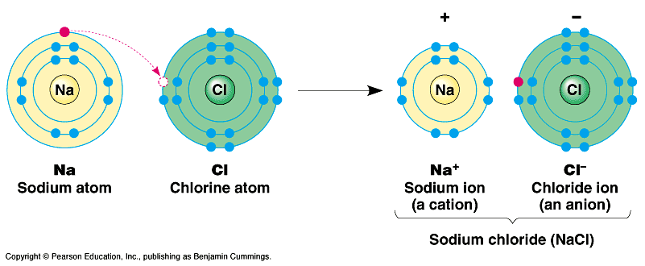

Ionic bonds are not true bonds; however, as the elements in an ionic compound are only held together due to electrostatic charge attraction (coulombic force) between the ions. No orbitals are overlapping or hybridizing.

Ionic compounds still clearly exhibit polarity though, since one side of the molecule has an overall positive charge and the other an overall negative charge.

Covalent Bonds (Non-Metal & Non-Metal, ΔEN = 0-1.7)
In the case of polar covalent bonding (ΔEN = 0.35-1.7), e- are shared unevenly between the two atoms due to a lower difference in EN. The e⁻ are still shared as neither atom has a strong enough EN to completely steal the shared e⁻.
Uneven sharing results in only partial charges forming on each atom involved in the polar covalent bond. The lower-case Greek letter “delta” (δ) is used to mean “partial”. A partially positive charge would be shown as δ+ and a partially negative charge would be shown as δ−, as in the following example:

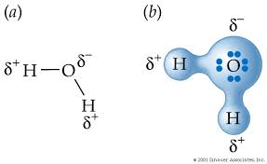

In the above example, hydrogen has a partial positive charge due to its lower EN (2.1), and oxygen has a partial negative charge due to its higher EN (3.5).

Another common way uneven e- sharing, or partial charges, is shown is with electron density maps.

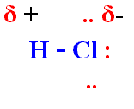
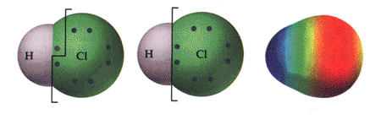

An electron density map shows regions of high electron density (partial negative regions) in red and low electron density (partial positive regions) in blue. In the map for HCl, it shows that the shared e- in the polar covalent bond are actually spending most of their time closer to chlorine’s nucleus than hydrogen’s.

Electron density maps will be especially helpful in determining the polarity of molecules over all, rather than just bond polarity.

In the case of non-polar covalent bonding (ΔEN = 0-0.35), e- are shared evenly between the two atoms due to an equal (or nearly equal) EN. The e⁻ are shared as neither atom has a strong enough EN to hog or steal the shared e⁻.
Even sharing results in no charges forming on either atom involved in the non-polar covalent bond.
Ex: solid iodine (I₂)
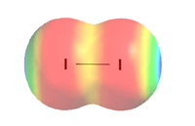

Common Bond Summary
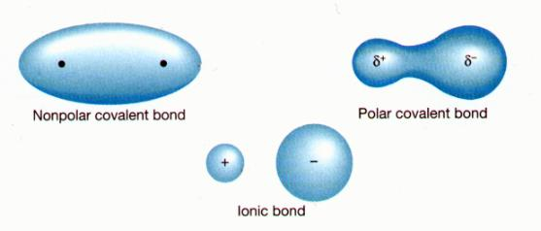

Metallic Bonds
Metallic bonding occurs between metal atoms. Instead of sharing or donating electrons, the valence electrons of metals create what is commonly referred to as a “sea of electrons” which are delocalized or not associated with any one atom/nucleus.

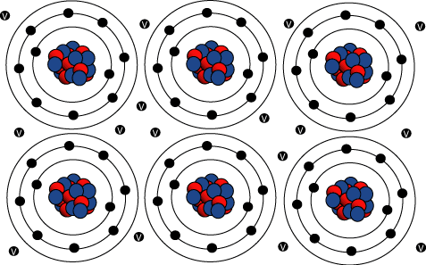

The delocalized electrons are responsible for many of the unique characteristics held by pure metals and metal alloys
- Conductors: delocalized electrons can “flow” in a certain direction through the matter, creating an electrical current
- Malleable: possible for the atoms to slide past each other when the metal is deformed instead of fracturing

Bond Character
bond character: what a bond acts like, based on the difference between the electronegativities (Δχ) of the two elements. The larger the difference, the greater the extent to which the electrons are associated with one element more than the other.
Linus Pauling invented the concept of electronegativity, and developed a formula for calculating bond character based on the electronegativity difference. According to Pauling, the ionic character of a bond is given by the formula:
where I is the ionic character (expressed as a fraction, 0 ≤ I ≤ 1) and Δχ is the difference between the electronegativities of the two elements participating in the bond. The following is a graph of Pauling’s formula:
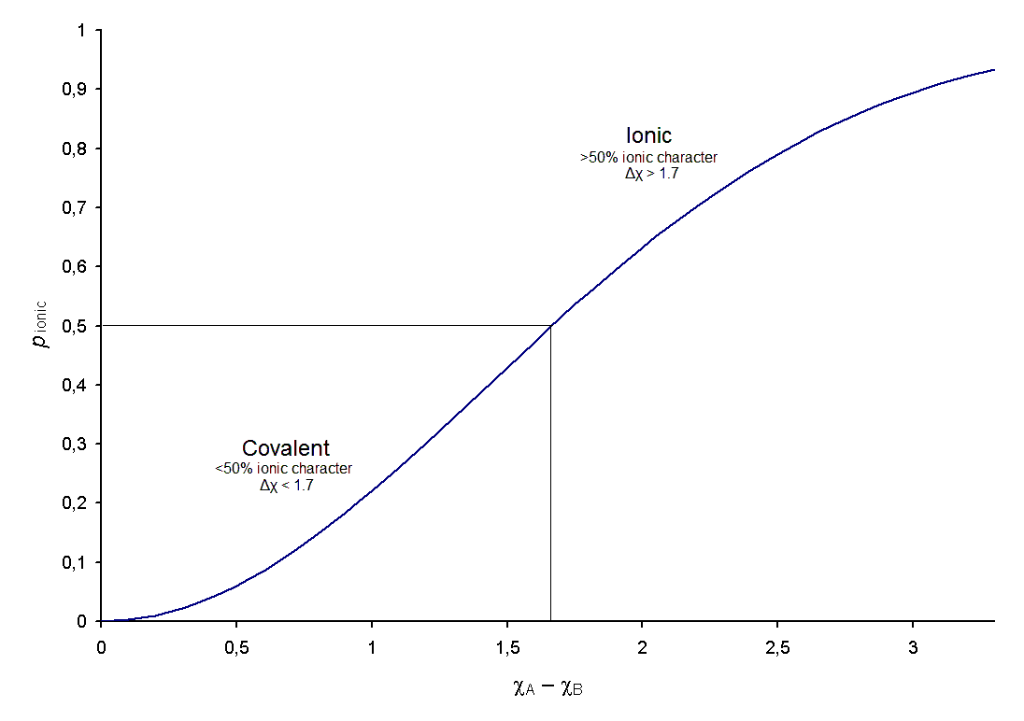
As a first approximation, Pauling’s formula can be used to predict bond character, based on the electronegativity difference:
Electronegativity  Difference (Δχ) | Ionic  Character | Bond  Character
0.35 or less (C—H) | < 0.03 | nonpolar covalent
between 0.35 and 1.7 | 0.03–0.5 | polar covalent
1.7 or more | > 0.5 | ionic
Note that the value 0.35 for a “nonpolar” bond is somewhat arbitrary. Chemists have observed that a C—H bond behaves as a nonpolar bond, so the C—H bond (3% ionic character and Δχ = 0.35) is chosen to be the upper limit for a nonpolar bond.

What is important to note, however, is that the only bond that has one true character is a perfectly non-polar covalent bond between two identical atoms. All other bonds are described based upon the type of bond they behave “more like”, or the one they share the most bond character with.
All other bonds exhibit some ionic character, with no bonds being 100% ionic.
Ex: Francium (0.7) & Fluorine (4.0) Carbon (2.5) & Nitrogen (3.0)
I = 1 – e ^{(-Δx^2/4)} I = 1 – e ^{(-Δx^2/4)}
I = 1 – e ^{(-(4.0-0.7)^2/4)} I = 1 – e ^{(-(3.0-2.5)^2/4)}
I = 1 – 0.065 = 93.4% I = 1 – 0.939 = 6.1%

Bond Type
bond type: how a chemical bond actually behaves. The bond type is affected by bond character (electronegativity difference), but also by the nature of the materials themselves (electronegativity values). In general, we consider three types of chemical bonds:
- covalent bond: between two nonmetals
- ionic bond: between a metal & nonmetal
- metallic bond: between two metals
In 1941, the Dutch chemist Anton van Arkel represented these three types of chemical bonds as the vertices of a triangle:
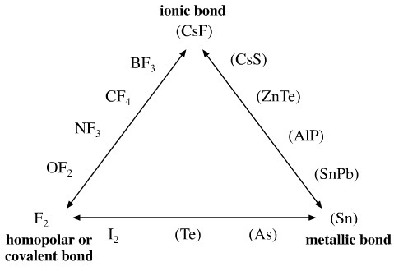
van Arkel claimed that the bond type of a binary compound could be predicted by the compound’s position on the above triangle.
In the 1990s, several papers were published describing various methods of quantifying the relationships in van Arkel’s triangle. The following diagram, based on Pauling electronegativities, is from Dr. George Boner at Purdue University:
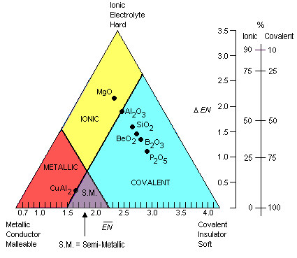
In this diagram, the horizontal axis () is the average of the electronegativities of the two elements in a binary compound.
The vertical axis (ΔEN) is the difference between the two electronegativities.

Examples:
The compound MgO is made from magnesium (χ = 1.31) and oxygen (χ = 3.44).
The point (2.38, 2.13) on the graph on the preceding page falls within the “ionic” region, correctly predicting that magnesium oxide is an ionic compound.

The compound P₂O₅ is made from phosphorus (χ = 2.19) and oxygen (χ = 3.44).
The point (2.82, 1.25) on the graph on the preceding page falls within the “covalent” region, correctly predicting that phosphorus pentoxide is a covalent compound.

- Where is the polar vs non-polar covalent region of the triangle?

Collectively, all of these types of bonds are categorized as intramolecular forces.

Intramolecular forces are the forces which hold a molecule together.
- “intra” = within
- “intramolecular” = within the molecule

As we have seen, the strength of intramolecular forces, or bond strength, is represented by bond dissociation energies.
- There is no general rule for the relative strength of intramolecular forces (ionic vs covalent bonds), as many ionic and covalent bonds have very similar dissociation energies.
  - Ionic bonds are often misconceived as the strongest bonds due to their high difference in electronegativity, but some of the strongest substances on Earth (like diamonds: network of C-C bonds) are covalently bound.

Any process which overcomes (breaks) intramolecular forces is a chemical reaction since bonds are being broken, which allows for atoms to rearrange and form new bonds.

