AP Chem Unit Rewiew
Kinetics, Equilibrium, Electrochemistry, Thermodynamics, Nuclear Chemistry

Kinetics
- Discuss the steps required for a reaction to initiate. Include a molecular diagram and energy change diagram to support your answer.

- Show how an energy diagram for a spontaneous reaction would look versus a nonspontaneous reaction. (hint: high energy to low energy is favorable)

- Demonstrate how rate changes over the course of a 150 second reaction by comparing the initial reaction rate of the decomposition of nitrogen dioxide to the final given the following data.
Time (sec) | NO₂ (mol/L)
0 | 0.0100
50 | 0.0079
100 | 0.0065
150 | 0.0055
- Graph the data from question 3 and show how you can determine the instantaneous rate at any given moment using concentration versus time data. Explain the directional slope.

- Write the decomposition reaction for nitrogen dioxide, producing nitrogen monoxide and oxygen. Discuss how the rates of production of nitrogen monoxide and oxygen will compare.

- Initial reaction rates allow us to ignore the influence of products on reaction rates. Write the initial rate law for the following reactions.
- CH₃CHO (g) ----> CH₄ (g) + CO (g)
- CO(g) + NO₂ (g) -----> CO₂ (g)+ NO (g)
- 2H₂ (g) + 2NO (g) ----> N₂ (g) + 2H₂O (l)
- 2Mg (s) + O₂ (g) ----> 2MgO(s)
- Given the following reaction data for reaction “c” from #6.: determine the rate constant and the overall rate order of reaction “c” from #6.
[H₂] | [NO] | Rate
0.1 | 0.1 | 1.0x10⁻¹
0.2 | 0.1 | 2.0x10⁻¹
0.1 | 0.4 | 4.0x10⁻¹

- Determine the rate constant
- Determine the overall rate order
- Predict the rate of the reaction if you start under the conditions [H₂] = 2.5M and [NO] = 0.95M

- Determine the rate order and rate constant for the following reaction:
[Co(NH₃)₅Cl]²⁺ (aq) + H₂O (l) → [Co(NH₃)5H₂O]³⁺ + Cl₂

Exp. Initial Concentration (mol/L) Initial rate of [Co(NH3)5Cl]+2 mol/(L• min)
1.0 × 10⁻³ 1.3 × 10⁻⁷
2.0 × 10⁻³ 2.6 × 10⁻⁷
3.0 × 10⁻³ 3.9 × 10⁻⁷
1.0 × 10⁻³ 1.3 × 10⁻⁷

- Explain how the manipulation of experimental conditions can allow us to determine the pseudo rate law for a reaction.

- Write out the integrated rate laws for zero order, first order and second order reactions and identify how to determine the rate constant from concentration over time data.

- The decomposition of N₂O₅ in the gas phase was studied at constant temperature.
2 N₂O₅(g) → 4 NO₂(g) + O₂(g)
The following results were collected:
[N₂O₅] Time (s)
0.1000 0
0.0707 50
0.0500 100
0.0250 200
0.0125 300
0.00625 400

Determine the rate law and calculate the value of k.

What is the concentration of N₂O₅(g) at 600 s?

At what time is the concentration of N₂O₅(g) equal to 0.00150 M ?

- Butadiene reacts to form its dimer according to the equation
2 C₄H₆ (g) → C₈H₁₂ (g)

The following data were collected for this reaction at a given temperature:
[C₄H₆] Time (± 1 s)
0.01000 0
0.00625 1000
0.00476 1800
0.00370 2800
0.00313 3600
0.00270 4400
0.00241 5200
0.00208 6200

a. What is the order of this reaction? Explain. Sketch your graph as part of your explanation.
Write the rate law expression:

b. What is the value of the rate constant for this reaction?
- What are the rules that a proper chemical mechanism for a reaction must meet?

- Discuss the influence a proposed mechanism has on the rate law for a reaction if the first reaction is the slow step, versus when the second step is the slow step. Support your discussion with an example problem from your notes.

- Explain the role of catalysts and show their influence on a reaction using an energy versus reaction progression diagram.

Equilibrium
- Discuss what chemical equilibrium represents by comparing the forward and reverse reactions for the ionization of water into hydronium and hydroxide ions.

- Write the general equilibrium expression for a reaction aA + bB → cC + dD

- Rewrite the equilibrium expression given the following phases. Explain your answer.
aA (aq) + bB (s) → cC (g) + dD (l)

- Use your understanding of the equilibrium expression to discuss the following:
- What does a large K value (K>1) represent?
- What does a small K value (K<1) represent?
- What does it mean when K = 1?

- Compare and contrast K_{p} and K_{c}.

- C (s) + 2H₂O (g) ↔ CO (g) + H₂ (g) has a value of Kc = 2.5 x10^{-6.}
- What is the Kc value for 2C (s) + 4H₂O (g) ↔ 2CO (g) + 2H₂ (g)?

- What is the Kp of the original reaction at 32C?

- Given the following equations:
H₂O (g) + CO (g) ↔ H₂ (g) + CO₂ (g) Kc = 4.8
FeO (s) + CO (g) ↔ Fe (s) + CO₂ (g) Kc = 0.48

Calculate the Kc value for:
Fe (s) + H₂O (g) ↔ FeO (s) + H₂ (g)

- For the reaction: 2 NO₂ (g) ↔ N₂O₄ (g)
At equilibrium [N₂O₄] = 0.25 M & [NO₂] = 0.175 M. Calculate Kc.

- Compare and contrast the equilibrium constant (K) and the reaction quotient (Q). Discuss what K>Q, K<Q, and K=Q represent.

- For the equation: N₂ (g) + O₂ (g) ↔ 2NO (g), Kc = 0.527. If your mix equal volumes of 0.20M N_{2,} 0.35M O_{2,} and 0.10M NO, are you at equilibrium? If not, which in direction will the reaction progress and what will be the final concentrations for each species?

- Discuss the affect each scenario will have on the equilibrium of the reaction from #10.
- Adding NO(g)
- Adding heat (assume this is an exothermic reaction)

- Write the general equilibrium expression for the following:
- Dissociation of a strong acid
- Dissociation of a strong base
- Dissociation of a weak acid
- Dissociation of a weak base
- Reaction of a strong acid and a strong base
- Reaction of a strong acid and a weak base
- Reaction of a weak acid and a strong base

- Identify the type of neutralization each titration curve represents
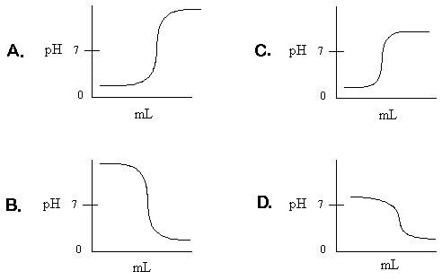

- Discuss what the half-way point and equivalence point represent regarding acid/base concentration and pH/pKa.

- A titration of a 25mL of nitric acid requires 54mL of 0.40M ammonia (pK_{b} = 4.74) to reach the equivalence point. What is the concentration of the nitric acid?

- Calculate the pH of solution upon mixing 15mL of 0.20M potassium hydroxide and 25mL of 0.40M acetic acid (pKa = 4.75)

- Review how to calculate the pH of a weak acid/strong base titration at any given time:
- Before adding any base
- Before the equivalence point
- At the equivalence point
- After the equivalence point

Electrochemistry
- Write out a general equation that shows oxidation and one that shows reduction.

- Identify the species being oxidized and the species being reduced in the following reaction and write out the proper half-reactions:
Sn²⁺(aq) + 2Fe³⁺(aq) → Sn⁴⁺(aq) + 2Fe²⁺(aq)

- Write out the complete balanced equation for the following redox reaction:
MnO₄– (aq) + C₂O₄^{2–} (aq) → Mn²⁺(aq) + CO₂(g)

- Discuss the difference between galvanic and electrolytic cells.

- Draw a diagram of an electrochemical cell. Identify the reaction that occurs at the anode and the reaction that occurs at the cathode, the charge each electrode takes on, the change in mass expected at each electrode, and the direction of electron flow.

- Determine the standard cell potential for the following reaction:
Sn²⁺(aq) + 2Fe³⁺(aq) → Sn⁴⁺(aq) + 2Fe²⁺(aq)

- Calculate the change in cell potential if the tin solution is 0.35M and the iron solution is 1.34M at a temperature of 39C.

- Is the cell in #7 spontaneous? Would it be a galvanic or electrolytic cell? Support your answer with a discussion of both cell potential and Gibbs free energy.

- How much voltage can be obtained from a concentration cell of magnesium in a magnesium sulfate solution if one half-cell has a concentration 0.21M and the other a concentration of 3.1M?

- Review the construction of common rechargeable and alkaline batteries and the chemical reactions that take place in each.

Thermodynamics
- A 5.0g sample of ice and a 5.0g sample of steam receive 250kJ of thermal energy. Which will experience a greater change in entropy?

- Discuss how entropy is related to the second law of thermodynamics and spontaneity.

- List the general characteristics of a chemical reaction or physical change that can be used to qualitatively infer the entropy of the system.

- Review the ways enthalpy (∆H) can be determined for a reaction or process overall.
- Bond dissociation energy
- Summation of enthalpy of formation values (∆H_{f})
- Hess’s law

- Review how entropy (S) can be determined for a reaction or process overall.
- ∆S = q/T = -∆H/T
- Summation of ∆S values

- Review how free energy (G) can be determined for a reaction or process overall.
- Summation of ∆G values
- Hess’ Law
- ∆G = ∆H-T∆S
- ∆G = ∆G° + RTlnQ
- ∆G° = -RTlnK
- ∆G° = -nFE°

- Discuss how nonspontaneous reactions can be driven by coupling them with other reactions and the importance of this process to biological systems.

- Explain the difference between spontaneous and instantaneous. Relate the terms to free energy and activation energy.

- Predict the spontaneity of the following reactions by looking up their standard enthalpy and entropy values.
- KOH (aq) + HBr (aq) →H₂O (l) + KBr (aq)
- H₂O (l) + CO₂ (g) → CH₄ (g) + O₂ (g)
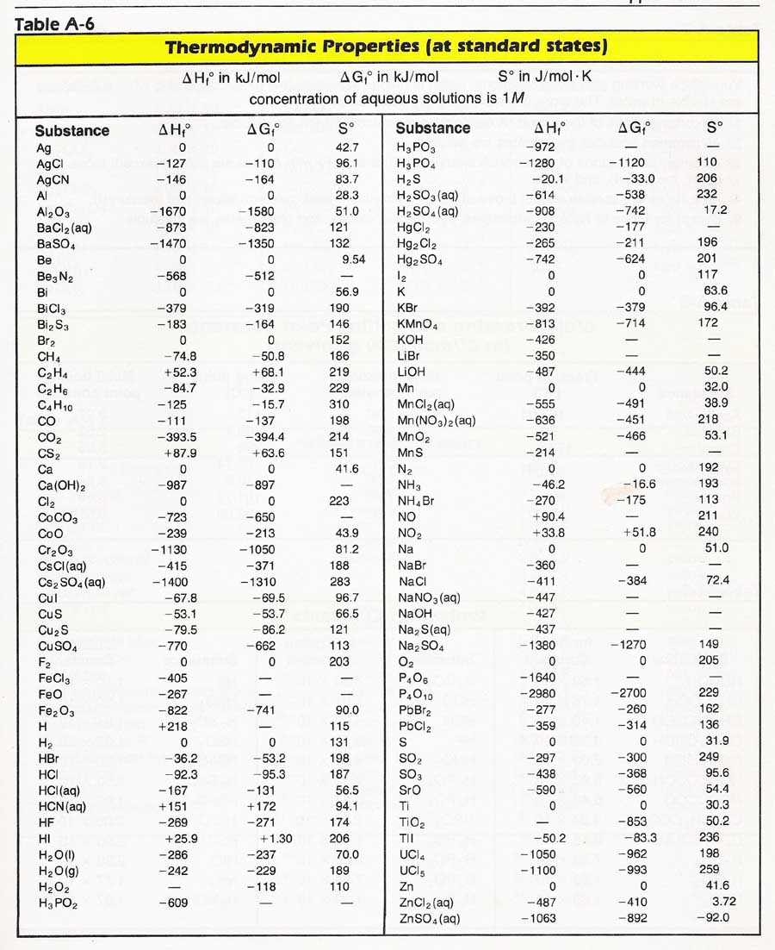
- Show how an increase in temperature influences free energy for the reactions in #9.

Nuclear Chemistry
- List and describe the types of nuclear decay.

- Review isotopic symbols and the information they provide. For example:

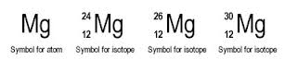

- Use isotopic symbols to show how a Uranium-238 isotope changes when undergoing alpha decay followed by beta decay.

- Explain why gamma decay is almost always happens simultaneously with alpha and beta decay.

- Discuss the processes of fission and fussion and use Einstein’s equation to explain how large amounts of energy can be gained from these processes.

- The half-life of tritium (³H) is 12.3 years. What mass of tritium will be left after 35 years following a nuclear accident if 75 mg is released?

- Relate the concepts of half-life, radioactivity, and stability.

- Be able to discuss how elements formed during the formation of the universe and why radioactive isotopes are now rare.

