### Unit 7: Atomic Theory

### Unit 7b – Quantum Mechanical Model and Electron Configurations

### Knowledge/Understanding:

* how electron configurations represent the quantum states of all of the electrons in an atom

### Skills:

* write the ground-state electron configuration for any element on the periodic table
* relate the quantum state to the orbital notation electron configuration
* predict & explain apparent exceptions to the aufbau principle

As we saw in the last packet, Bohr’s model was expanded upon with the help of Schrödinger’s wave equation. While treating each electron as a unique wave of energy, probability maps were defined to predict where electrons are likely to be found around the nucleus.

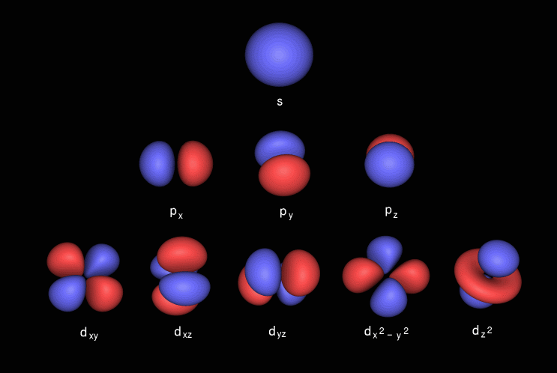

Each of these probability maps represents an orbital, which can hold 2 electrons. Orbital overlap: <https://www.youtube.com/watch?v=sMt5Dcex0kg>

These orbitals make-up sublevels, each of which has a different shape (s, p, d, f) and size depending upon which sublevel and energy level (1, 2, 3, 4, etc) it is found in.

Sublevel # of Orbitals Max # of Electrons

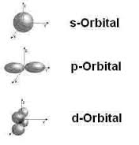 s 1 2

p 3 6

d 5 10

f 7 14

*Example:* A 2p sublevel is part of the 2nd energy level (n=2), it is made up of

3 p-shaped orbitals (hour-glass), and could hold up to 6 electrons

Hierarchy of energy levels, sublevels, orbitals, and electrons

These values are described as the 4 quantum values of the Quantum Mechanical Model: energy level (n), sublevel (ℓ), orbital (mℓ), and electron (ms).

The following chart, called the AUFBAU diagram, shows the relative amounts of energy that the electrons in each sublevel have. (Lowest energy is at the bottom, and highest energy is at the top.)

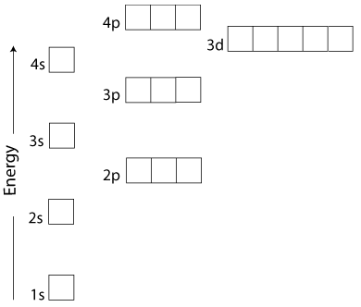

This can be confusing, because the energy levels overlap. For example, notice that the 3*d* sub-level is higher in energy than the 4*s* sub-level.

This means that the electrons will fill sub-levels in the following order:

1s, 2s, 2p, 3s, 3p, 4s, 3d, 4p, ...

But how do you predict the order of sublevel energy if not given this diagram?

The following “road map” shows the order in which sub-levels are filled, from lowest to highest energy:

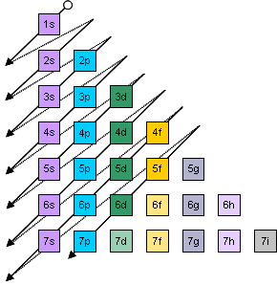

To read this map, start at the top and follow the arrows diagonally. The arrow leads you through the sub-levels in order, from lowest to highest energy. The arrow goes through 1*s* first, then 2*s*, then 2*p* & 3*s*, then 3*p* & 4*s*, then 3*d*, 4*p*, & 5*s*, and so on.Some people find it easier to just use the periodic table as the “road map”:

As you move through the elements in order by atomic number, you are moving through the sub-levels from lowest to highest energy.

Remember that the *“s”* sub-levels start with 1*s*, the *“p”* sub-levels start with 2*p*, the *“d”* sub-levels start with 3*d*, and the *“f”* sub-levels start with 4*f*. The caveats are:

* The 3*d* sub-level is in row 4, right after 4*s*.
* The 4*f* sub-level is in row 6, right after 6*s*.

## Writing Electron Configurations

*An element has electrons that correspond with each of the available quantum states, from the beginning of the periodic table (where hydrogen is located) up to where that element is located.*

If we were to represent an electron as an arrow, we could represent two electrons in a 1s sub-level like this: . The 1s sub-level has one orbital, which is represented by the one blank. The two electrons are represented as arrows.

Why do the arrows point in opposite directions?

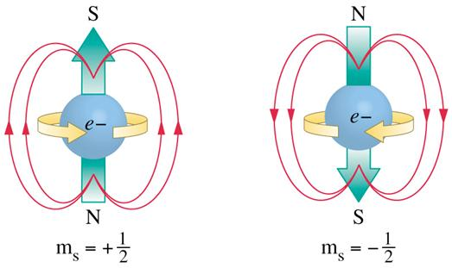

In order to allow 2 similarly charged particle to occupy the same theoretical space, the electrostatic repulsive force must be over-come. It is theorized that the electrons spin in opposite directions, creating opposing magnetic poles. The opposite pole attraction is enough to counteract the electrostatic repulsion.

Because two electrons sharing an orbital have opposite spins, we represent them with one arrow pointing up and the other arrow pointing down. The two quantum states associated with the two electrons in 1s would be:

{n = 1; ℓ = 0; mℓ = 0; ms = +½} and {n = 1; ℓ = 0; mℓ = 0; ms = -½}.

**Quantum State Values**

n (energy level) = 1, 2, 3, 4, 5, etc

ℓ (sublevel) = 0 (s), 1 (p), 2 (d), 3(f)

mℓ (orbital) = - ℓ to + ℓ

0 (s)

-1, 0, 1 (p)

-2, -1, 0, 1, 2 (d)

-3, -2, -1, 0, 1, 2, 3 (f)

ms (electron) = +½ or -½

We could represent five electrons in a 2p orbital like this: .

The 2p sub-level has 3 orbitals, represented by the 3 blanks. Two of those orbitals have two electrons in them, and the third one has only one electron.

1. What would be the quantum state of the one electron in the 3rd orbital?
2. What would be the quantum state of the second electron in the second orbital?

Answers: 1) {n = 2; ℓ = 1; mℓ = 1; ms = +½} 2) {n = 2; ℓ = 1; mℓ = 0; ms = −½}

We could represent all 13 of the electrons in aluminum like this:



This diagram shows the electron configuration of aluminum.

The quantum states represented are:

{n = 1; ℓ = 0; mℓ = 0; ms = +½}, {n = 1; ℓ = 0; mℓ = 0; ms = -½},

{n = 2; ℓ = 0; mℓ = 0; ms = +½}, {n = 2; ℓ = 0; mℓ = 0; ms = -½},

{n = 2; ℓ = 1; mℓ = −1; ms = +½}, {n = 2; ℓ = 1; mℓ = −1; ms = -½},

{n = 2; ℓ = 1; mℓ = 0; ms = +½}, {n = 2; ℓ = 1; mℓ = 0; ms = -½},

{n = 2; ℓ = 1; mℓ = +1; ms = +½}, {n = 2; ℓ = 1; mℓ = +1; ms = -½},

{n = 3; ℓ = 0; mℓ = 0; ms = +½}, {n = 3; ℓ = 0; mℓ = 0; ms = -½}, and

{n = 3; ℓ = 1; mℓ = −1; ms = +½}

electron configuration: a description of which levels and sub-levels the electrons in an element are occupying.

Notice that we have to show *all three* of the orbitals (blanks) in the 3*p* sub-level, even if some of those orbitals don’t have any electrons in them.

ground state: when all of the electrons in an atom are in the lowest-energy sublevel that has an available “slot”.

Pauli Exclusion Principle: every electron in an atom has a different quantum state from every other electron. In plain English, this means that *something* has to be different about each electron, whether it’s the level, sub-level, which orbital it’s in, or its spin.

aufbau principle: in the ground state, each electron in an atom will occupy the lowest available energy state. In plain English, this means that you start with the lowest sub-level (1*s*) and work your way up until you’ve used up all the electrons.

Hund’s Rule: electrons don’t pair up in orbital until they have to. (This is kind of like siblings not wanting to share a room if there’s an empty room available.)

For example, the electron configuration for nitrogen would be:

X

Wrong: 

☺

Right: 

If you don’t need to draw every electron, you can use a shorter form, in which you just write the level and sub-level, and use a superscript for the number of electrons in the sub-level.

For example,  would become 1s2, and  would become 2p6.

The electron configuration for aluminum would go from the orbital notation version:



to the “standard” version:

1s2 2s2 2p6 3s2 3p1

The shorter version can still get tediously long for elements with a lot of electrons.

For example, what would the electron configuration for gold (Au) be?

To shorten this even more, you’re allowed to use the *last* previous noble gas as an abbreviation for all of the electrons through the end of that row.

In our example, gold (Au) is in the 6th row of the periodic table, Xe would be the last previous noble gas:

This means we’re allowed to start from xenon (Xe) at the end of the previous (5th) row, and add on the parts that come after Xe. This gives us:

1s2 2s2 2p6 3s2 3p6 4s2 3d10 4p6 5s2 4d10 5p6 6s2 4f14 5 d9

Noble gas configuration: [Xe] 6s2 4f14 5d9

This notation is called the noble gas configuration, because the elements in the last column are called the noble gases.

## Apparent Exceptions to the Aufbau Principle

Atoms are the most stable when their electrons are the most evenly distributed within the atom’s energy levels and sub-levels. This means that elements with completely filled principal (numbered) energy levels are the most stable.

* The “noble gases” (the last column of the periodic table) already have all of their principal energy levels completely filled with electrons. This makes them very stable, because they do not need to react with other atoms to get their electrons into a more stable configuration. This is why noble gases almost never react with anything.
* Other elements gain, lose, or share electrons (in chemical reactions) in order to end up with electron configurations that are like the nearest noble gas on the periodic table.

Atoms with *p*, *d*, and *f* sub-levels that are exactly half full are more stable than atoms with slightly more or fewer electrons in their *p*, *d*, and *f* sub-levels. This makes those atoms slightly more stable (and therefore less reactive) than other atoms.

For example:

Nitrogen ([He] 2s2 2p3), which has an exactly half-filled 2*p* sub-level, is chemically less reactive than oxygen ([He] 2s2 2p4).

Manganese ([Ar] 4s2 3d5), which has an exactly half-full 3*d* sub-level, is chemically less reactive than iron ([Ar] 4s2 3d6).

In fact, elements with a *d* or *f* sub-level that is one electron away from being half full will “borrow” one electron from the nearest *s* sub-level, because the half-filled s and *d* or *f* sub-level is a more stable configuration than the stable, full *s* sub-level and unstable, partially full *d* or*f*.

For example:

Chromium“borrows” one of its 4*s* electrons to make its 3*d* sub-level exactly half full.

Predicted:

Actual:

Similarly, copper “borrows” one of its 4*s* electrons to make its 3*d* sub-level completely full.

Predicted:

Actual:

This borrowing phenomenon explains why the octet rule you learned in Gen Chem was not applied to the transition metals.

Practice

1. Write the full and short-hand (noble-gas) configuration for iron.

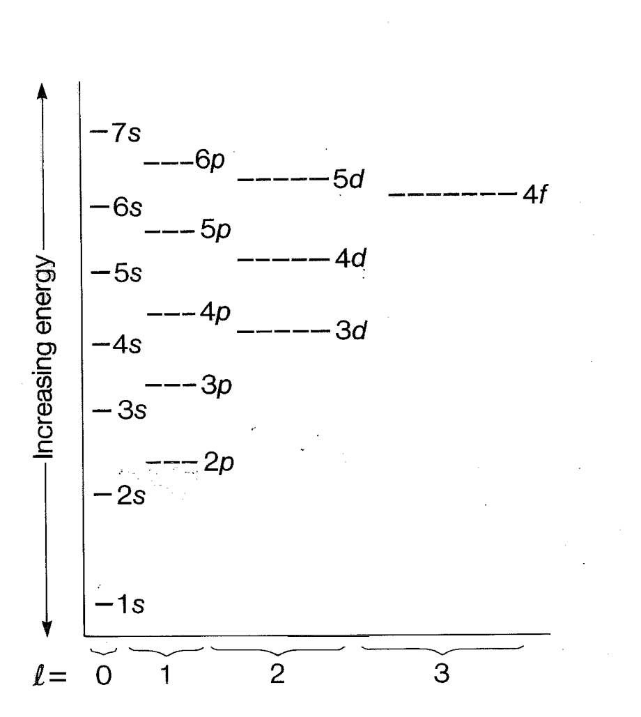

1. Complete the AUFBAU diagram for iron.
2. How many full orbitals does iron have?
3. Why is there a greater distance shown between 1s/2s than 3s/4s?
4. What is the quantum state of the first electron in the second orbital of sublevel 3d?
5. Iron typically takes on a +2 or +3 charge during bonding. Predict which electrons would be lost in each scenario.
6. Now, using your predictions, show the most stable configuration for Fe2+and Fe3+ by completing the AUFBAU diagrams provided.

Fe2+ Fe3+



1. Re-write the full electron configurations for Fe2+ andFe3+.