Electrochemistry
Unit 5B: Galvanic & Electrolytic Cells

Knowledge/Understanding Goals:
- how galvanic & electrolytic cells work
electrochemistry: using chemical (_________) reactions to produce ________________ or vice-versa. In an electrochemical reaction, oxidation and reduction reactions occur in separate containers, and the ___________ that travel from one container to the other pass through an electric circuit.
galvanic cell: (also called a voltaic cell)

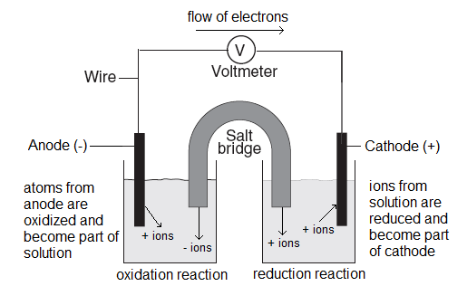
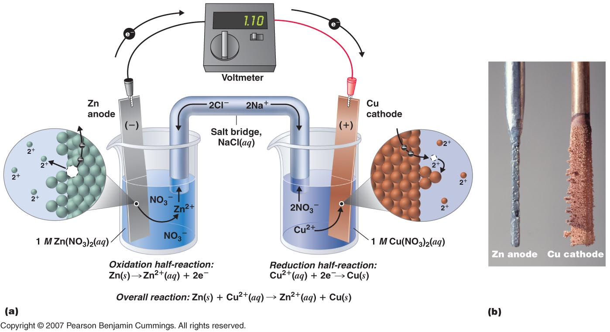
half cell: either of the two halves of a ___________ cell.
electrode: a solid _______ strip where either oxidation or reduction occurs. The metal strips also conduct the _____________ into or out of the electric circuit.
salt bridge: a salt solution that is connected to both _______________. The salt bridge provides ions for the two half-cells to keep the ____________ balanced. (If the charges are not allowed to balance, opposite charges would build up in both cells and the ________________________.) The salt solution must be made of ions that do not take part in the reactions at the cathode or anode. (______ is commonly used.)
anode: the negatively (−) charged electrode. At the anode:

cathode: the positively (+) charged electrode. At the cathode:

Note that electric “____________” is defined to be the direction that a positive particle would move. This means that the current flows in the ___________ direction from the electrons.

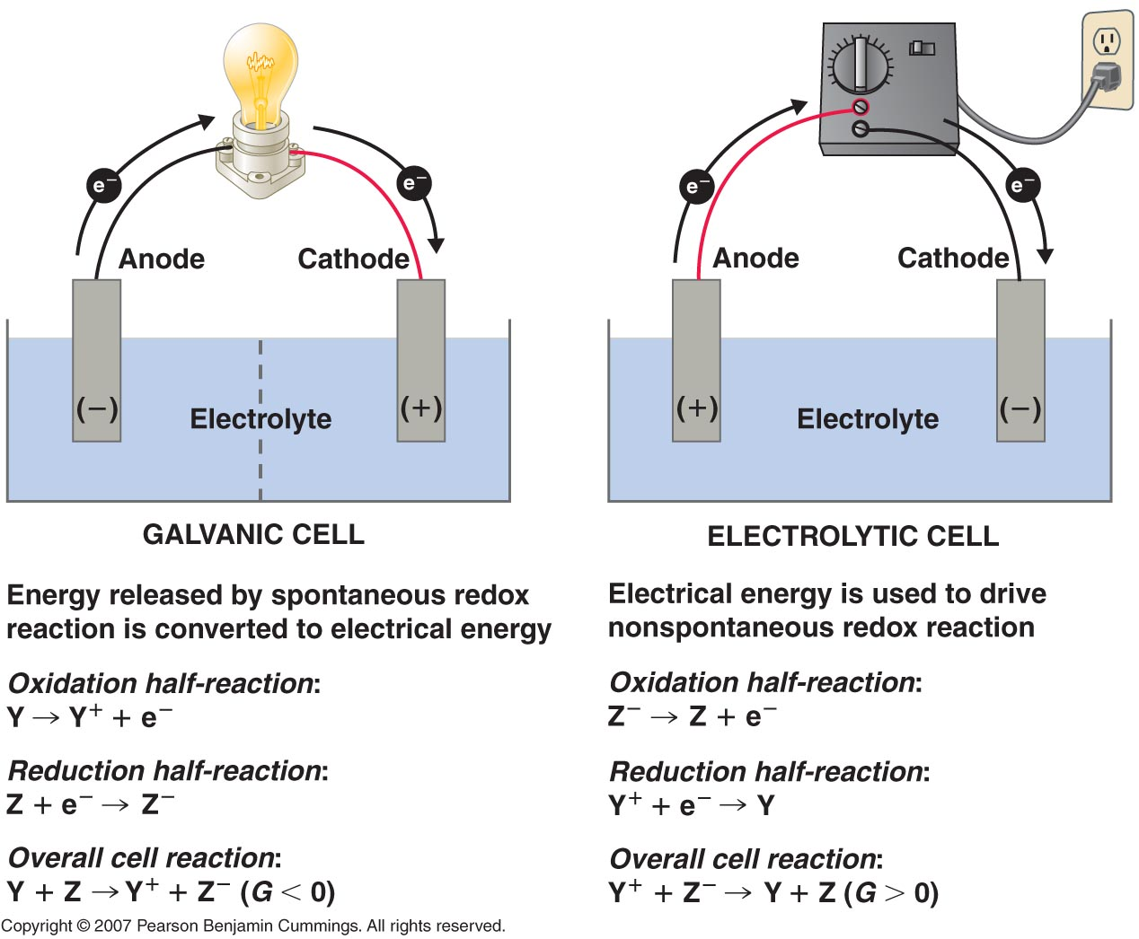

electrolytic cell: a cell similar to a galvanic cell, except that the reaction is _____________________, and _______________ is used to add the energy needed to make the reaction occur. (Electrolysis of water is an example.)
- Usually applied for metal plating (electroplating)
standard voltage (E°): the voltage (electric potential) of an electrochemical reaction in which all ____ concentrations are ____ and all gas pressures are 1 atm.
- E° values for ____________ reactions are published in tables of Standard Reduction Potentials. (Next Page)
- E° for an oxidation reaction is the ___________ of the E° for the reverse (reduction) reaction. (I.e., if you reverse the reaction, change the sign of E°.)
- The standard voltage of a cell is the ______ of the standard voltages for the oxidation and reduction half-cells:

- A ___________ E_{cell}° means the reaction is _______________. A negative E_{cell}° means the reaction is not spontaneous.

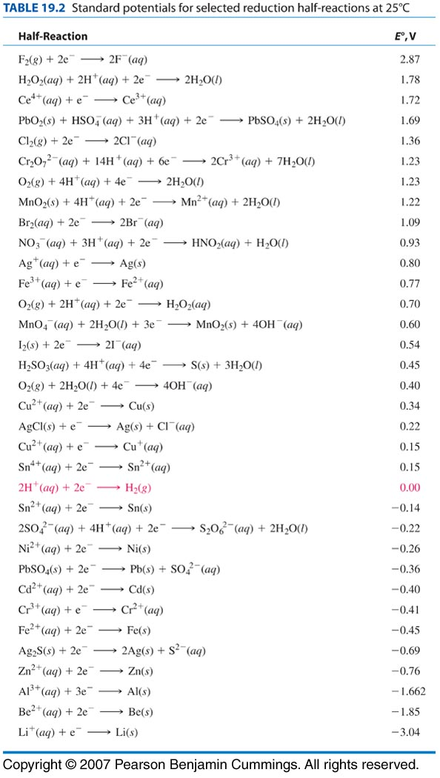
- Voltage is an ________________ property (similar to temperature). E° does not depend on the number of _____________ transferred, so you should never multiply E° by the coefficients in a balanced equation! (This is a common mistake on the AP exam.)
- The voltage does depend on the _______________ of the ions in solution. Qualitatively, this makes sense because the difference in concentration between where the reaction starts and where it ends up is what drives the reaction. E° values are at “standard conditions” (25°C, 1 atm, and all concentrations 1 M). If you lower the concentration, the potential drops. At the logical extreme, when the concentration reaches _______, the voltage drops to ________. At this point, the cell is “________”.
If the cell in question is a rechargeable battery, we would need to “recharge” the battery by putting _______________ to reverse the reaction. This would increase the reactant _______________, and the cell would once again be capable of delivering a ____________.
The effect of concentration on cell potential will be discussed in detail later in the topic.

Sample problem:
Q: A galvanic cell is set up with a Cu electrode and Cu²⁺ solution at the cathode, and a Mg electrode and Mg²⁺ solution at the anode. What is the standard voltage of the cell?
A: From the table of standard reduction potentials:

Because Mg is being ___________, the reaction is happening in the opposite direction, which means we need to ______________ the sign, making the voltage +2.37 V
The total voltage of the cell is therefore +2.37 V for the oxidation of Mg, plus +0.34 V for the reduction of Cu²⁺, giving 2.37 + 0.34 = 2.71 V for the standard voltage of the cell.
The positive potential of the reaction (+2.71V) shows us that the reaction is _____________________ in this direction.
electroplating: using an electrolytic cell to add a layer of ____________ to a _____________. The electric current reduces metal ions from the solution, which are then deposited onto the cathode.
charge: electrical charge (q) is measured in coulombs (C). One Faraday (F) is the charge, in Coulombs, of one mole of electrons. (1 F = 96,500 C/mol)
current: electric current (I) is caused by the flow of electrons and is measured in amperes (A). One ampere is one coulomb per second, so you can determine the total charge from the formula:
where I = current (Amperes), q = charge (Coulombs), and t = time (seconds).
In an electrolytic cell, the total mass plated can be determined by calculating the moles of electrons, and using the number of electrons transferred in the redox reaction to convert from moles of electrons to moles of the metal.

Sample problem:
Q: If we applied a current to our Mg/Cu cell from the previous example we could use it to electroplate magnesium at the cathode.
Cu²⁺ + Mg (s) Mg²⁺ + Cu (s) +2.71V

How many grams of magnesium could be plated using a current of 2.0 A for a period of 90 s?
A: First, calculate the charge (q): q = At
Next use F (C/mol e-) to convert from coulombs to moles of electrons.

Because the reaction was Mg²⁺ + 2 e⁻ Mg (s), it takes ______ electrons to plate ______ magnesium.
Therefore we plated _______________ of Mg. Using the molar mass of magnesium, this equals __________ of magnesium plated.

