Electrochemistry
Unit 5B: Galvanic & Electrolytic Cells

Knowledge/Understanding Goals:
- how galvanic & electrolytic cells work
electrochemistry: using chemical (redox) reactions to produce electricity or vice-versa. In an electrochemical reaction, oxidation and reduction reactions occur in separate containers, and the electrons that travel from one container to the other pass through an electric circuit.
galvanic cell: (also called a voltaic cell) a chemical apparatus that uses an electrochemical reaction to produce electricity. (A battery is a type of galvanic cell.)
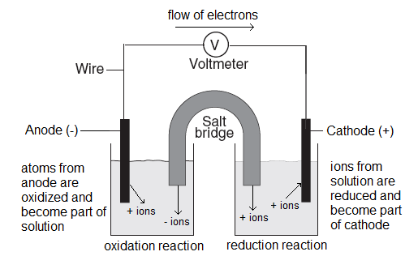
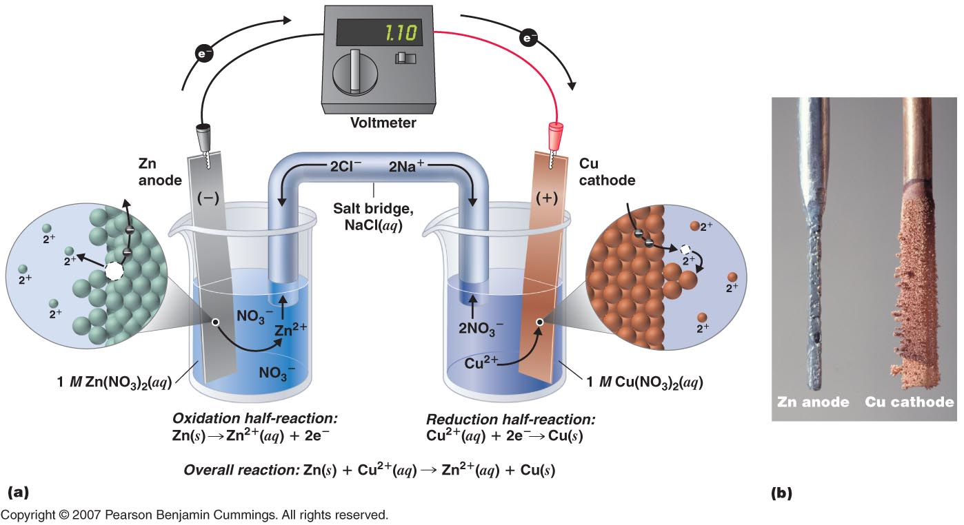
half cell: either of the two halves of a galvanic cell.
electrode: a solid metal strip where either oxidation or reduction occurs. The metal strips also conduct the electrons into or out of the electric circuit.
salt bridge: a salt solution that is connected to both half cells. The salt bridge provides ions for the two half-cells to keep the charges balanced. (If the charges are not allowed to balance, opposite charges would build up in both cells and the reaction would stop.) The salt solution must be made of ions that do not take part in the reactions at the cathode or anode. (KNO₃ is commonly used.)
anode: the negatively (−) charged electrode. At the anode:
- Oxidation happens. (Atoms from the anode are oxidized to positive ions.)
- These metal ions become part of the solution. (I.e., the anode loses mass.)
- The electrons produced by oxidation move up the wire into the electric circuit.

cathode: the positively (+) charged electrode. At the cathode:
- Reduction happens. (Ions from the solution are reduced to neutral metal atoms.)
- These metal ions become part of the cathode. (I.e., the cathode gains mass.)
- The electrons needed for reduction move from the electric circuit through the wire and into the cathode.
Note that electric “current” is defined to be the direction that a positive particle would move. This means that the current flows in the opposite direction from the electrons.

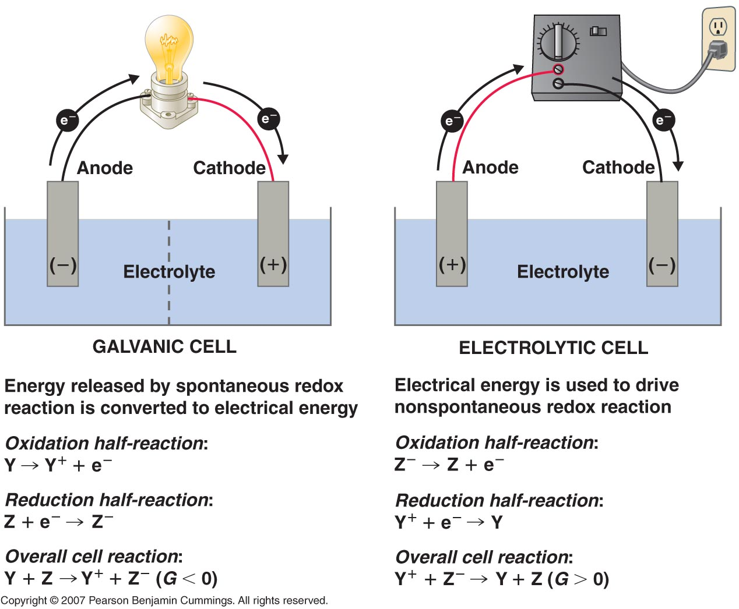

electrolytic cell: a cell similar to a galvanic cell, except that the reaction is nonspontaneous, and electricity is used to add the energy needed to make the reaction occur. (Electrolysis of water is an example.)
- Usually applied for metal plating (electroplating)
standard voltage (E°): the voltage (electric potential) of an electrochemical reaction in which all ion concentrations are 1M and all gas pressures are 1 atm.
- E° values for reduction reactions are published in tables of Standard Reduction Potentials. (Next Page)
- E° for an oxidation reaction is the negative of the E° for the reverse (reduction) reaction. (I.e., if you reverse the reaction, change the sign of E°.)
- The standard voltage of a cell is the sum of the standard voltages for the oxidation and reduction half-cells:
E°_{cell} = E°_{reduction} + E°_{oxidation}
- A positive E° means the reaction is spontaneous. A negative E° means the reaction is not spontaneous.

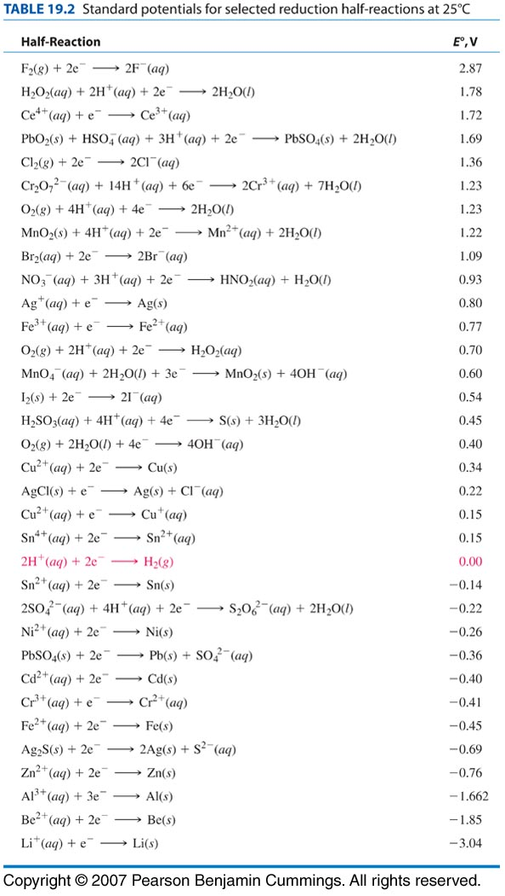
- Voltage is an intensive property (similar to temperature). E° does not depend on the number of electrons transferred, so you should never multiply E° by the coefficients in a balanced equation! (This is a common mistake on the AP exam.)
- The voltage does depend on the concentration of the ions in solution. Qualitatively, this makes sense because the difference in concentration between where the reaction starts and where it ends up is what drives the reaction. E° values are at “standard conditions” (25°C, 1 atm, and all concentrations 1 M). If you lower the concentration, the potential drops. At the logical extreme, when the concentration reaches zero, the voltage drops to zero. At this point, the cell is “dead”.
If the cell in question is a rechargeable battery, we would need to “recharge” the battery by putting in energy to reverse the reaction. This would increase the reactant concentrations, and the cell would once again be capable of delivering a voltage.
The effect of concentration on cell potential will be discussed in detail later in the topic.

Sample problem:
Q: A galvanic cell is set up with a Cu electrode and Cu²⁺ solution at the cathode, and a Mg electrode and Mg²⁺ solution at the anode. What is the standard voltage of the cell?
A: From the table of standard reduction potentials:
Cu²⁺ + 2 e⁻ Cu (s) +0.34 V
Mg²⁺ + 2 e⁻ Mg (s) −2.37 V
Cu²⁺ + Mg (s) Mg²⁺ + Cu (s) +2.71V
Because Mg is being oxidized, the reaction is happening in the opposite direction, which means we need to reverse the sign, making the voltage +2.37 V
The total voltage of the cell is therefore +2.37 V for the oxidation of Mg, plus +0.34 V for the reduction of Cu²⁺, giving 2.37 + 0.34 = 2.71 V for the standard voltage of the cell.
The positive potential of the reaction (+2.71V) shows us that the reaction is spontaneous in this direction.
electroplating: using an electrolytic cell to add a layer of metal to a cathode. The electric current reduces metal ions from the solution, which are then deposited onto the cathode.
charge: electrical charge (q) is measured in coulombs (C). One Faraday (F) is the charge, in Coulombs, of one mole of electrons. (1 F = 96,500 C/mol)
current: electric current (I) is caused by the flow of electrons and is measured in amperes (A). One ampere is one coulomb per second, so you can determine the total charge from the formula:
where I = current (Amperes), q = charge (Coulombs), and t = time (seconds).
In an electrolytic cell, the total mass plated can be determined by calculating the moles of electrons, and using the number of electrons transferred in the redox reaction to convert from moles of electrons to moles of the metal.

Sample problem:
Q: If we applied a current to our Mg/Cu cell from the previous example we could use it to electroplate magnesium at the cathode.
Cu²⁺ + Mg (s) Mg²⁺ + Cu (s) +2.71V

How many grams of magnesium could be plated using a current of 2.0 A for a period of 90 s?
A: First, calculate the charge: 2.0 A × 90 s = 180 C
Next use F to convert from coulombs to moles of electrons.
Because the reaction was Mg²⁺ + 2 e⁻ Mg (s), it takes 2 mol electrons to plate 1 mol magnesium.
Therefore we plated 9.5 × 10⁻⁴ mol of Mg. Using the molar mass of magnesium, this equals 0.023 g of magnesium plated.

