Basic Principles of Spectrophotometry Lecture Handout

- Introduction

One of the most important techniques of analytical and biological chemistry is spectrophotometry. Many routine clinical determinations are measured using the principles of spectrophotometry or adaptations of spectrophotometry. Spectrophotometers are instruments used to measure the ‘optical density’ of a solution.

- Electromagnetic Radiation (EMR)

  - Light is a form of energy known as EMR with several unique properties:
    - Light (EMR) travels at high velocities (speed of light = 3x10⁸ m/sec in vacuum)
      - Does not require the existence of a supporting medium to travel
      - Affected by the density of the material through which it travels

    - Light or EMR waves are often described as being similar to the waves produced by dropping a pebble into water, exhibiting a ‘cyclic or wave pattern’

      - Wavelength ( λ ): the linear distance traveled by one complete wave cycle

      - Wavelength is measured in nanometers: nm = 10⁻⁹ meter (one billionth)

    - The energy of electromagnetic radiation is inversely proportional to its wavelength

      - Shorter wavelength EMR = contains high amount of energy
      - Longer wavelength EMR = contains low amount of energy

  - Electromagnetic Spectrum

    - Wavelengths are divided into regions with approximate ranges
      - Ultraviolet region: ~180 - 380 nm
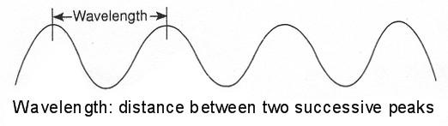  Visible region: | ~380 | - 750 nm
Infra-red region: | ~750 | - 2000 nm

  - The human eye responds to EMR between approx 390 - 700 nm, called the visible spectrum.

  - Modern laboratory instrumentation permits measurements at both shorter wavelengths (UV) and longer wavelengths (IR) of the spectrum in addition to the visible spectrum

- The ‘color’ of light:

  - ‘White light’ is the combination of all possible colors and is termed polychromatic light. Sources of white light include natural sunlight and artificial electric light (such as from a tungsten lamp)

Spectrophotometry Lecture Handout | 1

- The combination of the three primary colors of white light (red, blue, green) results in what our eyes perceive as white light:

- The visual sensation known as the color red is caused by light with a wavelength of 650 nm, and the color violet with a wavelength of 400 nm

Ultra Violet (UV), Visible and Infrared (IR) Spectrum Characteristics

Wavelength (nm) | Region Name | Color Absorbed
 |  | (visual sensation)
<380 | ultraviolet (UV) | not visible
380-440 | visible | violet
440-500 | visible | blue
500-580 | visible | green
580-600 | visible | yellow
600-620 | visible | orange
620-750 | visible | red
750-2000 | infrared (IR) | not visible

- The perceived color of an object is generally caused by an interaction of polychromatic (white) light and the object or pigments in the object

This interaction results in the unabsorbed wavelengths being reflected (or transmitted) to our eyes. It is the unabsorbed (or transmitted) light which our eyes see and perceive as the color of the object or solution

white light  | air
(polychromatic)

white light  Red solution

 white light 

(nothing is absorbed, all ‘colors’ transmitted as light we perceive as white light)

 red color 

(we see the solution as red because the red solution absorbs all wavelengths of light except red. Red (620-750 nm) is transmitted to our eye)

white light  | Green
 | solution

 green color 

(solution is green because the green solution transmits light between 500-580 nm (green), but absorbs all other wavelengths of light)

Spectrophotometry Lecture Handout | 2

      - When light interacts with matter, it is often described as ‘photons of light’ or packets of energy; and when it interacts with matter, it can be

        - Reflected (bounces off): reflective photometry
        - Refracted (bends): refractometry
        - Scattered (dispersed): nephelometry
        - **Transmitted** (pass through it): spectrophotometry
        - **Absorbed** (absorbed by absorbing molecules): spectrophotometry
          - We can determine the amount of light absorbed
          - We can determine the amount of light the molecule emits as it returns to ground state: emission photometry

- Absorption Spectrophotometry

A. Absorption Spectrum (spectral absorbance curve)
    - Every chemical species has a specific set of energy levels that it can absorb (this depends on its unique electronic configuration); a substance may be identified by the unique pattern of wavelengths it absorbs

    - To determine the absorption spectrum of a sample, a spectral absorbance curve is performed:
      - Absorbance readings are taken at each wavelength of light (usually in the visible spectrum)
      - Plot the absorbance values on the Y-axis and the wavelengths on the X-axis of linear graph paper
      - The wavelength showing maximum absorption is the optimal wavelength

    - The spectral absorbance curve is used to

  - Identify the absorbing species in solution
  - Determine the optimal wavelength at which to measure and quantitate the compound in solution

- Example: the chlorophylls in plants absorb strongly in the blue wavelengths (about 450 nm) and red wavelengths (about 650 nm) but transmit the green wavelengths (about 525 nm) of light

A plot of absorbance versus visible wavelengths (400 to 700 nm) for a solution of chlorophyll-a shows two major peaks, one at 460 and one at 660 nm, and several smaller absorbance peaks. This spectrum is characteristic for chlorophyll-a, and may be used as an aid in its identification.
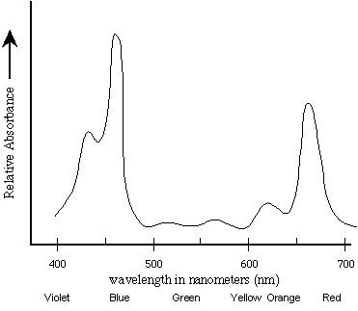

- The absorption maximum of any pure substance in solution is the wavelength where absorption is the greatest

    - The wavelength of maximal absorption is called the ‘optimal wavelength’ and this is the wavelength used in quantitative analysis of the substance in solution

    - Example: the absorption maximum (optimal wavelength) for chlorophyll-a (above) is 460 nm, since at 460nm we see the greatest amount of absorbance

    - Example: consider a solution with the absorption spectrum showing absorbance peaks labeled A, B, C

        - The wavelengths where absorption is greatest are 255 nm and 480 nm

        - Notice the steep slope of the absorbance peak at 255 nm and the pinpoint peak: any error in wavelength selection at this wavelength would be greatly exaggerated causing erroneous results

      - The absorbance peak at 480 nm is wider and more rounded, providing improved sensitivity and reliable results: the optimal wavelength for this solution would be 480 nm

  - Molecular Absorption

    - Monochromatic light (ie: light of a single wavelength) is necessary to accurately measure the absorption of substances in solution

    - The primary use of absorption spectroscopy lies in its application to quantitative measurements: this is a function of how much light is absorbed, and how that
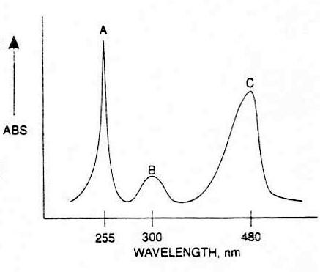
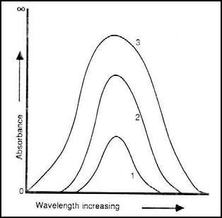

relates to the amount of absorbing molecules present in the sample.

- When a light beam of a specific wavelength and initial intensity (Io) passes through an absorbing sample, intensity of the light beam transmitted through the sample (Is) is dependent on three factors:

  - Wavelength of light: the sample must absorb light at that particular wavelength

  - Pathlength: the cell width or the amount of actual sample which the light must pass through must remain constant

  - The concentration of the absorbing species in the sample solution

1 = concentration 10

2 = concentration 20
3 = concentration 30

Spectral shape is not changed by the concentration of solution

Spectral absorption maximaun is not changed by the concentration of the solution

The area under the curve is changed by the concentration of solution

- Relationship of Transmittance and Concentration

  - Consider an incident light beam (Io) passing through a square cell containing a solution of a compound that absorbs light (radiant energy) of a certain wavelength

  - Because the compound (solute) in solution absorbs some of the incident beam of light, the intensity of the transmitted radiant energy (Is) will be less than the original incident beam of light (Io)

Io | Is
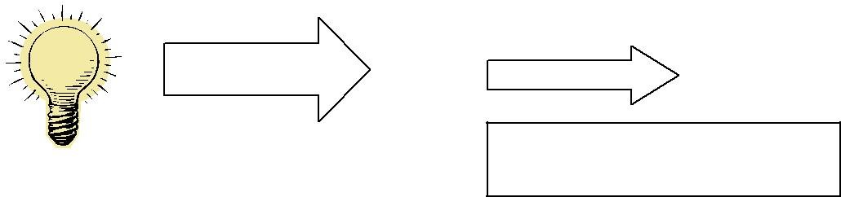

% Transmittance = Is x 100

Io

- In addition, some of the original light will be reflected by the surface of the cell, some absorbed by the solvent, and some transmitted.
  - To determine the amount of light absorbed only by the compound of interest (solute) we need to ‘negate’ the above effects by using a ‘blank’

  - A blank solution (or reference cell) is identical to the sample, except the compound of interest is omitted

Io Is
Blank
Io
Is
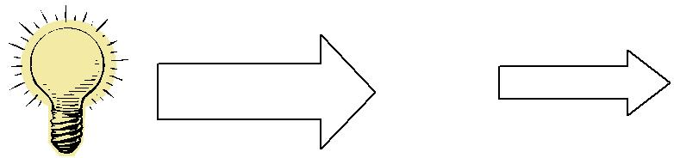

Is | x 100 of the blank is defined as
Io | 100 %T

This means the spectrophotometer is ‘set’ to read 100%T with this solution, ‘negating’ any absorbance occurring due to solvent, etc

Is x 100 of the sample ‘corrected’ for Io the absorbance due to solvent,

light lost, etc

Sample

- Transmittance (T) for the compound in solution is defined as the proportion of original incident light that is transmitted through the solution:
Transmittance = T = Is
Io

Percent T = %T = Is x 100%

Io

  - We can measure only the amount of light transmitted

  - As the concentration of the light-absorbing compound in solution increases, more light is absorbed and less light is transmitted. The relationship between %T and concentration is not linear, and assumes an inverse logarithmic relationship

The decrease in %T varies inversely and logarithmically with concentration

- Relationship of Absorbance and Concentration

  - The amount of light absorbed by a compound in solution varies directly with the number of absorbing molecules in the solution.

  - Example: if a 5% solution of a substance has an absorbance of 0.200, then a 10% solution of the same substance would be 0.400 AND a 15% solution would be 0.600
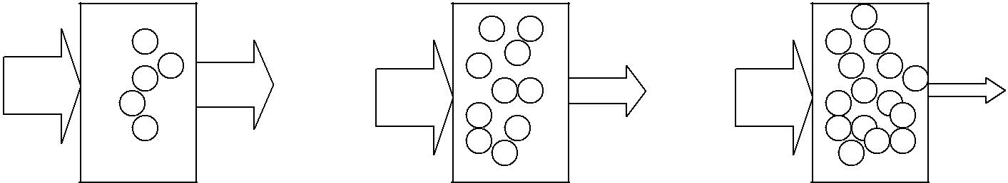

ABS=0.200 ABS=0.400 ABS=0.600

Example: Absorbance = 2 – log %T

= 2 – log 70 = 0.155

Absorbance 0.155 0.310 0.465 0.620 0.775

70% 49% 34% 24% 17% transmitted

- This implies ‘linearity’ with respect to concentration and absorbance

- Beer’s Law (Beer-Lambert Law) governs the measurement of light (absorbance) relative to a sample’s concentration.

Beer’s law states the amount of light absorbed by a solution varies directly with the concentration of substance in solution, under controlled conditions.

- Conditions necessary to ensure validity of Beer’s Law include:

  - Optimal wavelength of light
  - Monochromatic light
  - pH and temperature
  - Solvent absorption is minimal
  - Stray light not present
  - Sides of cell are parallel and clean
  - Concentration of substance within linearity

- The mathematical relationship correlating the direct relationship between ABS and

concentration is shown as A = abc and is known as the Beer-Lambert Law (Beer’s Law), where

A = absorbance

- = molar absorptivity (extinction coefficient) of the substance being measured; a constant for a particular solution at a specific wavelength under controlled conditions
- = pathlength of the cuvette (usually 1 cm)
- = concentration of the substance being measured

If pathlength (b) and absorptivity (a) are constants,

then absorbance and concentration are directly related: A ~ c

- The absorbance of a given solution in a 2 cm light path will be twice that given by the same solution in a 1 cm light path: the number of individual molecules of substance absorbing light determines absorbance, thus either increasing the concentration twofold of a given substance or doubling the light path length through that substance would have the same effect on the absorption of the substance.

1 cm, standard size 2 cm pathlength
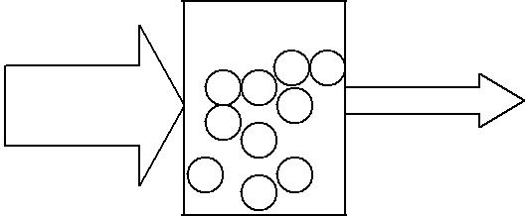

1 cm lightpath, concentration doubled

- Relationship of ABS and transmittance (%T)

  - Beer’s experiments showed linear increases in concentration are accompanied by exponential decreases in transmittance

  - The nature of this relationship can be demonstrated mathematically:

  - ABS is defined as the logarithm of 1

T

Transmittance (%T) is defined as Is x 100

Io

A = log 1 | or A = -log Is
T | Io

A = abc = log 100 - log%T

A = 2 - log%T

or A = log 100

%T

Remember: absorbance is not a measurable quantity and can only be obtained by calculation from transmittance data

4. Comparing %T and ABS values: A = 2 – log %T

%T | ABS |  | Maximum %T = Minimum Absorbance
0 | 4
0.1% | 3 |  | 100 %T | = | 0.000 ABS
1% | 2
10% | 1 |  | Minimum %T | = | Maximum Absorbance
100% | 0 |  | 0 %T | = | ∞

IV. Quantitative Measurements of Substances in Solution

- Beer’s law forms the basis of quantitative analysis by absorption spectroscopy. It allows us to determine the concentration of an unknown sample by measurement of its absorbance and determining its concentration from a plot (graph) of multiple standards (calibrators) on linear graph paper.

- Standard curve or calibration line:

  - The absorbance of a series of three to five standard solutions are measured and plotted on graph paper against the concentrations of these standards.

  - If the test solution follows Beer’s Law, then a plot of the various concentrations of solution versus absorbance will give a straight line when using linear graph paper

  - This is known as a standard curve (also called standard line or graph, calibration line, calibration curve). The absorbance of an unknown sample is measured, and its concentration is determined directly from this plot

- Which plot is preferred when determining unknown values? ABS vs Conc or %T vs Conc?

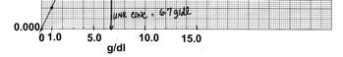
1. ABS vs concentration is a linear plot (linear graph paper) and is the most if not only popular graphical approach

a. Because plotting %T vs concentration yields a curvilinear line, too many standards would have to be run to gain accurate understanding of the calibration line: too expensive

b. With some solutions, up to 15 standards would be required before an unknown could be analyzed, whereas the ABS vs concentration curve is frequently established on the basis of 3 standard points: cost effective

c. The graphical approach serves to check method linearity and provides warning of a bad standard or absorbance value.

- When graphing a standard curve, it is good practice to insert a
best fit line into the data and determine the linearity correlation of your data (R² value). An R² near 1 shows a linear relationship between your standard curve data points.

2. Determining your standard concentrations
a. Your standard curve should cover an approximate absorbance range
from 0.000 to 1.100.

b. Spectrometer detectors experience insufficient absorbance detection
below an absorbance of 0.100 and begin to reach signal saturation
under high absorbance conditions, therefore losing accuracy above
absorbencies of 1.000.

1. Optimal accuracy is typically observed between 0.100 and 0.700
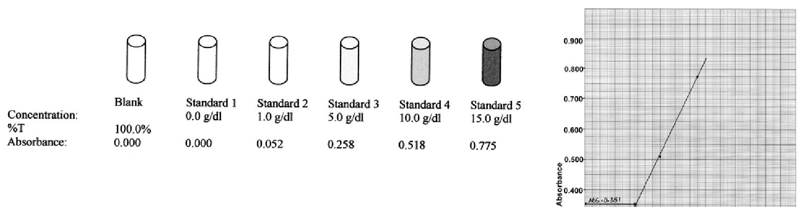

c. An optimal standard curve will therefore include standard solution
concentrations which span the optimal absorbency region and place
unknown sample concentrations in the optimal absorbancy region.

- Deviations from Beer’s Law (ABS vs concentration is not linear relationship) will
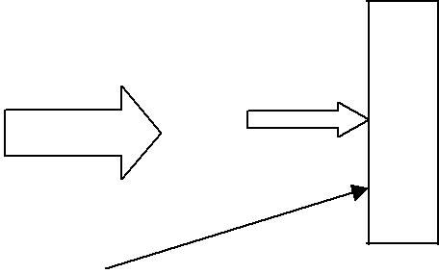
occur under the following conditions:
 |  |  |  |  | %T
1. | Measurements not taken at the optimal wavelength |  | C
2. | Monochromatic light is not used |  | E
 | (wide bandwidth instrument) |  | L
 |  |  | L
3. | pH and temperature are not ideal
 |  | Stray
4. | Significant difference between reference (blank)
 | and patient sample matrix | light
- Solvent absorption is significant (solvent and compound of interest absorb light)
- Stray light is present (absorbance falsely decreased)
- Sides of cell are not parallel or are dirty (fingerprints, dust, chemicals)
- Particulates in solution being measured (lipids, cells)
- Very elevated concentrations are measured: concentration of compound of interest is too high so that absorbance is no longer directly proportional to concentration

D E T E C T O R

E. Evaluation of Linearity
 |  |  |  |  |  |  |  | STD concentration (mg/dl)
1. |  | Plot the concentration of the glucose |  |  |  |  |  |  | Glucose |  | ABS
 |  | standards on the x-axis and the |  |  |  |  | 1. | 0 |  |  | 0.000
 |  | absorbance value on the y-axis of linear
 |  | graph paper. |  |  |  |  | 2. | 100 |  |  | 0.150
 |  |  |  |  |  |  | 3. | 200 |  |  | 0.300
 |  |  |  |  |  |  | 4. | 400 |  |  | 0.600
2. |  | Draw a straight line through the data |  |  |  |  | 5. | 500 |  |  | 0.750
 |  |  |  |  |  |  | 6. | 600 |  |  | 0.860
 |  | points that are consecutively linear
 |  |  |  |  |  |  | 7. | 800 |  |  | 1.120
 |  | with each other, and extend this
 |  |  |  |  |  |  | 8. | 1000 |  |  | 1.260
 |  | linear line to ‘infinity’
3. |  | List the standards that do not follow Beer’s Law: _________________________
4. |  | The upper limit of linearity for this solution is: ___________________________
5. |  | If a test result is obtained on an ABS value that is greater than the ABS value of
 |  | the upper limit of linearity standard, would this test result be valid? __________
 |  | What corrective action needs to be done to the test sample:
6. |  | Plot the absorbance values on the standard curve and determine the glucose
 |  | concentration for each sample
 |  | Sample Identification |  |  | ABS |  |  |  | Glucose concentration (mg/dl)
 | 9. | Salsa Lita |  |  | 0.180
 | 10. | Pollie Smith |  |  | 0.440
 | 11. Mike Lambda |  |  |  | 1.060
 | 12. Mike Lambda |  | diluted 1:2 |  | 0.560 |  |  |  | __________ x 2 = _________
 | 13. Mike Lambda |  | diluted 1:3 |  | 0.360 |  |  |  | __________ x 3 = _________

- Discuss the validity of Mike Lambda’s glucose result determined using on the undiluted sample. Should this test result be reported?

- Mike’s sample was diluted x2 and x3. The value obtained by the x2 dilution is reported. Discuss the rationale used for choosing the x2 dilution and not the other

- How do we know if this calibration curve is correct/accurate?

- How do we determine when calibration curves need to be performed?

- Spectrophotometry A. Basic Principle
    - Monochromatic light is passed through an absorbing (often colored) solution of a fixed depth (cuvette)
    - The light transmitted through the solution is directed upon a photosensitive device that converts radiant energy into electrical energy
    - Remember: light will be absorbed not only by the compound (solute) in the solution being evaluated, but also by ALL of the molecules in the liquid through which the light passes
      - Instrument is adjusted using a ‘blank’
      - Blank contains all of the components of the unknown solution (solvents, reagents, etc) but under conditions that will NOT permit the color reaction to take place (omit unknown sample)
      - The blank is used to set the instrument to a fixed point:

100.0 % T -or- 0.000 absorbance

    - The response of the test sample (unknown) can then be measured to determine the concentration of the compound

- Instrumentation: spectrophotometers are used to measure the light transmitted through a solution when we want to determine the concentration of a compound (amount of light-absorbing substances) in the solution

Refer to schematic of spectrophotometer: textbook, page 93, figure 4-5

  - LAMP = Light source: emits radiant energy (polychromatic)

    - Visible region: tungsten or quartz halogen
    - Ultraviolet region: deuterium or hydrogen or mercury-arc
    - Laser:
      - Truly monochromatic
      - Wavelength, direction, phase, plane of polarization of emitted light are the same as the incident light
      - Narrow bandwidth of few kilohertz making it more sensitive than conventional light source

  - MONOCHROMATOR = disperses polychromatic light into the electromagnetic spectrum so that ‘one’ wavelength of light may be selected

    - Remember: monochromatic light is needed for sensitivity, selectivity and adherence to Beer's Law
    - Filters: designed to transmit a narrow ‘range of wavelengths’
    - Prisms:
      - Polychromatic light is dispersed into spectrum (rainbow) but each color of the spectrum is refracted to a different degree
      - Results in a nonlinear wavelength scale bending shorter wavelengths (blue) more than longer wavelengths (red), thus generally not useful in the UV region
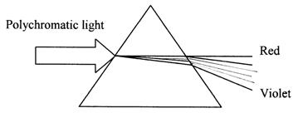

  - Diffraction Grating:

    - Thousands of parallel grooves are cut into a polished surface (usually glass) at specific angles and depth.
    - Results in more linear dispersion of light , increased resolution and sensitivity, when compared to a prism (thus practical for all wavelengths of light)

- EXIT SLIT: allows one wavelength or a narrow range of wavelengths to pass on to the sample cuvette

- SAMPLE CELL : also called a cuvette

  - Holds the solution being evaluated, allowing light transmission
  - Square cuvettes present flat surface to incident light resulting in less light loss from reflection than round cuvette; glass, quartz, plastic
  - Sample cuvette: contains test or unknown solution
  - Reference cuvette: contains blank solution
  - Fixed pathlength (1 cm is standard)

- PHOTODETECTOR: refer to schematic, textbook, page 95, figure 4-7, 4-8

  - Photomultiplier tube (PMT): commonly used in most laboratories and functions to convert light energy to electrical energy that can be measured

  - Consists of a cathode, anode and a series of dynodes
  - When radiant energy strikes the cathode, photosensitive material emits electrons that are attracted to the first dynode
  - Upon striking the first dynode, each ‘primary’ electron cause the emission of 3-6 ‘secondary’ electrons that are focused and attracted to the second dynode where the process is repeated

  - Chain reaction continues until anode is reached resulting in an internal amplification of the initial signal; amplification can reach 10⁶
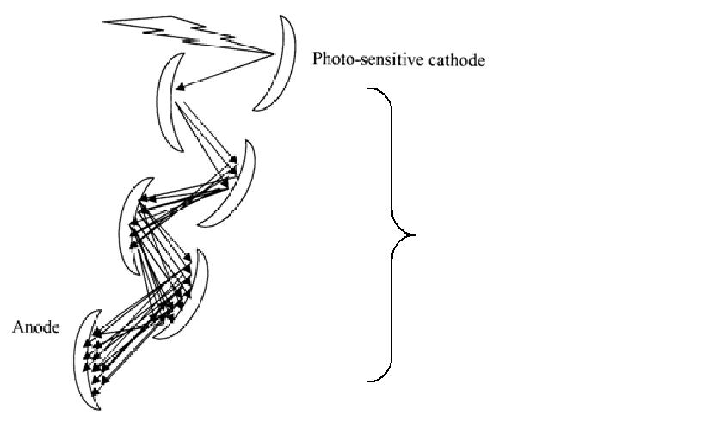

Dynode chain

- READOUT DEVICE: (with microprocessors and recorders)

  - Digital readouts capable of displaying data in alphabetic or numeric form
  - Converter changes electric signals to digital binary data which is further converted to arithmetic data

- Spectral Bandwidth and its effects on Linearity and Resolution

  - The light obtained by a monochromator is not truly one single wavelength, but is
    - range of wavelengths dependent on the spectral bandwidth

  - Spectral Bandwidth (Bandpass)

    - Term that refers to the range of wavelengths transmitted to the cuvette
    - Example: Wavelength selected = 450 nm Bandpass = 10 nm
Range of wavelengths passing through cuvette = 445-455 nm
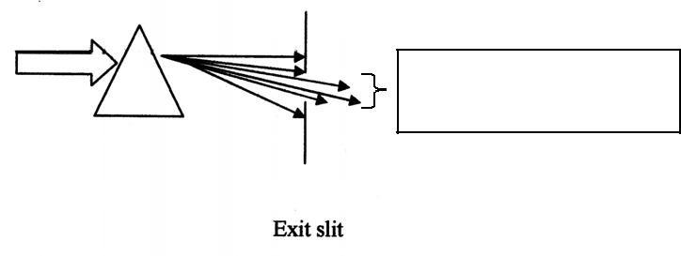

Range of wavelengths to cuvette = 445 – 455 nm

- Narrow bandpass is desirable

  - Increases sensitivity of instrument: can accurately measure low concentration of substance in solution
  - Increases linearity
  - Increases resolution of compounds in solution
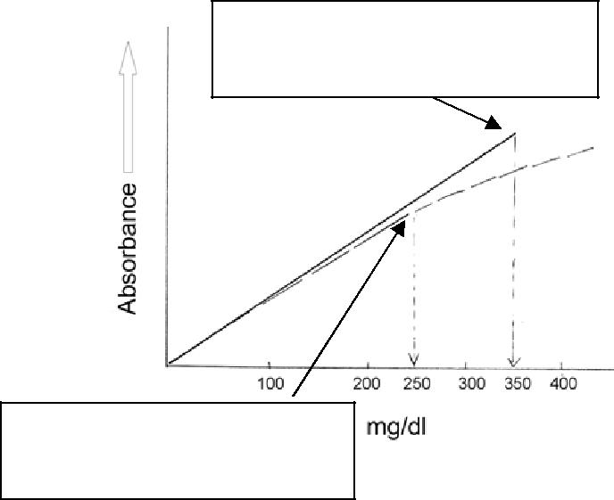

Narrow bandpass instrument
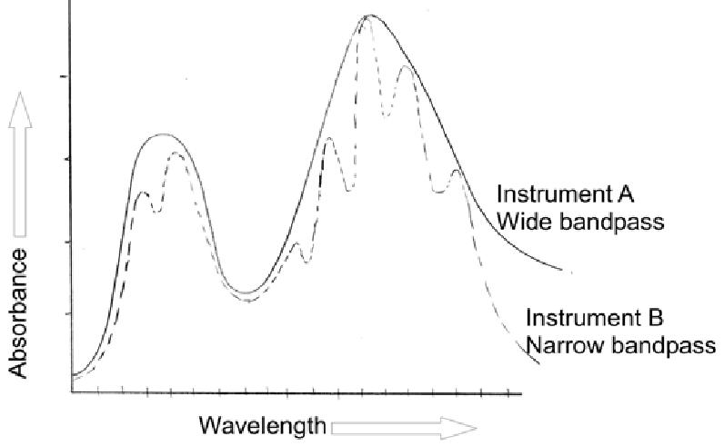
Linear to 350 mg/dl

Wide bandpass instrument

Linear to 250 mg/dl

VI. Sources of Error in Spectrophotometry: the total error made in spectrophotometry is the sum of all errors accumulated throughout the entire procedure!

- Test sample

  - Lipemia: additional lipid particles increase scatter of light resulting in less light reaching the detector ( %T) causing false increased absorbance readings

  - Hemolysis: can affect test results in several ways

    - Spectral absorbance curve of released hemoglobin shows absorbance peaks at specific wavelengths causing false increased absorbance readings at those specific wavelengths
    - Released hemoglobin may interfere with chemical reaction and cause
decreased or increased absorbance readings
    - Released intracellular components can falsely increase corresponding test results: LD, K+, Mg2+, folate, hemoglobin

  - Icterus: amber to orange color due to bilirubin pigment may interfere with measurements

- Temperature not held constant, or not optimal for reaction

  - Many reactions are temperature sensitive; most instruments have internal temperature monitoring and regulation
  - Cuvette temperature controlled: + 0.1ºC

- pH

  - pH of buffers and reagents may vary if stored improperly or used beyond their expiration date

  - Always use the purest or highest grade of water

- Standards and Standardization

  - Highest purity of standards is preferred
  - Precise pipetting and weighing techniques must be used: volumetric measurements
  - Always use the purest or highest grade of water when preparing

- Preparation of Solutions/Reagents

  - Precise pipetting and weighing techniques must be used. Imprecise techniques can introduce errors of 0.1-1.0% for each individual measurement
  - Must use chemically pure water, highest grade of water to prepare reagents
  - Mix contents of all tubes well before measuring (generally by vortexing, which can produce air bubbles, or by complete inversion)

- Cuvettes

  - Clean, dry and free of scratches, fingerprints, smudges
  - Remove air bubbles from solution by gently tapping cuvette against soft surface
  - Remove fingerprints, etc from cuvette surface using kimwipes (don't scratch the cuvette)
  - Check cuvettes for flaws, scratches, dirt etc. before using

- Wavelength Selection

  - Optimal wavelength not selected
  - Wavelength calibration error

- Presence of Stray Light: radiation outside that transmitted by the monchromator results in:
- Decreased absorbance readings
- Increased %T readings

 |  |  |  | D
 | C |  | %T
 |  |  |  | E
 | E |  |  | T
 | L |  |  | E
 | L |  |  | C
 |  |  |  | T
 |  |  |  | O
Stray |  |  |  | R
light

- Incorrect Blank Used

    - Water, saline, reagent blank, patient sample, etc can be used as blanks depending on the procedure
    - Sample matrix differs from matrix of blank: try to keep matrix similar

- Particulates in solution

  - Presence of lipids, cells, etc will cause falsely increased absorbance readings (falsely decreased %T)
  - Sample should be re-centrifuged prior to analysis

